Property Maintenance
for Managers

Property Maintenance for Managers

Facilitator Guide

Table of Contents
Introduction 8
Welcome 8
Agenda 8
A X’s Role and Responsibilities 10
Maintenance Overview 10
Types of Maintenance 13
Types of Maintenance 13
Standards 15
Maintenance Personnel 17
X Responsibilities 19
Set Maintenance Up for Success 20
Maintenance Training 23
Training Types 24
Technician Training 27
XT 28
Taking Service Requests 29
Service Request Form Template 30
Information Needed in Service Requests 31
Hiring Maintenance Personnel 32
Job Descriptions 33
Hiring Maintenance Technicians 33

Maintenance Skills Checklist 34
Job Descriptions 34
Skill Levels 40
Maintenance Technician Skill Levels 41
Administering Service Requests 44
Service Request Process 44
Service Request Summaries 45
Information in Service Request Summaries 46
Service Request Software 48
Service Request Process 49
Service Request Summary Template 50
Managing Inventory 51
Standard Inventory 51
A X’s Role 51
Costs 51
Tool Grades: Comparative Shopping 53
Storing Tools and Supplies 57
Suppliers 58
Vendor Programs 58
Maintenance Software 59
Emergency Supplies 59
Contractors and Vendors 60
X’s Role 60
Contractors 61
Bidding Process 64
Scope 65
Specifications 66
The Bidding Process 67
Scope and Specifications 67
Bidding 68
Awarding the Contract 68
Contracts 68
What to Include in a Contract 70
Minimizing Risk 71
Reducing Risk with Contractors 72
Lien Waivers 73
Multiple Payee Payments 73
Payment and Performance Bonds 74
Certificates of Insurance 74
Inspections 75
Exterior and Interior Inspections 77
Move Out and Make Ready Inspections 77
Property Inspections 78
Exterior Maintenance 78
Interior Maintenance 79
Move-Out Inspections 79
Make-Ready Inspections 79
Vacancy 80
Vacancy 83
Asset Preservation 83
Deferred Maintenance 84
Inspection Impact on Budgets 84
Preventative Maintenance 85
How to Manage a Preventative Maintenance Program 86
Preventative Maintenance Benefits 86
5-Step Maintenance Program 87
Preventative Maintenance Schedule 90
Maintenance Management Software 91
Conservation and Green Practices 92
Green Practices 93
Wrap Up 96
Key Points 96
Knowledge Check Answers 97
Green Practice Reference Materials 103
Energy Efficiency Best Practices 103
Self-Assessment Energy Audit Guide 107
Indoor Environmental Quality (IEQ) 108
Resource Efficiency 110
Water Efficiency 112

Notes to Facilitator
This guide is designed to help you manage the information for this module and to help increase consistency at all training locations nationwide.

Duration
This is a 6 hour module (excluding breaks and lunch).

Materials Needed
- PowerPoint Slides
- Creekwood Case Study
- Property Maintenance Participant Workbook (PWB)

Equipment Needed
- Flipchart or whiteboard with stand and markers
- Computer with connection to project PowerPoint slides
- Microphone if necessary – dependent on room size and setup
- Sound system to play videos if necessary at your location

Using Slides
You will notice that some of the slides build, and when that happens, it can be difficult for the Facilitator to know when the slide is at its end. To help with that, there is a red period that indicates the last build. On any slide where you don’t see a red period, that means that there is more, and to click again.

Knowledge Checks
There are Knowledge Checks at the end of the PWB. They are used by participants as a self-study after class and are not to be reviewed in class. A copy of the Knowledge Checks with answers is at the end of this Facilitator Guide.

Participant Workbook
Participant Workbook pages are noted throughout the facilitator guide. Use them to direct participants to summaries of classroom content. When providing page numbers, explain to participants they can follow along with classroom content, take notes, and/or use the content as a study aid after class. In some cases additional details are listed in the Participant Workbook; this is supplemental “nice-to-know” information.

Remind participants that the space provided in the workbook should be used for notes. Tested concepts and explanations will include the case study, the slides, the reference material and the facilitator’s oral explanations.

At the end of each Participant Workbook, you will see Knowledge Checks pertaining to that section. Explain to participants that they can use these for self-study after class. Answers are provided on the pages following the questions.
Module “At-A-Glance”
The timing in this guide is provided as a guideline and is estimated for an average class size of 25; modify as needed.
Topic | Activity | Duration
Introduction | - n/a | 5 mins
A X’s Role and Responsibilities | - Using maintenance issues, participants will practice asking questions needed to complete service request forms and review training and types of maintenance | 60 mins
Hiring Maintenance Personnel | - Participants will evaluate necessary maintenance skills and review candidate qualifications | 40 mins
General Maintenance Terminology | - n/a | 15 mins
Overseeing Service Requests | - Participants will review information on the service request summary. They will identify trends and look for causes and performance expectations. | 30 mins
Managing Inventory | - Participants will review emergency supplies.  - Given inventory scenarios, participants will make a collective decision about what actions to take. | 45 mins
Hiring Contractors and Vendors | - Given maintenance and repair scenarios, participants will learn the selection process for in-house, contractor or vendor selection  - Bidding and scoping of jobs will be discussed | 60 mins
Inspections | - Participants will learn the variety of inspections necessary for the property and look at images to identify maintenance issues to address. | 20 mins
Preventive Maintenance | - Participants will learn the value of and how to develop a preventive maintenance program. | 30 mins
Green Properties | - Participants will learn about the many ways to “green” property operations  - Participants will determine the amount of water and money saved by replacing showerheads | 45 mins
Wrap Up | - n/a | 10 mins
 | Approximate time | 360 mins

Introduction
Welcome | Slide 1  Display slide.  Welcome participants. | 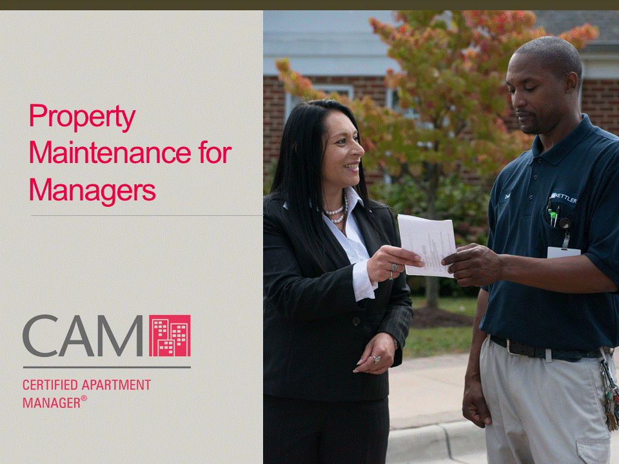
 | Slide 2  Display Materials slide.  Provide the following materials and explain their purposes.  Click and Explain the Participant Workbook:  - Used in class to follow along with information, take notes, and complete activities  - Contains high-level information covered in class, worksheets, activity information, etc.  Click and Explain the Reference Guide:  - Used after class as an on-the-job reference  - Contains detailed information about topics covered in class | 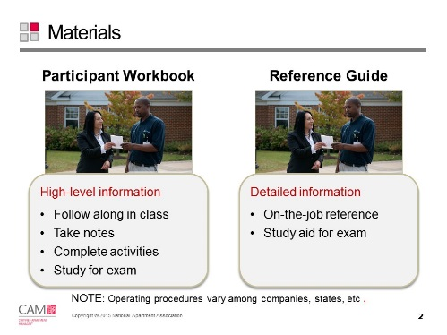
Agenda | Slide 3  Display Agenda slide.  Review the Agenda. | 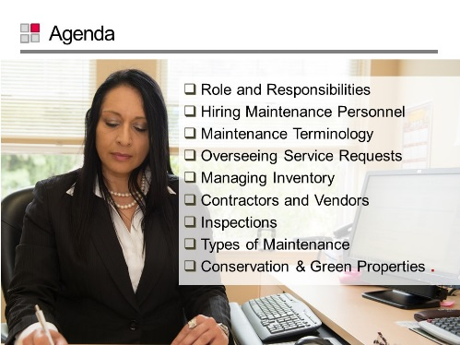
 | Slide 4  Display slide.  Introduce video: “We asked the industry professionals in this video to give us some insight into the topic of property maintenance. Let’s see what they have to say.”  Play video. | 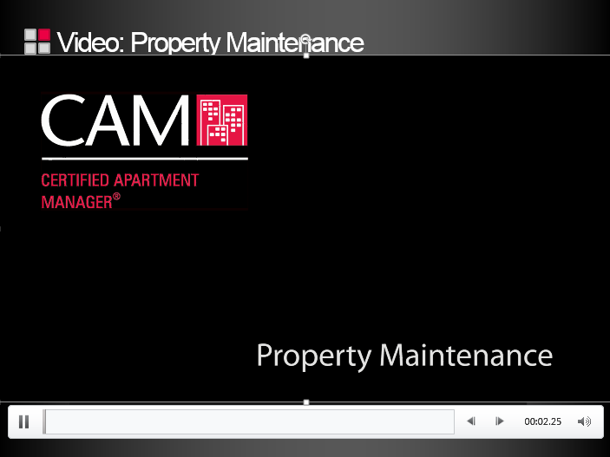

A X’s Role and Responsibilities
Slide 5
Display the title slide and introduce the topic.

Transition “Although many people and groups are involved in maintaining a property, the X is ultimately responsible for the property’s effective functioning, including maintenance operations.”
Maintenance Overview | Slide 6  Display and Review Maintenance Overview slide.  Define Maintenance  - Refers to the upkeep and repair of property and equipment.  Click to show each point and Review what is included in maintenance. Remind students “inspect what you expect.” | 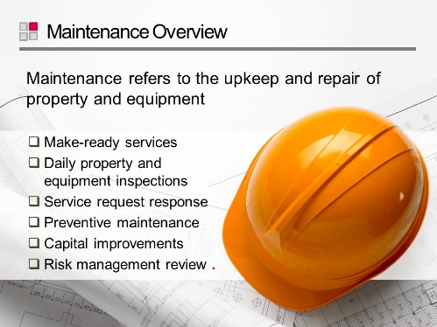
 | Slide 7  Display Property Maintenance – Purpose slide.  Click to show each point and Review the benefits and purpose of having a well-maintained property.  Ask “If you were looking for a new place to live what types of things would you notice when driving through the community? What kind of impression would that make?” | 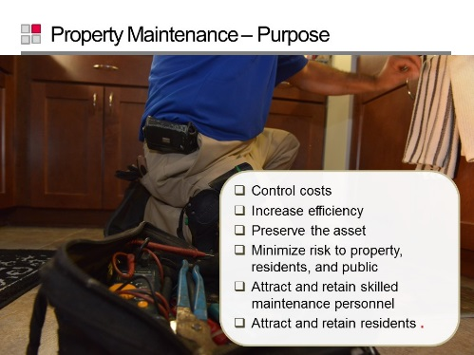
 | Slide 8  Display slide.  Ask participants how comfortable are you supervising work you may not understand.  Introduce video: “Our industry professionals had some things to say about the importance of learning about property maintenance.” | 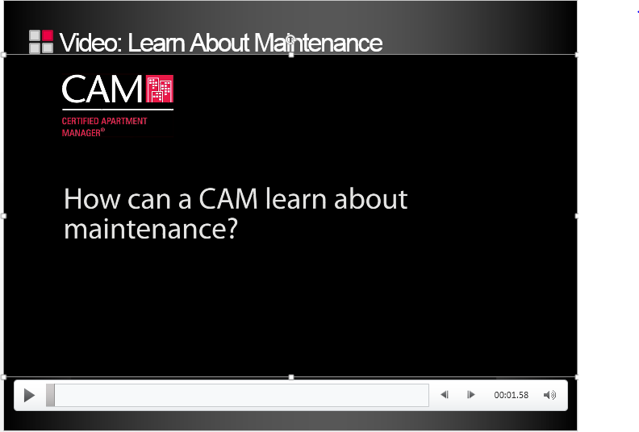
 | Slide 9  Display Benefits of Maintenance Knowledge slide.  Explain that having maintenance knowledge helps a X manage maintenance staff, communicate better, and prioritize tasks better.  Review examples on the slide. | 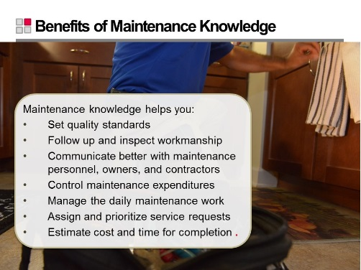
 | Slide 10  Display the slide and define the Types of Maintenance I slide.  Define Exterior Maintenance, Interior Maintenance and Make Ready Maintenance  Review the list in the Participant Workbook. | 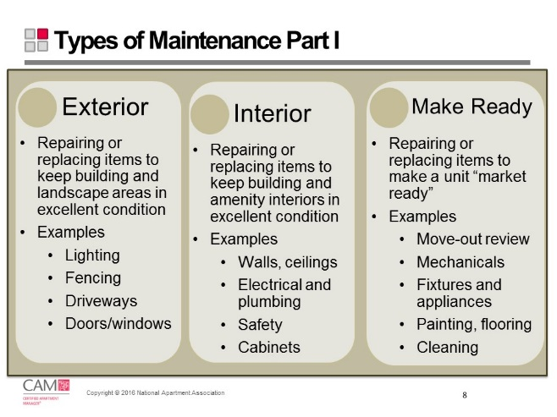
 | Slide 11  Display and Review Types of Maintenance II slide  List the types of maintenance, management, and prevention discussed in this section of the module.  Define Capital Maintenance  Review information about Moisture Management Plans  Define Preventative Maintenance | 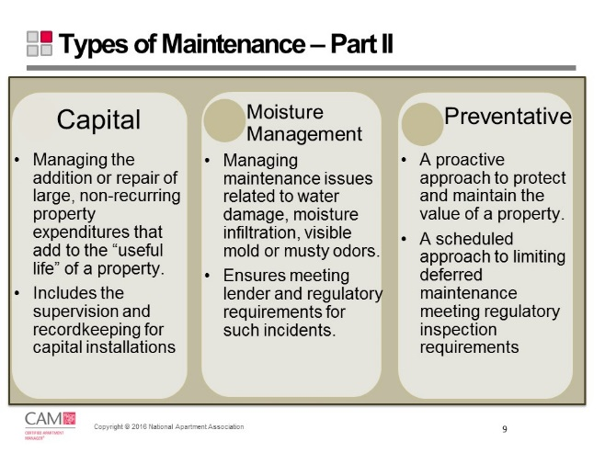

Types of Maintenance
Types of Maintenance
You will oversee the Maintenance Supervisor or Service Manager, but the Maintenance Supervisor or Service Manager is responsible for the “market-ready” condition of a property.
Type of Maintenance | Description | What is Included
Exterior | Repairing or replacing items to keep building exteriors in excellent condition | - Landscape irrigation  - Exterior lighting  - Siding and roofs  - Fences and retaining walls  - Drives and parking lots  - Sidewalks and other concrete surfaces  - Trash enclosures  - Doors and windows
Interior | Repairing or replacing items to keep building interiors in excellent condition | - Walls, ceilings, windows, floors  - Safety components  - Smoke/CO detectors  - Fire extinguishers  - Doors, cabinets, counter tops  - Electrical and mechanical  - Appliances, plumbing, HVAC
Make Ready | Repairing or replacing items to make a unit “market ready” and meet the expectations of prospective residents | - Pre-inspection  - Trash removal  - Pest control  - Mechanical systems – electrical, plumbing, appliances, HVAC  - Retrofits & rehab items  - Drywall, doors, windows, screens, locks, cabinets, counters, vanities | - Shelving, towel racks, ceiling fans  - Storage rooms, pantries  - Painting, caulking  - Flooring  - Drains, sinks, tubs, showers  - Post-inspection  - Final cleaning and welcome gift

Type of Maintenance | Description | What is Included
Capital Expenditure Projects | Large, non-recurring property expenditures that add to the “useful life” of a property  Note: Depreciated over an expected life rather than a single year and are not used to calculate NOI | Non-recurring expenses, such as:  - Replacing a roof  - Painting buildings  - Repaving a parking lot  - Adding a swimming pool
Preventative | A proactive approach to protect and maintain the value of property.  It maintains the property so deferred projects do not overwhelm staff and helps meet requirements for inspection set by authorities. | All aspects of interior and exterior areas of a property.
Moisture Management Plan | A plan outlining how to deal with maintenance issues related to water damage, moisture infiltration, visible mold, or musty/moldy odors  - Many lenders and insurance carriers require properties to have a plan  - Treat issues of this type as emergencies and follow a specific protocol  - Know what actions to take for water damaged materials | - Carpet, backing and pad  - Ceiling tiles  - Cellulose insulation  - Fiberglass insulation  - Concrete or cinderblock surfaces  - Hard surface, porous flooring (linoleum, ceramic tile, vinyl)  - Non-porous hard surfaces (plastics and metals)  - Upholstered furniture  - Wallboard (drywall and gypsum board)  - Window drapes  - Wood surface

 | Slide 12  Display Reference: Types of Maintenance slide.  Refer participants to the Participant Workbook for more information about each of the Types of Maintenance.  Review content from Participant Workbook. | 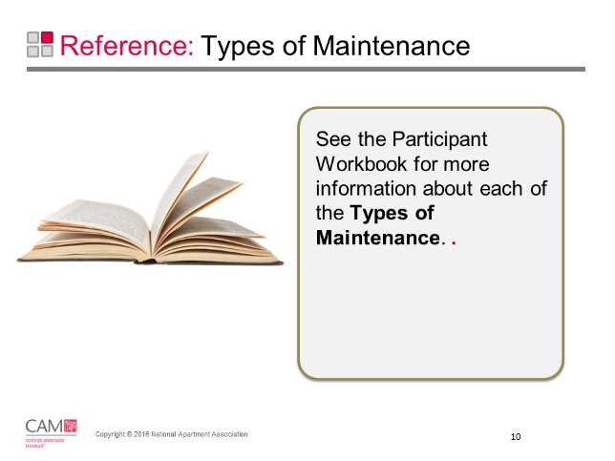
 | Slide 13 12  Transition “We now know a little more about what maintenance is and why we do it. It’s clear that it takes a team to accomplish all of the tasks. And that team needs to be focused in one direction. So let’s talk about how we get it done.”  Play Copa Airlines video.  Slide 14 12  After watching the video, guide participants to answer the three concept questions as a class. Solicit personal takes on the lesson points.  Reinforce the concept that a team plays a critical role in strengthening performance for a property.  Ask volunteers to share ways they have or would encourage using this approach with maintenance on their property. | 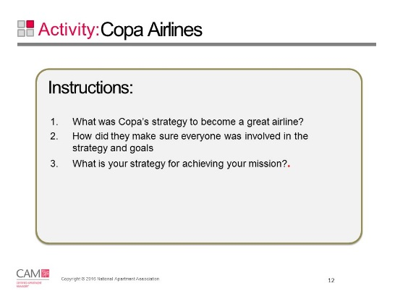
Standards | Slide 15 13  Display Setting Standards slide.  Explain that a key component of property maintenance is setting high quality standards to ensure that the property is well-maintained and improved.  Explain that setting high quality standards is another action Xs can take to achieve their ultimate goal: to add value to the property. | 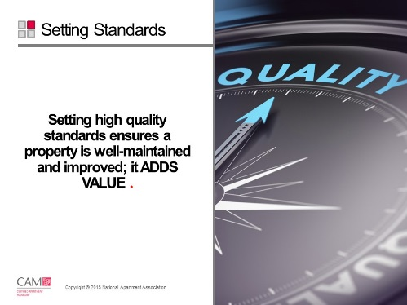
 | Slide 164  Display Quality Standards slide.  Explain that quality standards include the way you treat others. A X sets the tone for the team and should act in the way they want staff to act. This includes:  - Set an example to follow  - Be respectful, ethical, and honest  Click to show each point and Review the remaining key points in the slide.  Explain that quality workmanship extends the useful life of everything on the property such as:  - Buildings  - Equipment  - Mechanical systems  - Major appliances  - Landscaping  Click and Emphasize the final key point on the slide. | 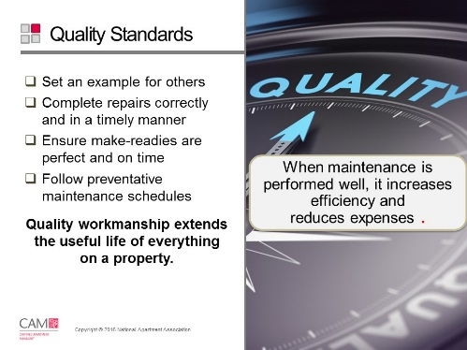
 | Slide 17  Display Communicating Standards slide.  Ask “What happens if a standard or expectation isn’t communicated properly?”  Accept responses. Responses will vary.  Explain that to avoid the adverse effects participants listed, a X must communicate expectations well.  Click and Review the communication tips listed.  Note that staff should know their manager will check that they completed the requested work.  Ask “What are some ways to clearly communicate expectations?” | 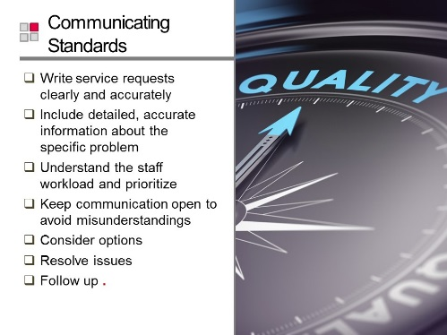
Maintenance Personnel | Slide 186  Display slide.  Emphasize the value of maintenance personnel to a property. Ask how many of you are looking for staff right now. | 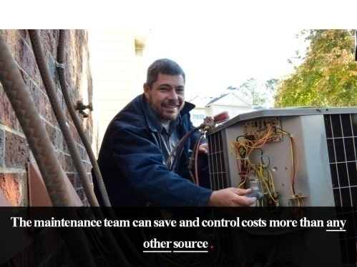
 | Slide 197  Display slide.  Emphasize the impact maintenance personnel have on the resident experience. Quality maintenance leads directly to strong resident retention. | 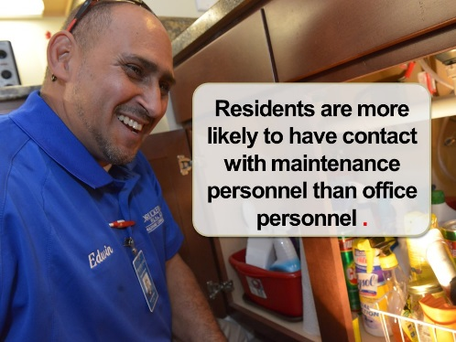
 | Slide 208  Display Maintenance Personnel slide.  Click to show each point and Read the ways Maintenance can make major contributions to a property’s financial condition. | 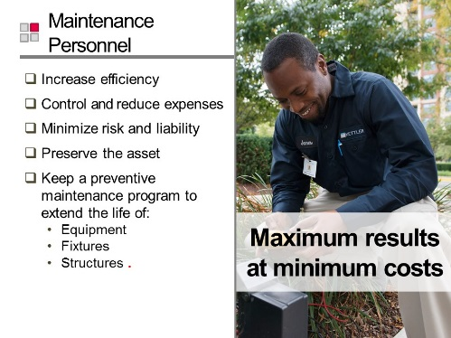
 | Slide 219  Display X Responsibilities slide.  Click to show each point and Review key tasks listed on slide.  Provide examples where applicable.  Use the last bullet as a transition into the next four slides.  Ask “Which of these responsibilities is most important to you on your property right now?” | 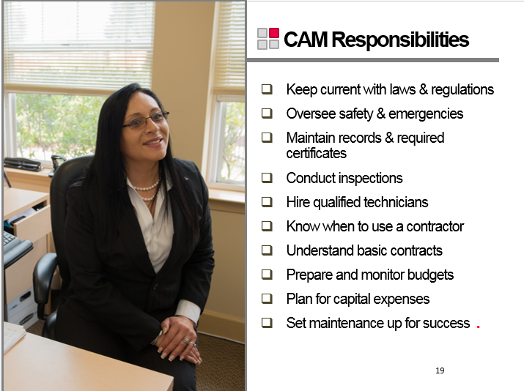
 | Slide 22 20  Display Reference: X Responsibilities slide.  Refer participants to the Participant Workbook for a summary of X Responsibilities.  Review content from Participant Workbook. | 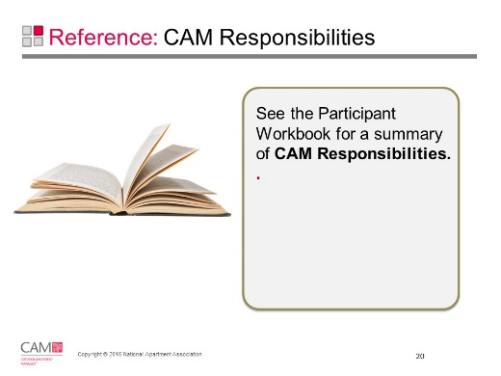
X Responsibilities
- Keep current with new laws and regulations that impact the property, particularly those relating to safety for residents and staff.
- Maintain records and required certificates (occupancy, elevators, swimming pools, etc.) for the property. This includes the Environmental Protection Agency (EPA) certification for working with refrigerants and Certified Pool Operator (CPO) where required.
- Understand the maintenance repairs necessary to ensure that all OSHA, local and state safe workplace requirements are met.
- Conduct inspections.
- Oversee safety issues and emergencies.
- Hire qualified maintenance technicians and evaluate their performance.
- Know when to use a contractor, and how to write a job specification and conduct a bidding process.
- Understand basic contracts.
- Prepare and monitor budgets.
- Plan for capital expenses.
- Set maintenance up for success.

Set Maintenance Up for Success | Slide 23 21  Display and Review Set Maintenance Up for Success: Manage Tasks & Personnel slide.  Transition “Let’s see some of the ways you can set your maintenance personnel up for success.”  Read the ways a X can set maintenance up for success.  Click and Review the key points on the slide. | 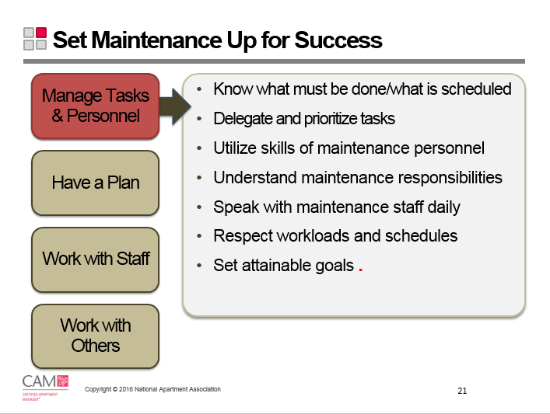
 | Slide 24 22  Display and Review Set Maintenance Up for Success: Have a Plan slide.  Review the key points on the slide. | 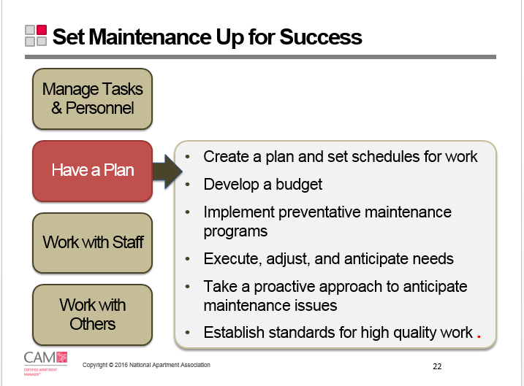
 | Slide 25 23  Display and Review Set Maintenance Up for Success: Work with Staff slide.  Review the key points on the slide.  Say “Have your sneakers ready. Walk the property.” | 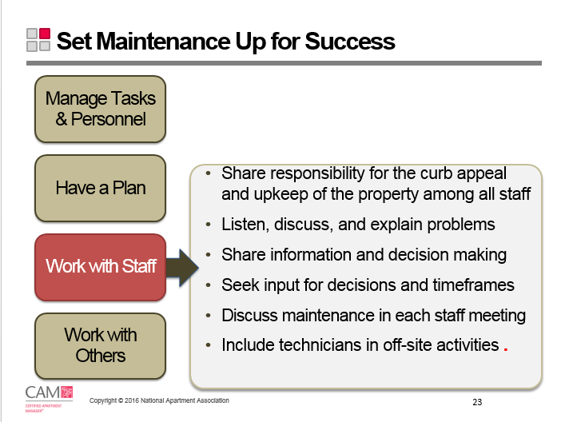
 | Slide 26 24  Display and Review Set Maintenance Up for Success: Work with Others slide.  Review the key points on the slide.  Ask “Do you have a list of contractors ready if needed?” | 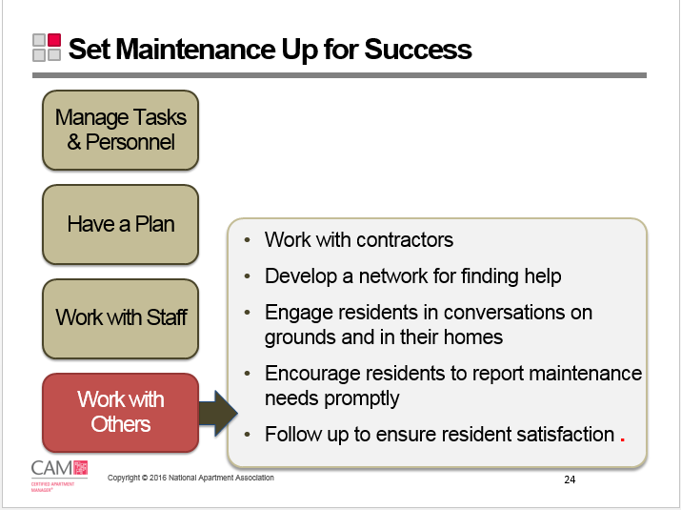
 | Slide 275  Participant Workbook  Refer participants to the Participant Workbook for an unabbreviated list of ways to Set Maintenance Up For Success.  Review content from Participant Workbook. | 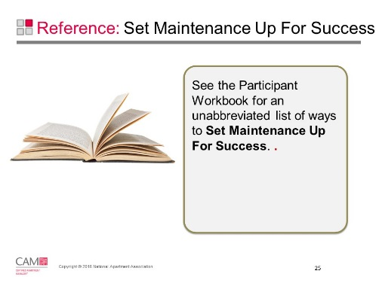

Set Maintenance Up for Success

Manage Tasks & Personnel | - Know what maintenance work must be done  - Know what is scheduled for the day  - Work with the maintenance supervisor to assign responsibilities; delegate tasks and prioritize tasks  - Work closely with and utilize skills of the maintenance supervisor or service manager  - Understand the duties/responsibilities of maintenance personnel  - Speak with the maintenance supervisor or staff daily  - Respect workloads and schedules  - Schedule 20% of day for supervisor  - Set attainable goals
Have a Plan | - Create a plan (daily, weekly and long term)  - Work with your maintenance supervisor to set schedules for daily, weekly, monthly and overtime maintenance work  - Develop a budget  - Work with your supervising office to plan and implement preventative maintenance programs  - Execute, adjust, and anticipate needs  - Take a proactive approach to anticipate maintenance issues; “Fix it before it breaks”  - Make decisions  - Establish a standard for high quality work; “Inspect what you expect”
Work with Staff | - Inform the staff that maintenance and curb appeal is everyone’s responsibility, not just maintenance personnel  - Everyone is responsible for the appearance and upkeep of the property  - Listen, discuss and/or explain specific problems  - Share information and decision making  - Seek input for possible decisions and timeframes  - Discuss maintenance in every staff meeting – even if it is only a brief update or praise for everyone’s effort  - Include service technicians in off-site activities such as community service and job fairs
Work with Others | - Work with contractors  - Develop a network for finding help: schools, temp employees, contractors, vendors  - Engage residents in conversations on grounds and in their homes  - Encourage residents to report maintenance needs promptly before they become more costly repairs or emergencies – not just when rent is due  - Follow up to make sure repairs were completed and the resident is satisfied

Maintenance Training | Slide 286  Display Maintenance Training slide.  Transition “Training is an excellent way to set your employees up for success.”  Review the key points on the slide. | 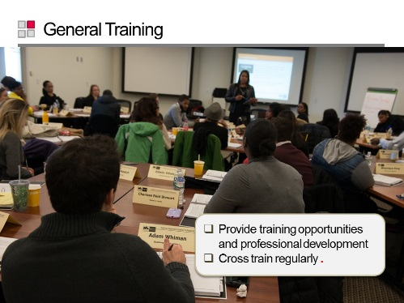
 | Slide 297  Display Reference: Training Types slide.  Refer participants to the Participant Workbook for a summary of Training Types.  Review content from Participant Workbook.  Ask the participants how important the office staff is in taking service requests. | 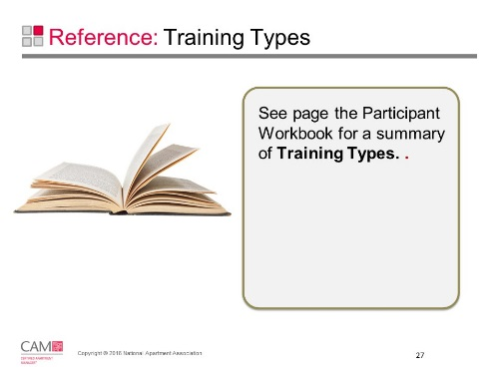
Training Types

General Training | Office Staff
- Provide training opportunities & professional development  - Cross train regularly | - Staff must take accurate, detailed service requests  - Getting work done right the first time:  - Saves time & money  - Increases resident satisfaction
Technician Training | XT
- Increases:  - Maintenance personnel’s skills  - Productivity  - Employee job satisfaction  - Resident satisfaction  - Work finished correctly the first time  - Reduces:  - Maintenance expenses  - Wasted time  - Employee & resident turnover  - Service call backs  - Include technicians in reward, incentive and recognition programs  - Encourage relationships with technicians at other properties  - Include technicians in mystery shopping assignments | XT training:  - Consists of seven courses.  - Is an introduction for new maintenance professionals or a refresher for more experienced maintenance technicians.  - Gives professionals the knowledge and tools necessary to run an effective maintenance operation.  - Is accredited by the American National Standards Institute (ANSI), a private non-profit organization that administers and coordinates the U.S. voluntary standardization and conformity assessment system.  Prerequisites for the Certification:  - One year of apartment or rental housing maintenance experience  - Successful completion of the seven courses and online content  - Meeting all examination requirements within 24 months of declaring candidacy for XT  XT provides the knowledge and tools necessary to run an effective maintenance operation.  For more information: http://www.Xhq.org/learn/education/designation-programs
Maintenance Technicians who increase their skill levels and accept greater responsibility create a stronger team and potentially add greater value to the property.

 |  | Slide 30 8  Display Maintenance Training for Office Staff slide.  Review the key points on the slide.  Click and Emphasize the key points on the slide. | 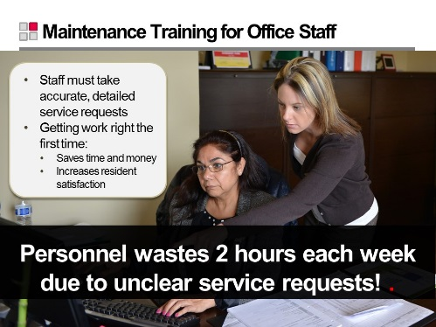
 |  | Slide 319  Display Activity: Take Service Request Order slide.  Duration: 20 minutes  Instructions:  - In groups, put together a list of questions Xs should be asking when someone calls with a service request to be sure that the request is as specific as possible.  - Scenario One: My disposal doesn’t work.  - Scenario Two: I have no hot water.  - Scenario Three: I have no power.  Debrief:  - Ask “What questions did you ask for scenario one (disposal doesn’t work)?”  Sample answers:  - When was the last time you put something in the disposal? What was it?  - Is it making any noises when you turn it on?  - Will there be children alone in the apartment (maintenance can’t enter if there are children alone in the apartment)? Pets?  - Ask “What questions did you ask for scenario two (no hot water)?”  Sample answers:  - When did it start?  - Did you check the fuse box?  - Did you pay the water bill?  - Is this a localized problem or is it all over the unit?  - Will there be children alone in the apartment? Pets?  - Ask “What questions did you ask for scenario three (no power)?”  Sample answers:  - Did you check the breaker?  - Is the pilot light on?  - Is there water leaking? Is the water penetrating to other parts of the apartment?  - Will there be children alone in the apartment? Pets?  - Discuss how the information collected impacts service requests and resident interaction.  - Explain that a missed piece of information results in an additional call to the resident , using more time, not providing a technician with the information they need, service request form, etc. | 