HOS Order to Cash

Objective
By the end of this module, participants should be able to:
- Explain how HOS OTC enables HOS Gold
- Describe the key components of the HOS OTC Framework
- Discuss how the HOS OTC Framework enables a plant manager to successfully execute the business imperatives (stability, sustain and improve, complex problems)
- Apply HOS OTC to solve business problems and address business opportunities

Duration
This module is estimated for 4 hours.

Outline
Time | Topic | Presentation | Media
5 min | Introduction | Facilitator introduces modules and goes over Course Objectives and Agenda. | PPT slides
20 min | What is OTC? | Facilitator presents content on what OTC is. This section includes a discussion on strategic priorities and engagement with the participants on what they know about the new OTC. | PPT slides
5 min | HOS Maturity Paths | Facilitator will present on the HOS Maturity Paths. | PPT slides
10 min | Activity: Tennis Balls | Activity: Participants have several rounds of trying to get tennis balls from one side of the room to the other, improving their process during each round to improve the time it takes. | 2 boxes  Tennis Balls  Stopwatch
30 min | Four Focus Areas | Facilitator will present content on the Four Focus Areas. | PPT slides
10 min | Activity: Manager vs. Leader | Activity: Participants will have a discussion in their groups on what makes a manager vs. a leader, while separating a list of tasks they are given into the two categories. They will put the tasks on post-its and place on a flip chart in one of the two columns.  Note: This activity takes place during the Four Focus Areas section. | PPT slides  Flip Chart  Post-Its  Markers or Pens
10 min | Activity: Connectedness | Activity: Participants move to any spot in the room and freeze, then choose 2 other people to be focal points in their current location. Several rounds are conducted where participants are asked to move to another spot that is in between their 2 focal points. Goal is to show interconnectedness.  Note: This activity takes place during the Four Focus Areas section. | None
15 min | Break | This break will fall in the middle of the Four Focus Areas section (above.) It will most likely fall right after the Process Improvement section and before Performance, but gauge how the class is going and give a break when it makes sense. | None
35 min | Tools: So what helps me do all this? | Facilitator will show tools that participants can use improve in the four focus areas and other areas discussed in this module. | PPT slides
90 min | Case Study Activity | Activity: Participants will complete a case study. They will read a scenario in their Participant Guide, discuss in their groups, and present to the class. | PPT slides  Participant Guide
5 min | Wrap Up | Summarize the module and answer any lingering questions. | PPT slides
5 min | Review - Start, Stop, Continue | Activity: Participants will reflect on what they learned in the module and write it in their Participant Guide. | PPT slides  Participant Guide

HOS Order to Cash

Course Objectives
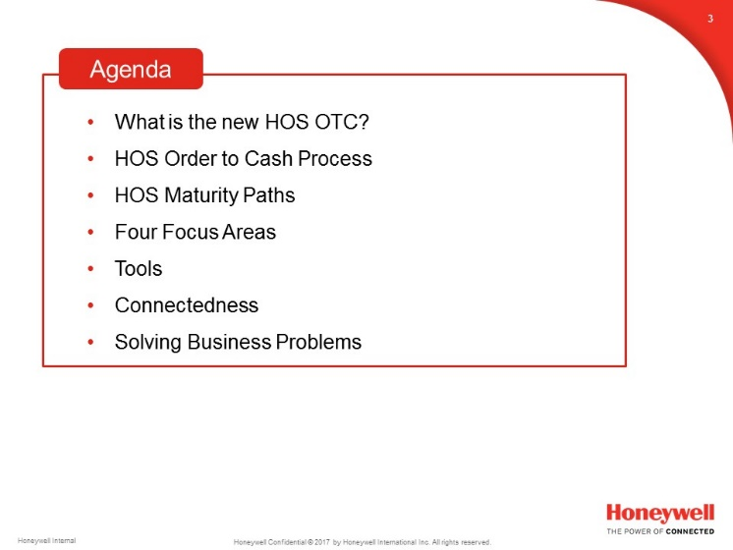

Introduce the module and review the Course Objectives.

Agenda

Review the agenda.

HOS Order to Cash, continued

X’s Strategy to Accelerate Value Creation
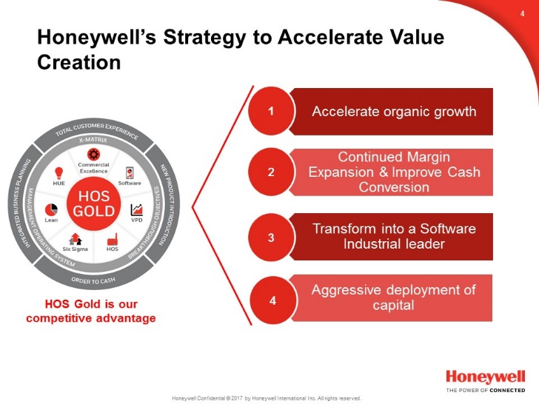

Review the 4 Strategic Priorities.
Accelerate Organic Growth-
Bring high return products to market rapidly
Enhance customer experience at every touchpoint
Expand margins via productivity
"The Power of One"
Sourcing Excellence
ERP consolidation
Lean Manufacturing
Aggressive deployment of balance sheet
Smart acquisitions
High return on CapEx
Transform into a Software-Industrial Company
Integrated solutions across our technologies and businesses
Internet Of Things
Build tested, iterated, and proven solutions
X Sentience- non-software is just as important
Culture- the essential ingredient- how we treat our customers, work together, and drive accountability for results.
Successful leaders will have a passion for winning and hatred for losing. The will be more hands-on than hands-off.
Collegial yet driven
Challenge each other's ideas and push to perform at our highest level

HOS Order to Cash, continued

Discussion: Strategic Priorities
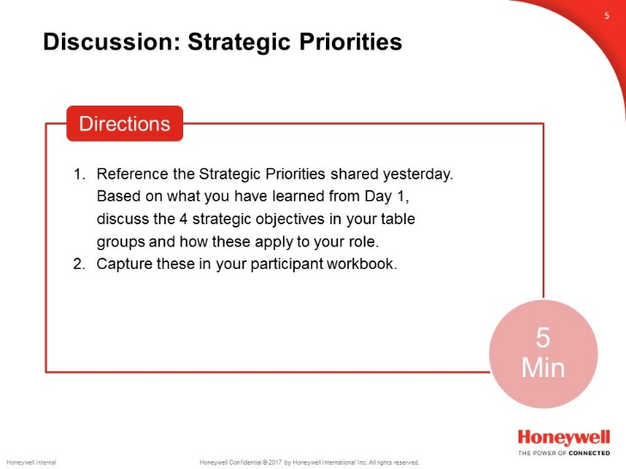

Total Activity Time: 10 minutes
Participants should already be divided into groups by tables. If they aren’t, divide them into groups of 5 or 6.
Tell participants that they have 5 minutes to discuss the strategic priorities that we just reviewed and that were covered in Day 1. Tell them to discuss how these priorities apply to their role.
Allow groups 5 minutes to discuss and then call time. Debrief for the next 5 minutes by calling on individuals, one at a time, to answer the questions, based on what was discussed within the group. Make sure to only call on one representative from each group.

X’s Strategy to Accelerate Value Creation
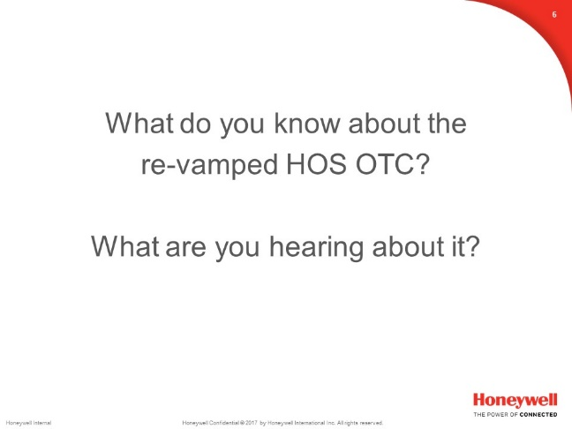

Facilitate a quick large group on what participants know or have heard about the new HOS OTC. Ask for volunteers to share what they know. Spend 5 minutes on this.

HOS Order to Cash, continued

Recent Communications

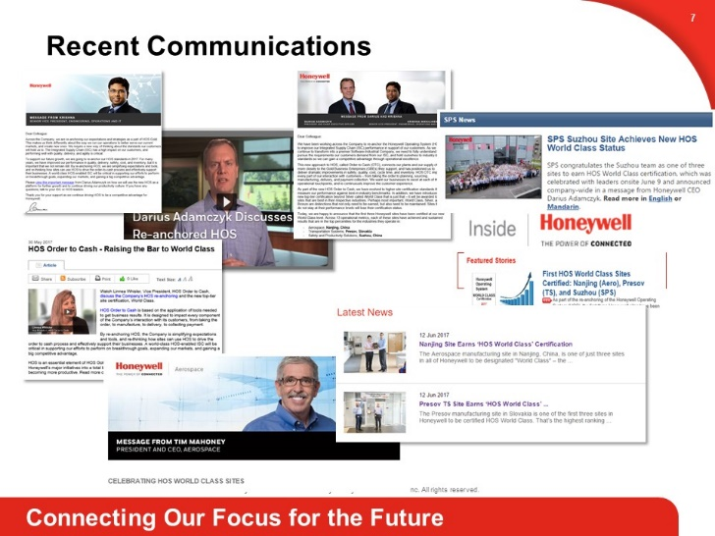

Mention some of the recent communications in the news about HOS OTC.

World Class Recognition

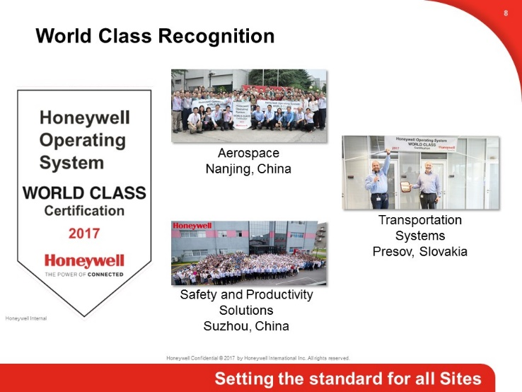

Mention sites that have received world class recognition for their Operating System.

