Invention Disclosure Storyboard

Screen Title: Welcome
Audio: | On-screen text: | On-screen graphics: | Reviewer comments:
 | Welcome to Invention Disclosure | Animation of something related to Inventions with music

Screen Title: Course Objectives
Audio: | On-screen text: | On-screen graphics: | Reviewer comments:
After taking this course, you will be able to:  - Explain why it is important to create and protect innovative technologies  - Define invention  - Identify when something should be disclosed as an invention  - List the steps in the Invention Disclosure process  - Locate the invention disclosure form  - Explain where to reach out for support, if needed | Course objectives  After taking this course, YOU will be able to:  - Explain why it is important to create and protect innovative technologies  - Define invention  - Identify when something should be disclosed as an invention  - List the steps in the Invention Disclosure process  - Locate the invention disclosure form  - Explain where to reach out for support, if needed | Text on left and image on right.

Screen Title: Overview
Audio: | On-screen text: | On-screen graphics: | Reviewer comments:
- One of X’s Enterprise Strategies is to “Differentiate performance through technology and functional excellence.”  - Generating new and creative solutions to technical problems is part of how we execute this strategy.  - Documenting these novel technical solutions and making sure they are protected in the right way is what the invention disclosure process is about.  - Properly protecting novel technical solutions is how X is able to differentiate through technology. | - “Differentiate performance through technology and functional excellence.”  - Generating new and creative solutions to technical problems is part of how we execute this strategy.  - Documenting these novel technical solutions and making sure they are protected in the right way is what the invention disclosure process is about and helps X differentiate through technology. | Color block will appear with first set of text.  When second set of text is read, image below will appear.  Then third block of text appears in a color block with certain words highlighted.
Screen Title: What is an Invention?
Before we get into invention disclosure, we need to make sure we are all on the same page regarding defining an invention.  An invention occurs when one or more people generate a novel solution to a technical problem. The term “invention”, “inventive idea”, and “novel technical solution” are used interchangeably.  Novel technical solutions can take the form of a new or improved product, process, system, or design.  The novel technical solution can be a minor tweak to an existing solution, or it can be a revolutionary advance.  Many seemingly individual technologies are often combinations of numerous inventions or inventive ideas. | Novel solution to a technical problem  “Invention,” “Inventive Idea”, or “Novel Technical Solution”  New or improved product, process, system, or design  Minor tweak or revolutionary advance  Often combinations of numerous inventions | As the narration is going, the text will fly in on top of a color block (no bullet points.) Next to it will be an image of an invention (could be from X or could be common inventions that people are familiar with but maybe aren’t so obvious).  So, when everything is on the screen at the end of the narration, you will see a square color block on the top left with the first phrase and an image on the top right. In the second row, the image will be on the left and the square color block will be on the right with the text, and so on down the slide.

Screen Title: What is Invention Disclosure?
Audio: | On-screen text: | On-screen graphics: | Reviewer comments:
What is Invention Disclosure?  - Invention Disclosure is the formal capture and documentation of novel technical solutions, where such solutions serve to differentiate X from its competitors.  - Documentation is made via an Invention Disclosure form. Click on the image to learn more about what that entails: | The formal capture and documentation of novel technical solutions, where such solutions serve to differentiate X from its competitors  - A description of the novel technical solution  - The technical problem to which it relates  - Oher efforts at solving the same or similar problems | Image appears with first set of on-screen text.  When user clicks on the image, it flips and shows the bottom 3 bullets.

Screen Title: When in Doubt, Disclose
Audio: | On-screen text: | On-screen graphics: | Reviewer comments:
Technical experts often dismiss their own inventive ideas as being obvious or unimportant because they seem obvious to them. This is not the proper test.  As mentioned in the previous slide, an invention can be a minor tweak to an existing process. You may not think that tweak is something worth disclosing, but if it improves the process, it may be something that is important for X to protect.  Don’t make the decision yourself about whether you think it is classified as an “invention.” Disclosing it anyway gives the committee the chance to make that decision. We don’t want to lose the possibility of protecting an innovative technology because it was deemed to be too small. | Don’t make the decision yourself about whether you think it is classified as an “invention.” Disclosing it anyway gives the committee the chance to make that decision. | Have each crumpled up ball of paper show up individually and then the lightbulb shows up at the end.

Screen Title: Why is it Important?
Audio: | On-screen text: | On-screen graphics: | Reviewer comments:
Why is it so important to disclose inventions?  - Technical staff should already be documenting their work. The Invention Disclosure process merely extends this so that any associated intellectual property can be evaluated and managed accordingly.  - Failure to properly document inventive ideas can lead to forfeiture of any potential intellectual property rights and the competitive advantages that could be gained from those rights.  - With few exceptions, X owns the intellectual property generated by its employees, and employees have an obligation to disclose any and all such intellectual property to the company.  - Invention disclosure is required by corporate policies 450 and 480. | - Failure to properly document inventive ideas can lead to forfeiture of any potential intellectual property rights and the competitive advantages that could be gained from those rights.  - With few exceptions, X owns the intellectual property generated by its employees, and employees have an obligation to disclose any and all such intellectual property to the company.  - Invention disclosure is required by corporate policies 450 and 480. | Something like this will be recreated so each text box and arrow appear as the narration is going. The image would build (it wouldn’t just appear at once like it is). This will be timed with the first bullet in the Audio section.  Then the bullets in the on-screen text section will appear in color blocks.  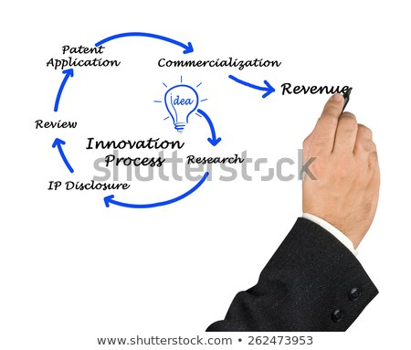

Screen Title: Invention Disclosure Process
On-screen text: |  |  | On-screen graphics: | Reviewer comments:
It is critical to our continued success that internally-generated technical solutions, irrespective of their initially-perceived impact, be captured and evaluated in a timely manner. This is done via the Invention Disclosure Process outlined here. If you have generated a new solution to an existing technical problem, you are asked to document it and have it processed as follows: |  | Click on each arrow to reveal the next step in the process.  - Inventor develops a potentially innovative solution to a technical problem.  - Inventor documents solution on Invention Disclosure form (Form Law-44).  - Inventor sends completed Invention Disclosure form to their Intellectual Property Manager or disclosures@X.com  - Invention Disclosure is assigned a docket number and routed to an appropriate IP Committee for evaluation  - The IP Committee evaluates the Invention Disclosure and determines whether or not to protect it and, if so, how. | Something similar to this but will be redone and shown one box at a time. When each arrow is clicked, the next box will reveal itself.  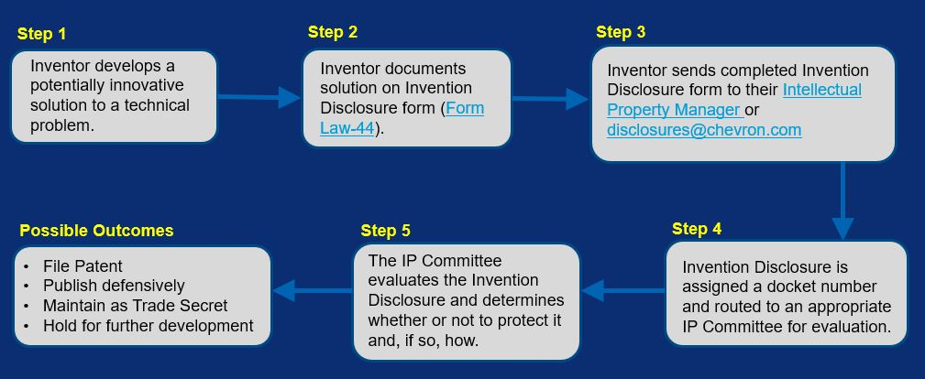

Screen Title: Invention Disclosure Form
On-screen text: |  |  | On-screen graphics: | Reviewer comments:
- Invention disclosures are submitted on an Invention Disclosure form (LAW-44).  - Completed disclosures are sent to the Law Dept. for docketing.  - Best practice is to have the appropriate IP Manager review and submit the completed disclosure on your behalf.  - Alternatively, completed disclosures may be emailed to disclosures@X.com.  - IP Managers are available to assist in the completion of the Invention Disclosure form. A list of IP Managers by function and organization can be found here. |  | - Completed disclosures are sent to the Law Dept. for docketing.  - Have appropriate IP Manager review and submit completed disclosure.  - Alternatively, email completed disclosures to disclosures@X.com.  - IP Managers are available to assist in completion of the form. A list of IP Managers can be found here. | The form will be shown while the first bullet is read  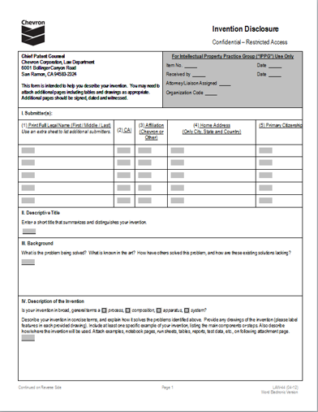  It will then shrink into a process flow like the one below but will have a step for IP Manager review and Law Dept. docketing before going to the Evaluation committee. The additional branches for Public Disclosure, trade secrets, etc. will not be shown here but will be covered on the next slide. This graphic will be redrawn – will not be using as is.  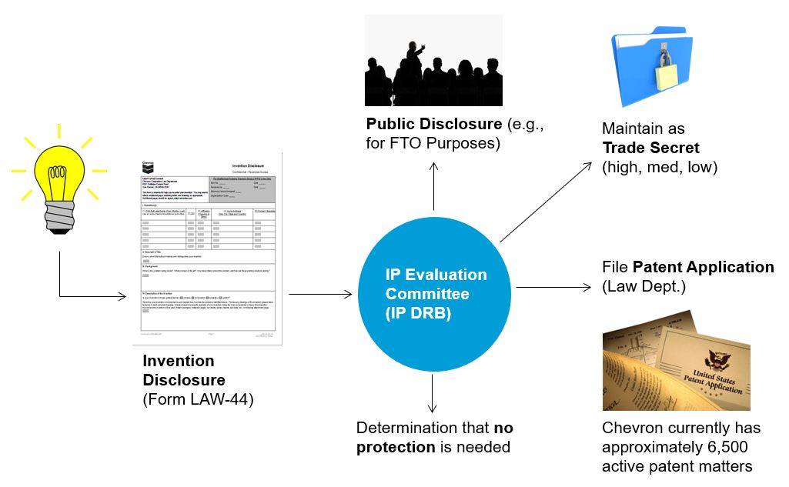

Screen Title: Possible Outcomes
On-screen text: |  |  | On-screen graphics: | Reviewer comments:
Submittals are evaluated in order to ascertain the best method by which to protect them and maximize their benefit to X. There are several potential outcomes.  While many submittals are identified for possible patent protection, many others are protected as trade secrets. Still others are identified for public disclosure, i.e., placing the ideas in the public domain to help provide freedom-to-operate.  That’s why it is important to disclose your intention even if you don’t think it is a patent-worthy idea. It may be, but even if it isn’t, there are other ways in which X protects its intellectual property that are just as important. |  | - File Patent  - Publish defensively  - Maintain as Trade Secret  - Hold for further development | The first part of the redrawn version of the below graphic will have been shown on the previous slide and will continue here. This slide will show the branches for patents, public disclosure, trade secrets, etc.

Screen Title: Review
On-screen text: |  |  | On-screen graphics: | Reviewer comments:
Irrespective of how a novel technical solution is ultimately protected, it is important to emphasize that the Invention Disclosure process itself serves a critical role in X’s research and development efforts. If you have an inventive idea that has improved a process, product, system or design, no matter how small, submit an Invention Disclosure form. |  | “There’s no good idea that cannot be improved on”  -Michael Eisner

Screen Title: Questions?
On-screen text: |  |  | On-screen graphics: | Reviewer comments:
For questions concerning this process, please contact Ted Mickelson, X Global Intellectual Property Manager (emickelson@X.com) or the Intellectual Property Manager for your Department or Business Unit (List of Intellectual Property Managers) |  | Ted Mickelson  X Global Intellectual Property Manager (emickelson@X.com)  Intellectual Property Manager for your Department or Business Unit (List of Intellectual Property Managers)

