Participant Workbook

Human Resources

Human Resources

Participant Workbook

Table of Contents

Introduction 4
Employment Laws 6
Employment Laws 7
Federal Posting Requirements 14
Compensation, Benefits, and Overtime 17
Activity: Employee Housing 23
Activity: Cost of an Employee Part One 25
Activity: Cost of an Employee Part Two 27
Employment Records 31
Employment Process 33
Activity: Job Synopses 36
Sample Job Synopses 37
Recruitment Methods 41
Activity: What Can You Ask? 46
Examples of Acceptable/Unacceptable Interview Questions 48
Activity: Develop Interview Questions 55
Activity: Evaluate a Candidate Survey 55
Employee Needs throughout Employment 64
Writing SMART Goals 71
Activity: Write SMART Goals 73
Motivational Program Ideas 78
Conflict Resolution Approaches 83
Activity: Employee Complaint 84
Wrap Up 93
Knowledge Check Answers 95

Introduction
Slide 1
Slide 2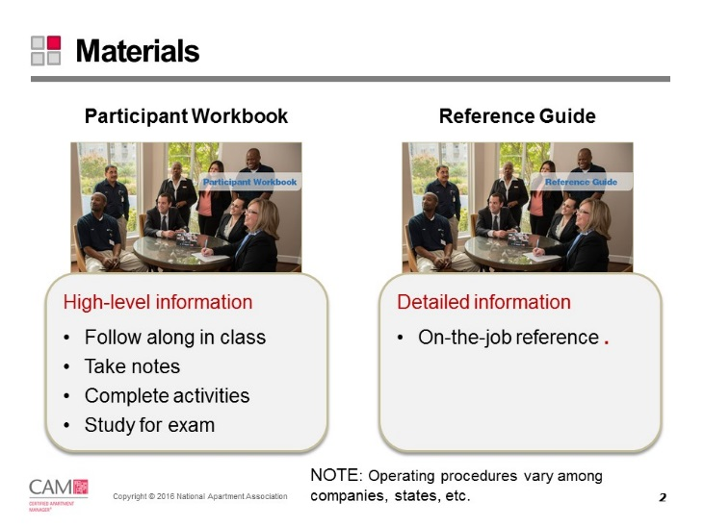

Slide 3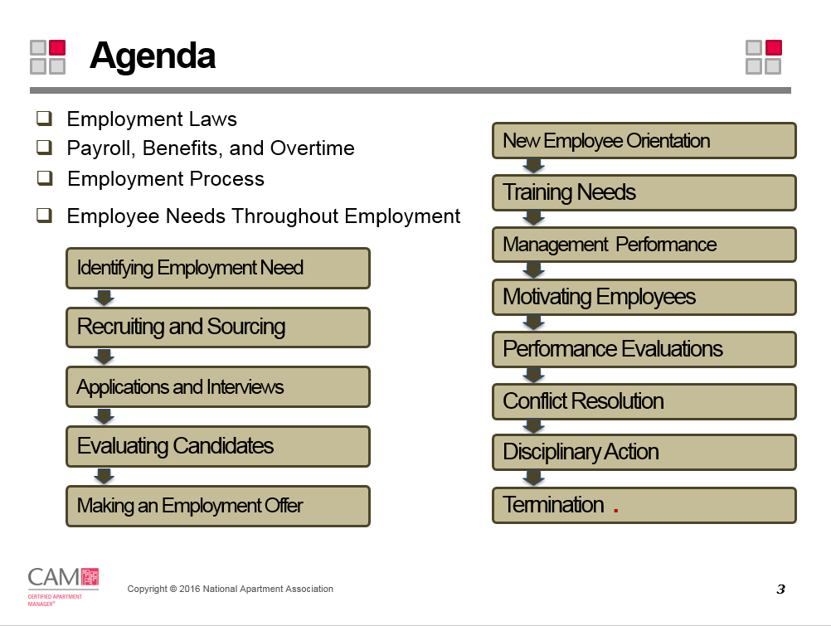
Slide 4

Employment Laws
Employment law covers virtually everything from hiring, terms, and conditions of employment, termination, and the post-employment relationship. As an employer, it is your responsibility to know and understand all federal, state and local employment laws.
Slide 5
Slide 6
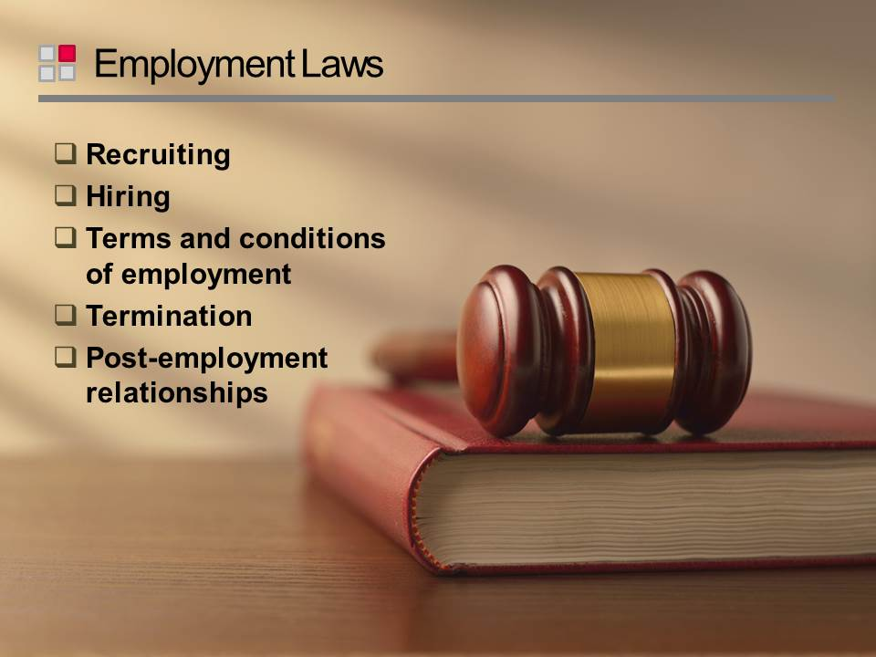
Slide 7
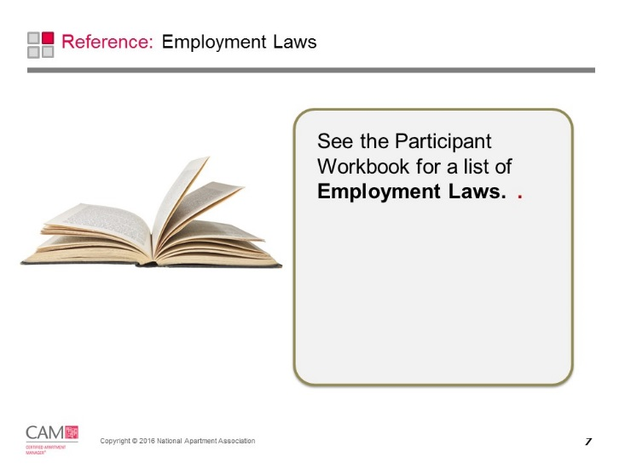
Employment Laws
Employment law covers virtually everything from recruiting, hiring, terms and conditions of employment, termination, and post-employment relationships.
- The Equal Employment Opportunity Commission (EEO or EEOC) dictates who is protected under employment laws in the United States.
- The EEOC oversees and enforces all policies and regulations utilizing the following:
  - Laws from Title VII of the Civil Rights Act of 1964 (Title VII)
  - The Equal Pay Act of 1963 (EPA)
  - The Age Discrimination in Employment Act of 1967 (ADEA)
  - Title I and Title V of the Americans with Disabilities Act of 1990 (ADA)
  - Others

Employment Law | Compliance | Coverage and Enforcement
Fair Credit Reporting Act (FCRA)  Employers must gain written consent to request a report | - To request a consumer report, gain written consent from the applicant or employee.  - If you reject an applicant as a result of the report, you must provide two written notifications, a copy of the report, a copy of FCRA rights, and credit reporting agency contact numbers. Notifications include a pre-adverse and an adverse action notice. | Covers: All employers  Enforced by: Federal Trade Commission
Title VII of the Civil Rights Act of 1964, as Amended  Prohibits discrimination of race, color, religion, sex, or national origin throughout entire employment process | - In ads and job descriptions, avoid words suggesting preferences towards race, color, sex, religion, or national origin.  - Advertise in publications with as wide a circulation base as possible.  - Application forms must comply with laws.  - Ensure that job interviews are uniform & focused on job-related issues.  - Display EEOC employee rights poster. | Covers: Employers with at least 15 employees  Enforced by: EEOC
The Civil Rights Act of 1991  Anyone suing for intentional discrimination is allowed to recover compensatory and punitive damages | - Use caution with adverse employment actions.  - Avoid situations where an applicant or employee can assert willful discrimination.  - Ensure tests are validated for neutrality and do not adversely impact against any group.  - Retain all records for 1 year. | Covers: Employers with at least 15 employees  Enforced by: EEOC
Age Discrimination in Employment Act (ADEA)  Prohibits employment discrimination based on age over 40 years. | - Don’t ask questions regarding or revealing age.  - Don’t advertise suggesting age preferences (e.g. recent college graduate).  - Don’t consider age when making employment decisions, or considering reviews and promotions.  - Don’t inquire about or encourage retirement.  - Retain the following records for one year:  - applications, resumes, job inquiry forms  - documentation regarding promotions, demotions, transfers, training selection, layoff, recall, or discharge | Covers: Employers with at least 20 employees  Enforced by: EEOC
Title I of the Americans with Disabilities Act  Prohibits employment discrimination against disabled persons who, with or w/out reasonable accommodation, can perform the job. | - Make interviewing & hiring decisions on the ability to do the job, not on a disability.  - State the requirements of the job and ask if they can satisfy the requirements.  - Do not ask additional questions only to applicants who may have disabilities. Avoid application or interview questions focusing on possible disabilities.  - Focus job descriptions on essential job functions so a person with a disability isn’t eliminated from job consideration due to inability to perform a marginal job duty.  - Defer medical exams and inquiries until after a conditional offer of employment.  - If a question, inquiry, examination, or test screens out someone, the exclusionary criteria must be “job-related and consistent with business necessity.”  - If an applicant is not hired for safety reasons, you must demonstrate a “direct threat” to himself or others that cannot be eliminated through accommodation.  - Health or medical records must be maintained in a separate, confidential file from standard employment records. | Covers: Employers with at least 15 employees  Enforced by: EEOC
Fair Labor Standards Act (FLSA)  Sets requirements for timekeeping, minimum wage, overtime, and regulates child labor employment | - Exemptions from the FLSA’s minimum wage, overtime, and timekeeping provisions exist for executive, administrative, professional, computer, & outside sales employees. Is dependent on how a person is paid and actual job duties (not job title).  - For non-exempt employees, ensure time is documented, and they are paid accordingly.  - If you hire anyone under the age of 18, check all child labor laws; do not hire anyone under the age of 14.  - Retain the following records for two years:  - basic employment and earnings records  - supplemental records such as contacts and records about wages and hours | Covers: Employees who work for an “enterprise” or meet individual eligibility requirements  See the Human Resources Reference Guide for more information.  Covers most apartment firms  Enforced by: Wage & Hour Division of Department of Labor
FLSA Overtime Rules  Employers must pay at least the federal minimum wage and 1.5 times their regular rate for overtime. | - Carefully review actual job duties & compensation levels of each employee to ensure they’re properly classified & compensated under FLSA.  - Proactively consult legal counsel and a professional HR team regarding exempt and non-exempt status to avoid costly investigations and litigation.  - Use the three tests that are used determine whether an employee is eligible for overtime pay: Salary, Salary Basis, & Duties Tests.  - Perform regular compliance audits that include the tests, housing benefits, records, & overtime wages.  - Always check state law to ensure compliance.  Note: Executive, administrative, professional, computer, outside sales, & highly compensated employees are exempt. Job titles do not determine status; salary & duties do. | Covers: Employees who work for an “enterprise” or meet individual eligibility requirements  See the Human Resources Reference Guide for more information.  Covers most apartment firms  Enforced by: Wage & Hour Division of Department of Labor
Equal Pay Act  Employers must pay equal wages to male & female employees who perform similar work of equal skill, effort, and responsibility | - Do not pay an individual more or less based on gender.  - Specific recordkeeping is not required. It is suggested that records be maintained one (1) year under the requirements for Title VII of the Civil Rights Act of 1964. | Covers: Employees who work for an “enterprise” or meet individual eligibility requirements  Covers most apartment firms  Enforced by: EEOC
Occupational Safety and Health Act (OSHA)  Regulates workplace safety and health | - Provide employees a workplace free from hazards and comply with OSHA safety and health standards.  - Employers with 11 or more employees must maintain a log of all injuries and illnesses.  - Require all employees to read safety policies.  - Report any job-related fatality or overnight hospitalization to OSHA following regulations.  - Conduct periodic safety inspections of facility.  - Provide:  - Work safety instructions before job start  - Safety Data Sheets (SDS) in a binder  - Personal protective equipment | Covers: Private sector employers  See the Human Resources Reference Guide for more information.  Enforced by: Occupational Safety & Health Administration (OSHA)
Employee Retirement Income Security Act (ERISA)  Regulates employee pension and welfare benefit plans. | - Know about company retirement or pension plans.  - Appoint a plan administrator to:  - Follow through on law’s requirements  - Provide a summary plan (within 90 days)  - Answer questions about pension plans  - Records must be kept for six years supporting the data in the Summary Plan and related welfare pension reports.  - Records determining eligibility for benefits must be retained as long as relevant. | Covers: Employers who maintain or sponsor pension and welfare plans  Enforced by: The Secretary of Labor
Immigration Reform and Control Act (IRCA)  Prohibits employment discrimination based on national origin or citizenship  Prohibits employers from hiring illegal aliens or to knowingly accept false documents | - I-9 process must be followed.  - Do not refuse to hire an individual because you believe they may not have legal employment status. Let the verification process of the I-9 form determine eligibility.  - It is illegal to request more documents other than required by form I-9.  - I-9s and supporting documents must be kept for three (3) years after hire and one year after termination. | Covers: Employees hired after Nov. 6, 1986  Enforced by: Department of Homeland Security
National Labor Relations Act (NLRA)  Regulates all labor-management relationships and prohibits discrimination based on union activity | - Be familiar with the law and/or the collective bargaining agreement specifics.  - Consult HR or Legal counsel about your responsibilities.  - Do not interfere, restrain, or coerce employees about union participation, membership, or activities the Act protects.  - Specific recordkeeping is not required. Written reprimands or disciplinary action may be needed in case of a dispute. | Covers: Private sector employers that impact interstate commerce  Enforced by: National Labor Relations Board (NLRB)
Uniformed Services Employment and Reemployment Rights Act of 1994 (USERRA)  Prohibits employment discrimination due to military obligations | - You must reinstate an employee’s job upon honorable completion of military duty.  - No specific recordkeeping is required, however all employment records that are retained may be subject to review should a claim be filed. | Covers: All employers  Enforced by: Office of Veterans’ Employment & Training Service (VETS) of Department of Labor
Jury Systems Improvement Act  Prohibits disciplining or discharging employees due to being called to serve on a federal jury | - Grant unpaid leave to employees performing federal jury service and reinstate them to their jobs when jury service is over.  Note: Although this law addresses federal juries, similar laws may exist at the state or local level. Check state and local law or consult legal counsel. | Covers: All employers  Enforced by: Department of Justice
Employment Polygraph Protection Act of 1988 (EPPA)  Prohibits employers from requiring applicant polygraph tests  Limited exceptions apply | - Do not use polygraphs as a means of pre-employment screening.  - Consult with legal counsel whether the facts allow for an employee polygraph.  - Do not allow an employee to volunteer to take a polygraph test.  - Every employer subject to EPPA must post a poster advising employees of their rights under the Act.  - Retain these records for three (3) years:  - A copy of any statement provided to employees, relating a specific incident being investigated that resulted in economic loss.  - The basis for testing, records of employer loss, nature of employee’s access to person/property being investigated or any | Covers: Most private sector employers  Apartment management firms  Enforced by: Secretary of Labor
Family and Medical Leave Act (FMLA)  Entitles employees to unpaid, job-protected leave for specified family & medical reasons | - Ensure that your company has a policy that clearly defines the limitations and requirements for employee and employer. Your FMLA policy must be included in employee handbooks.  - During leave, continue health insurance coverage without extra charges. Employee must continue to pay premiums (typically deducted from a paycheck).  - Reinstate employment to the same or equivalent position upon return.  - Display FMLA rights poster.  - Provide written guidance on employee rights & responsibilities to those who request leave.  - Keep the following records for 3 years:  - Payroll data, leave documents, employer notices of leave, & premium payments  - Dispute records & medical records | Covers: Employers that employ 50 or more employees at a worksite or at combined worksites within a 75 mile radius.  Employees must meet eligibility requirements.  Enforced by: Secretary of Labor
Consolidated Omnibus Budget Reconciliation Act of 1986 (COBRA), as amended  Allows extension of insurance coverage on a self-pay basis, to those who would otherwise lose coverage due to leave, reduced hours, termination, etc. | - Notify an employee of his right to continue coverage within 14 days from employee separation date.  - Require a return receipt for all notices.  - Collect ex-employee’s premium each month.  - Your HR, payroll, or an insurance company will likely be responsible for compliance.  - No specific recordkeeping is required, but you should keep records of notifications sent to employees about their rights to extend coverage. | Covers: Most private sector employers with 20 or more employees with a group health plan.  Enforced by: Secretary of Labor
Health Insurance Portability and Accountability Act of 1996 (HIPAA)  Provides standards for an employee’s new group health plan to limit or exclude pre-existing conditions | - Compliance with this law is more the responsibility of the employer’s medical insurance company.  - The plan administrator for an employer is responsible for providing HIPPA documentation and must have copies of employee enrollment documents, and any correspondence with the insurance company | Covers: Employers who provide health coverage  Enforced by: Secretary of Labor
Workers’ Compensation  Each state has its own insurance system for workplace injury claims | - Check with your state agencies responsible for workers’ compensation administration for compliance and record keeping information.  Note: Not all states require workers’ compensation. | Covers: All employees who work at the property  Enforced: At state level only
Within these laws protected classes include:
- Race
- Color
- Religion
- Sex (including harassment)
- Women (with respect to equal pay)
- Individuals age 40+
- Genetic Information
- Disability
- National Origin
- Pregnancy

Slide 8
Slide 9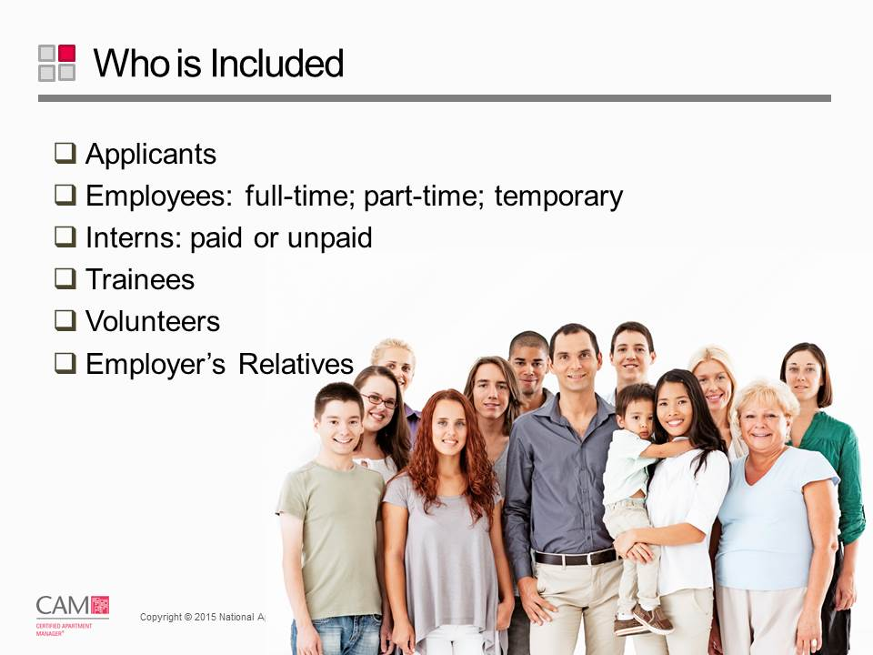
Slide 10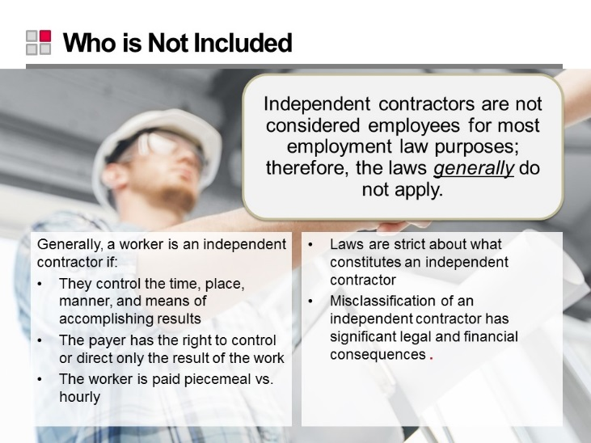
Slide 11
Slide 12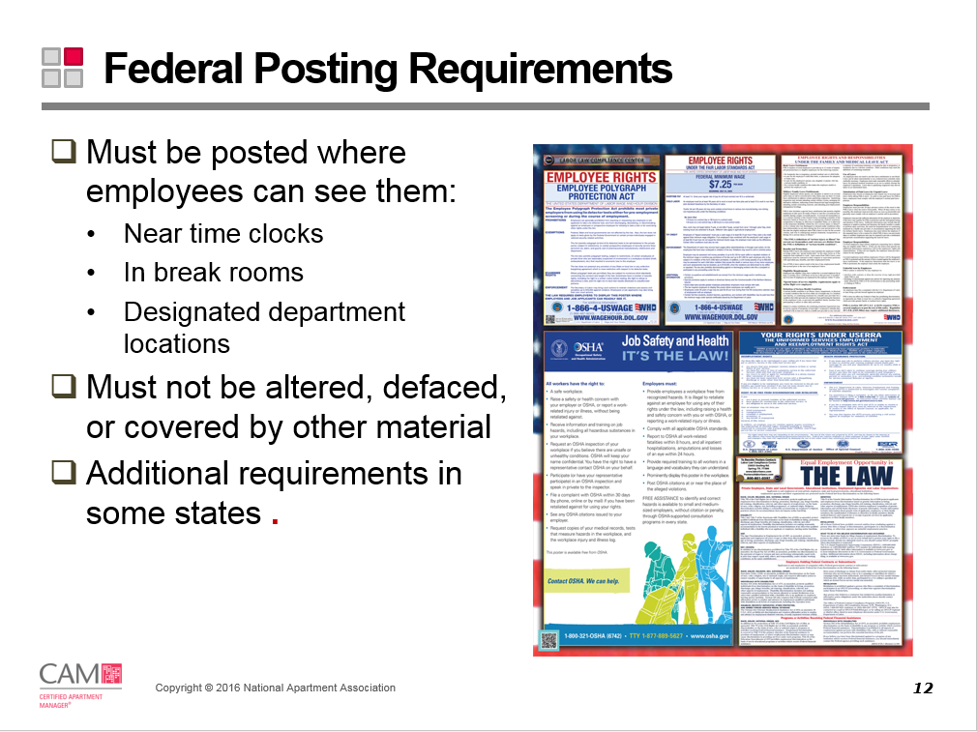
Slide 13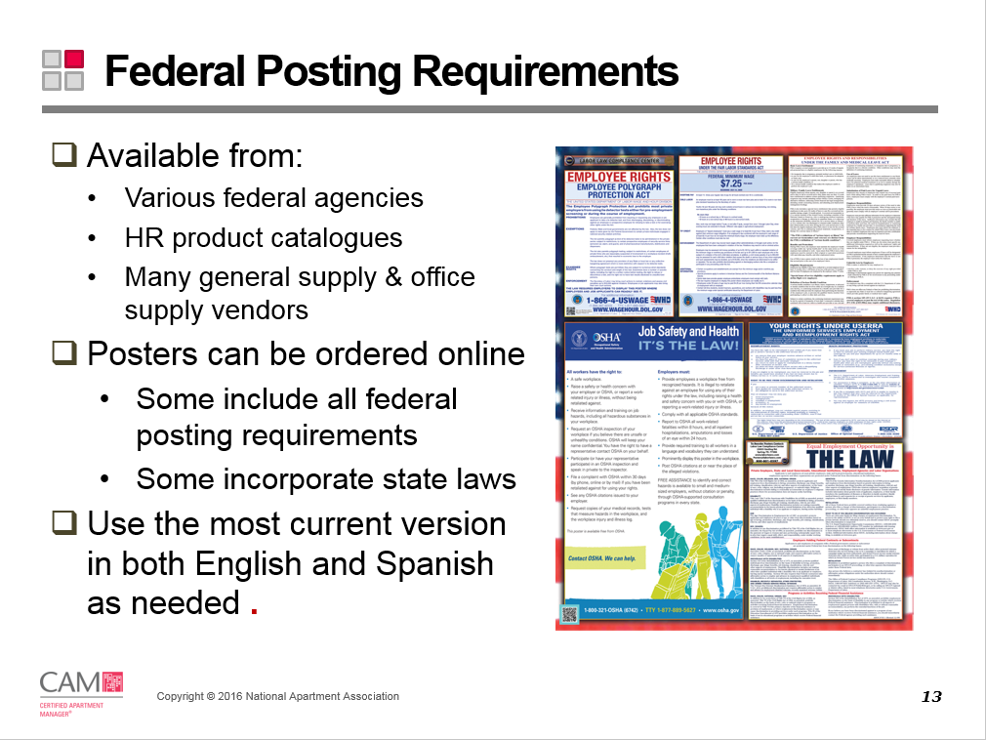
Slide 14
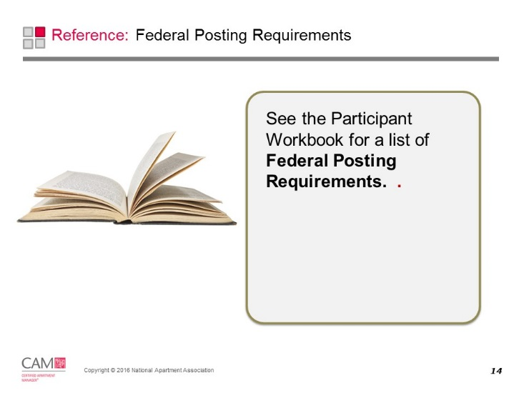
Federal Posting Requirements
All of the federal required posters are available from various Federal agencies, but are also available from human resource product catalogues and many general supply and office supply vendors. You can buy posters online. Some include federal posting requirements and some include federal and state. Purchased posters are usually laminated.
Law | Posting
Fair Labor Standards Act | “Employee Rights Under The Fair Labor Standards Act”
Title VII of The Civil Rights Act of 1964 and the Age Discrimination in Employment Act of 1967 (ADEA) | “Equal Employment Opportunity is The Law”
Employee Polygraph Protection Act | “NOTICE - Employee Polygraph Protection Act”.
OSHA- Occupational Safety and Health | “Job Safety & Health Protection—It’s the law”
Americans with Disabilities Act of 1990 | A notice, which is included in the “Equal Employment is The Law” poster.  Caution: Failure to post this notice is punishable by a fine of up to $100 for each separate offense
Family and Medical Leave Act | “Your Rights under the Family and Medical Leave Act of 1993”
Equal Pay Act | A posting, which is included in the “Equal Employment is The Law” poster.  Caution: Willful violations of the EPA may be prosecuted criminally and the violator fined up to $10,000. A second conviction for such a violation may result in imprisonment.
Uniformed Services Employment and Re-Employment Rights Act (USERRA) | “Your Rights Under USERRA”

Compensation, Benefits and Overtime
Employees typically want to know how compensation is determined, understand what components make up the total pay package, and, in general, learn as much as they can about the company’s policies and guidelines.
Slide 15
Slide 16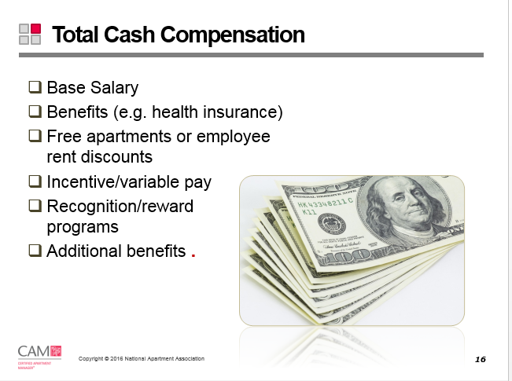
Slide 17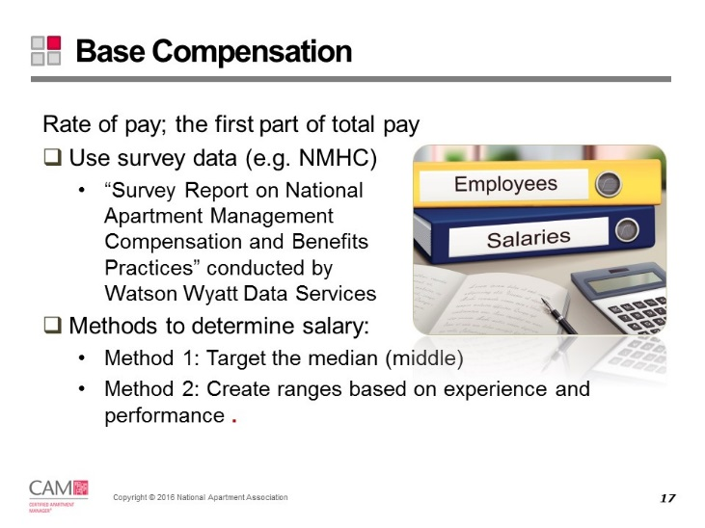
Slide 18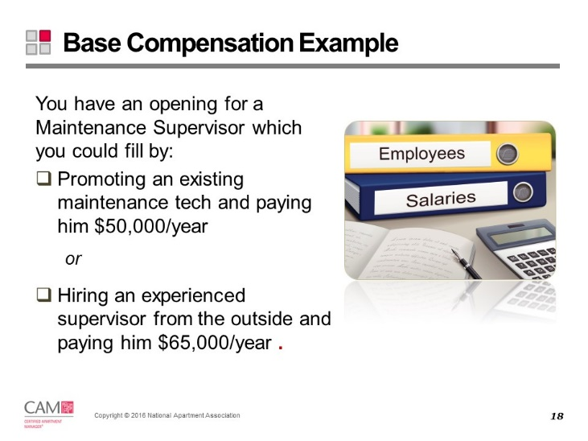
Slide 19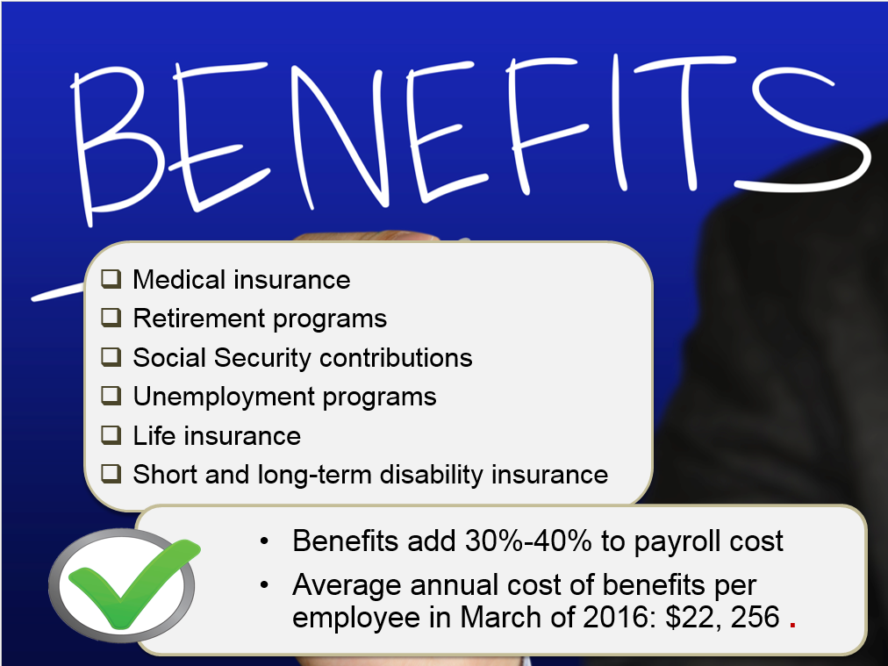
Slide 20
Slide 21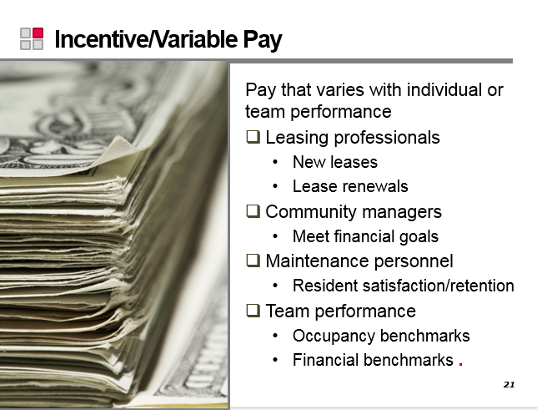
Slide 22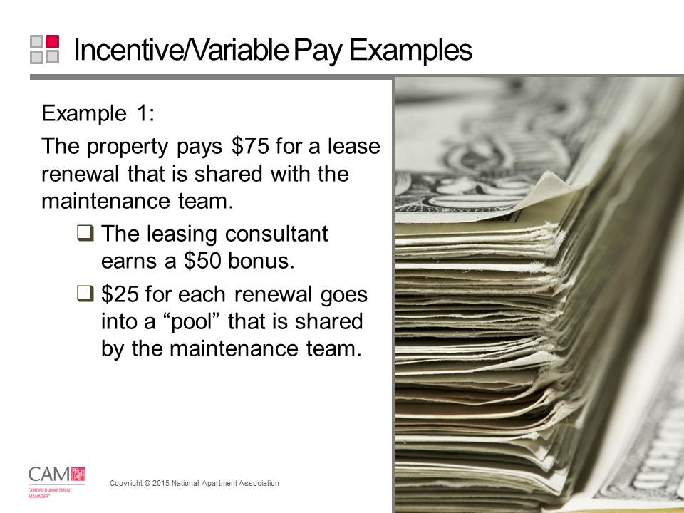
Slide 23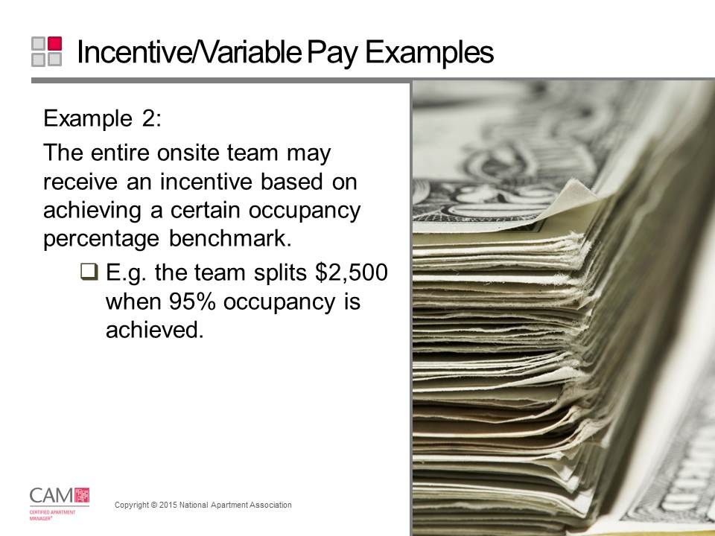
Slide 24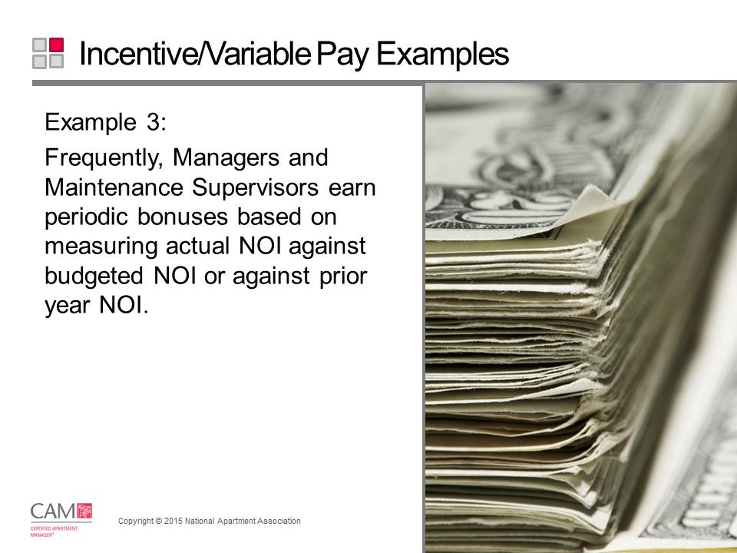
Slide 25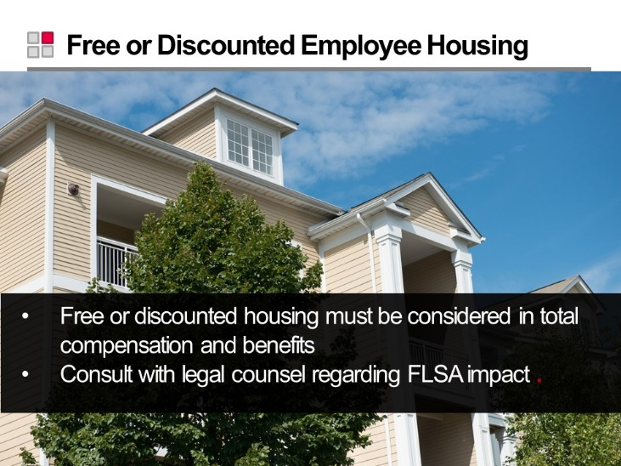
Slide 26 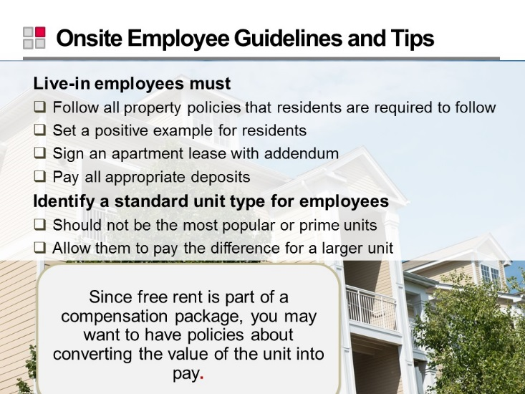
Slide 27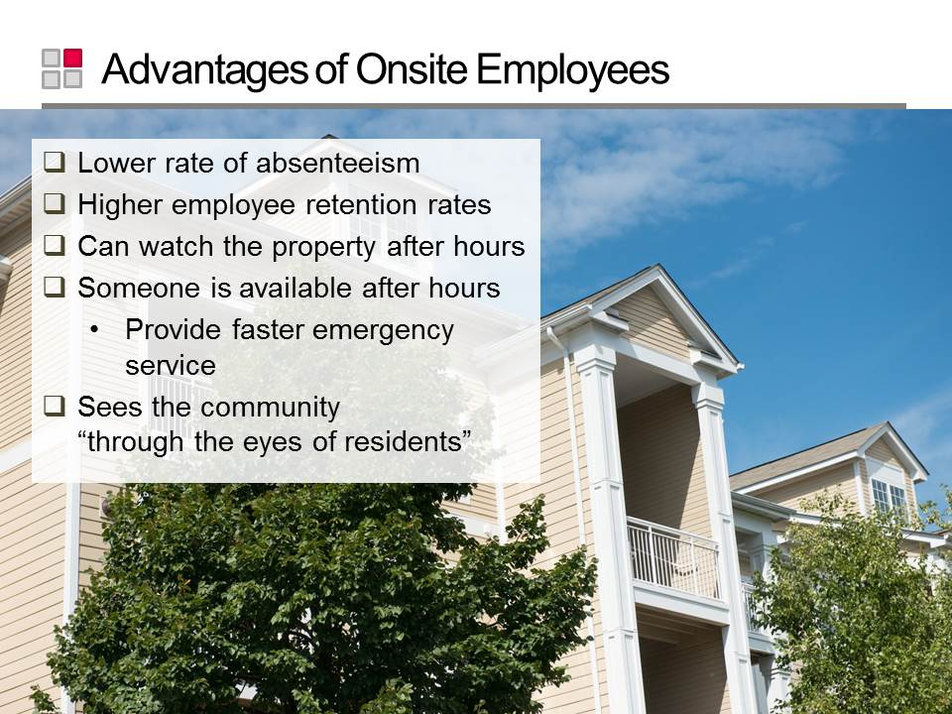
Slide 28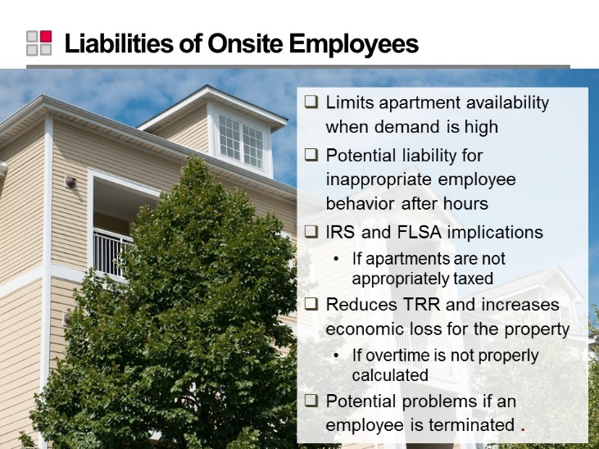
Slide 29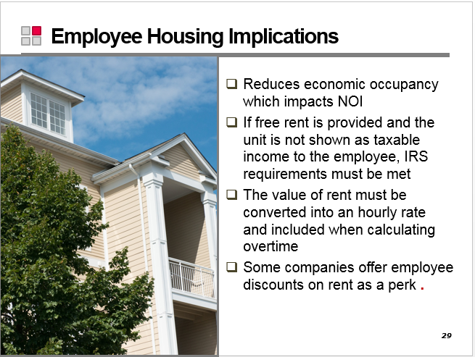
Slide 30
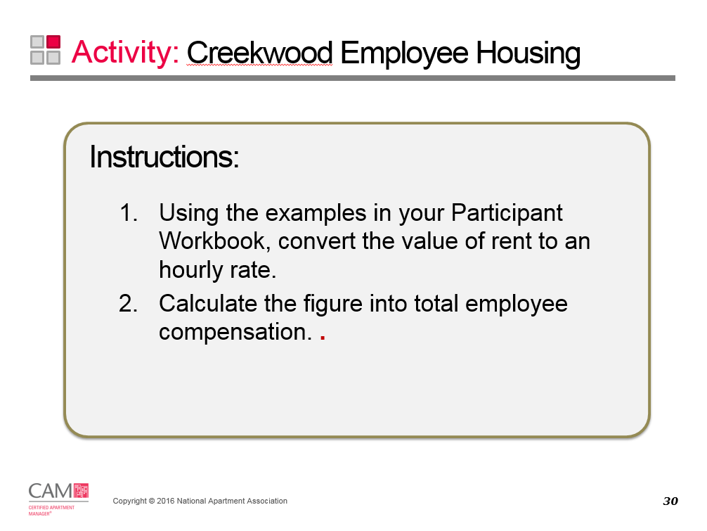

Employee Housing Scenario:
Your Creekwood maintenance supervisor’s standard rate of compensation is $19 per hour. As part of his compensation, he lives on site in a free two bedroom-two bath apartment; the monthly market rent on this apartment is $730.
To find the total hourly compensation for the maintenance supervisor, calculate the ‘Rate of Rent Discount’ for his free employee housing and add it to his standard rate of compensation.

Annual value of apartment = Monthly rent x 12 months
Total hours worked in a year = 40 hours x 52 weeks
Rate of Rent Discount = | Annual value of apartment
 | Total hours worked in a year

Slide 31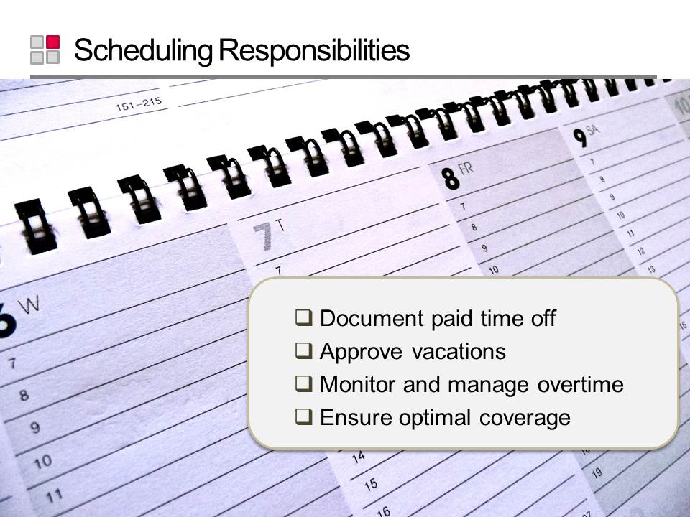
Slide 32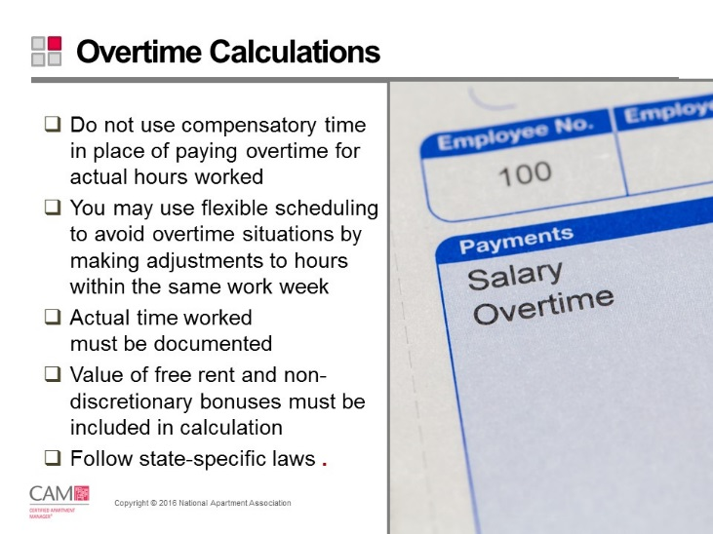
Slide 33

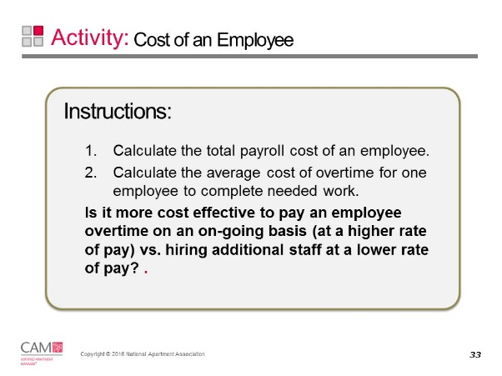

Cost of an Employee Scenario Part One:
Earnings: Your full-time maintenance technician earns $15 per hour. He regularly achieves performance goals, earning him an additional $500 non-discretionary bonus per quarter.
Benefits: His benefit plan includes health insurance and 401k employer contributions. The company also pays his workers’ compensation insurance and unemployment insurance. The total cost of all benefits is 30% of the employee’s total pay.
Housing: He receives a 50% discount on his three-bedroom townhouse. The market rent for this unit is $1,200/month.

- How much is the maintenance technician’s total payroll cost?

Cost of an Employee Scenario Part Two:
Each month the same maintenance technician logs an average of 20 hours of overtime each month to get 3 vacant units turned and ready for occupancy.
- Assuming overtime is paid at time-and-a-half of the regular rate, what is the total overtime cost per hour of this employee?

- At 20 hours of overtime per month, what is the total annual compensation of this employee?

- If the manager hired a contractor to turn those 3 vacant units per month for the entire year at $500/unit, what would the cost to the property be?

Slide 34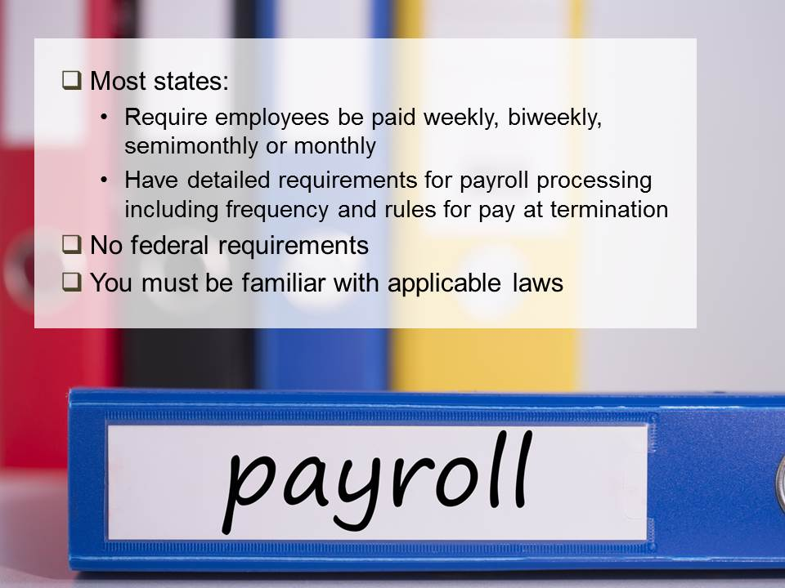
Slide 35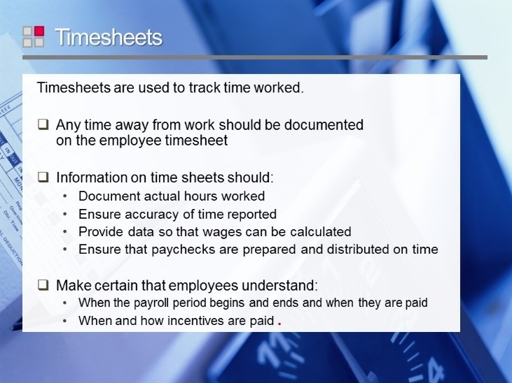
Slide 36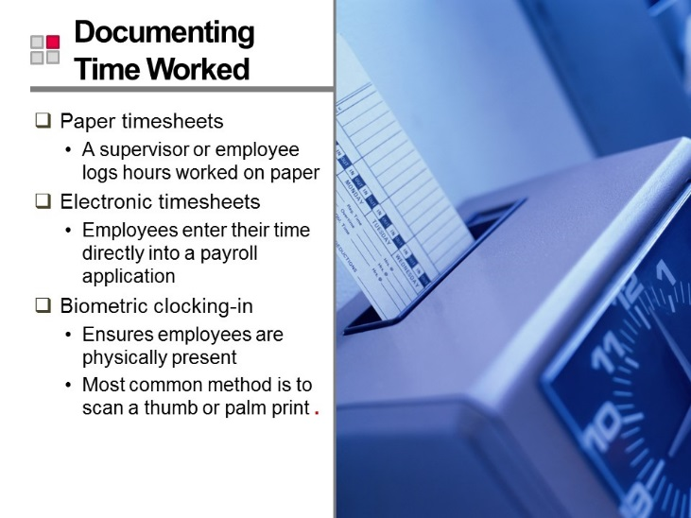
Slide 37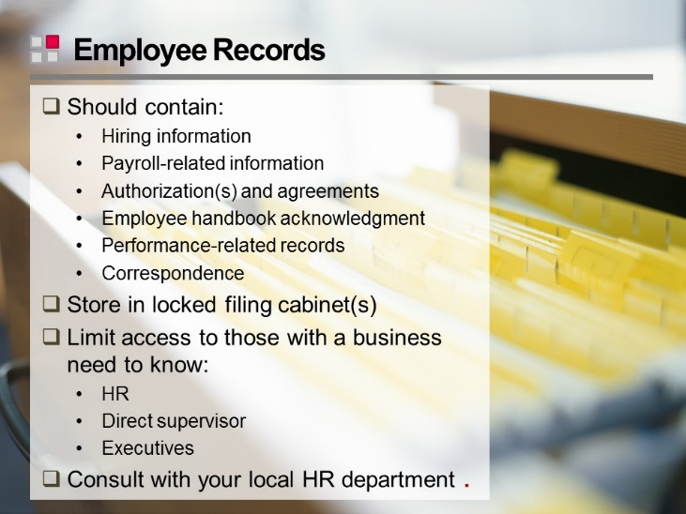
Slide 38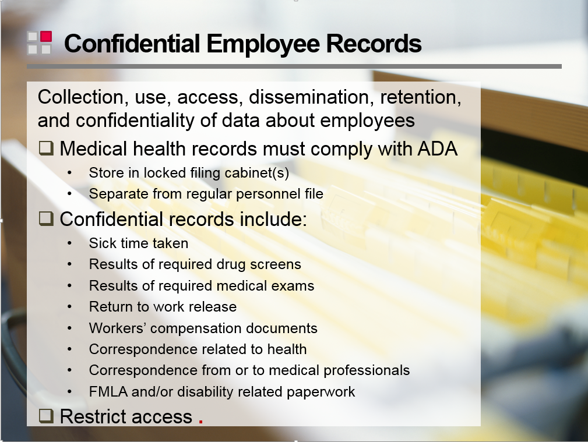
Slide 39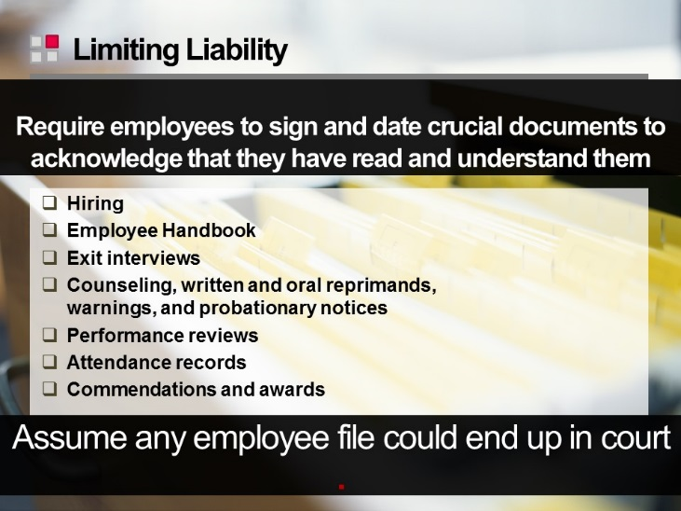
Slide 40
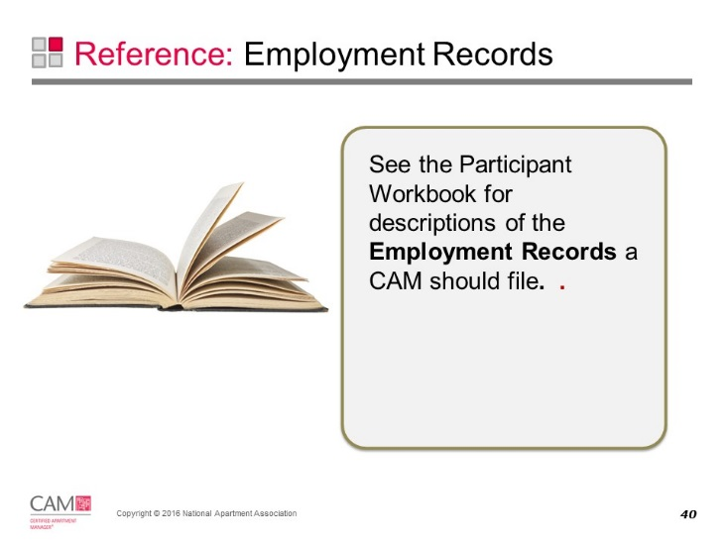

Employment Records
Form | Details
Pre-Employment Documents | Pre-employment documents consist of:  • Notice and Authorization Regarding Consumer Report  • Job Description Acknowledgement  • application and resume  • employment tests and result  • Interview Evaluation form, and  • Reference Verification Worksheet.
Employment Documents | These are generally compiled into a package commonly referred to as the “new hire packet,” which includes required forms and employee policy/benefit documents.
Employee Change Form | This provides payroll with the new employee’s basic information, job title, job location, rate of pay, start date, and all other pertinent data that is needed to enter the new employee on payroll and generate a payroll check.
W-4 Form | This must be completed by the employee for the employer to withhold the correct amount of Federal income tax. Each state has a similar form for use in withholding for state income tax.
I-9 Form | The I-9 verifies identity and employment eligibility to work in the United States to comply with the Immigration Reform and Control Act.  The Form I-9 is available for downloading at www.usics.gov
Workers’ Compensation Notice | If your state does not require workers’ compensation insurance or a private plan of some type, and your company does not provide coverage, you must notify your employees and they must sign the notice. This is to be used only if your company does not carry workers’ compensation insurance.
Employee Equipment & Supplies Agreement | It details the equipment/supplies that each new employee receives and their responsibility for returning when and if employment ends.
Back Support Belt Acknowledgement form | Any employees, regardless of job title, who may be lifting per their job descriptions, must sign the Back Support Belt Acknowledgement form.
Proof of Automobile Liability Coverage form | Employees who drive for work purposes such as making bank deposits or shopping for supplies should be driving with a current driver’s license and liability insurance. This form documents their current driver’s license information, requires that they comply with the law, and may also protect your company and property.
Acknowledgement of Employee Fair Housing Compliance form | This should be signed by all new employees acknowledging that they have read your company fair housing policy, understand it, and agree to follow it.
Harassment Policy | All employers need a harassment policy and acknowledgement signed by all new employees.
Electronic Systems Policy and Acknowledgement | Users must respect the rights of other users, respect the integrity of the systems and related physical resources, and observe all relevant laws, regulations, and contractual obligations, such as software copyright agreements.
Substance Abuse Policy and Acknowledgement | This policy is a prescription and over-the-counter medications statement.
Handbook Acknowledgement Statement | It is common practice during the new employee orientation to review the company policies and rules included in the Employee Handbook. The new employee then signs a written statement acknowledging receipt of the handbook, acceptance of responsibility for reading and complying, and understanding where to direct questions.
Employee Lease Agreement Addendum | All employees living onsite should have a written lease agreement. They are subject to the same occupancy rights and restrictions as other residents.  It’s advisable to have a written agreement in addition to the lease agreement which details in writing the conditions and limitations of their occupancy.  *These occupancy rights may differ from state to state.
Additional forms and policies | You may have other forms and policies, depending on your state laws and your specific needs.

Employment Process
Slide 41
Slide 42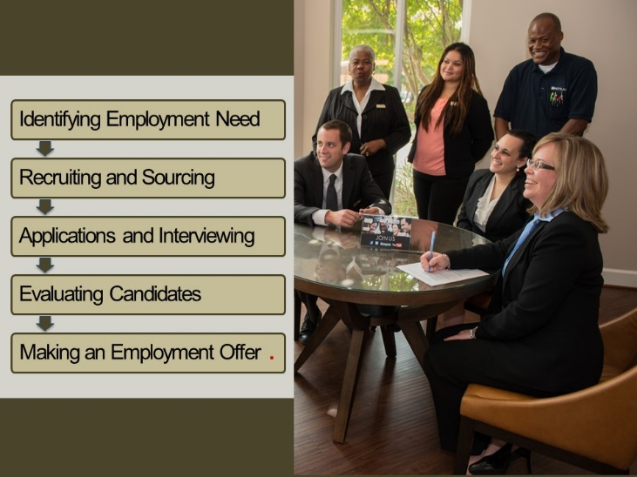

Employment Process
Stage in Process | Description
Identifying Employment Need | Job descriptions clearly detail the work to be performed and help ensure a proper fit.  - Review job descriptions before posting or filling any position.  - Update job descriptions annually.  - You may need multiple job descriptions for a position.
Recruiting and Sourcing | Use a variety of methods to ensure you can find the best candidate for the position.
Applications | - Applications must not request information that may be considered discriminatory.  - Retain all submitted resumes and applications for one year after the date received  - Make sure applications and resumes are date-stamped when received.
Interviewing | - Interviews introduce an applicant to the company and help you learn about an applicant’s skills and knowledge, accomplishments, past experiences, and how they behave on the job.  - Consider the technical skills, physical requirements, and the interpersonal skills desired.  - Most property management jobs require some weekend and evening hours; determine in advance whether that is acceptable to the applicant.  - Develop and use consistent interview guides for each position.  - Use open-ended questions and behavioral interviewing techniques.
Evaluating Candidates | - Use pre-employment tests if applicable.  - Check references and criminal background.  - Conduct drug tests.  - Refine the candidate pool by:  - Using your interview evaluation form  - Verifying references  - Conducting second interviews  - Using pre-employment screening agencies
Making a Conditional Offer | - A conditional offer is contingent upon satisfactory references and results of tests and background checks.  - It includes a criminal background screen, a credit check if applicable, a drug screen, and various letters and paperwork.  - Typically handled via written letter so that there is no confusion about what has been offered by the employer and accepted by the candidate.

Slide 43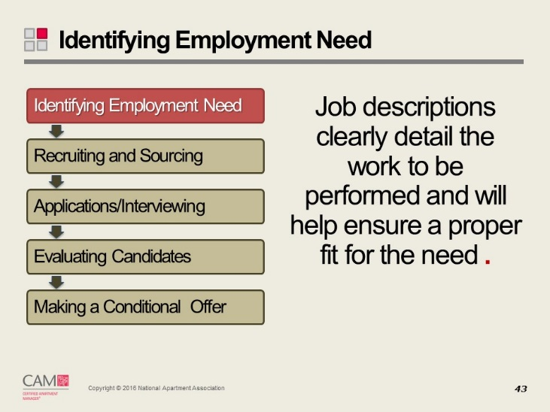
Slide 44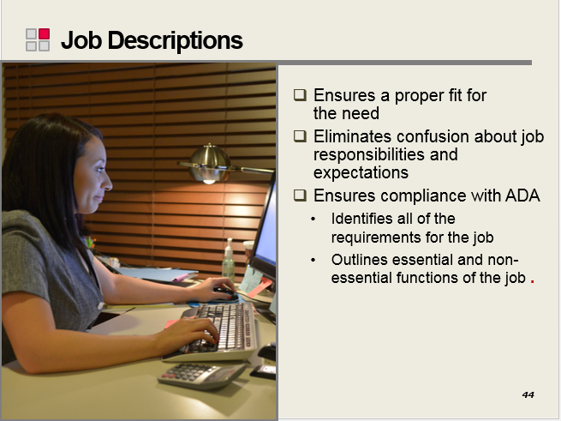
Slide 45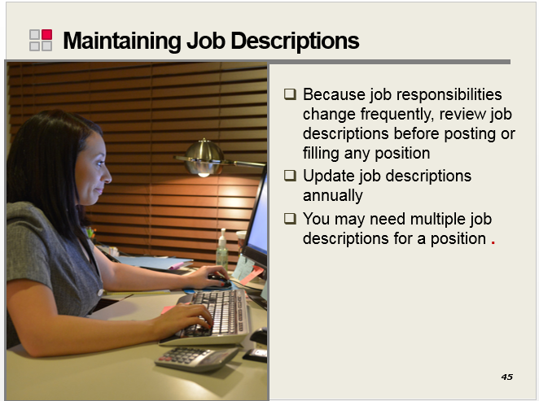
Slide 46
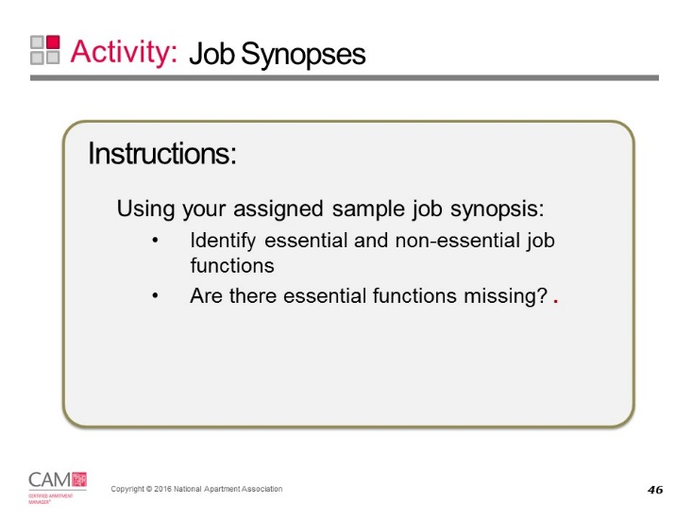
Essential Job Functions | Non-Essential Job Functions

Sample Job Synopses
Position | Sample Job Description
Regional Manager | The Regional Manager is responsible for all operational and financial aspects of an assigned portfolio of properties with 2,400-5,000 units. Portfolio size may range from 2-10 properties depending on size and complexity.  The position directs and coordinates all activities of the properties in their portfolio to ensure that company and/or owner (if applicable) financial and business objectives are achieved.  Results are achieved through successful implementation of comprehensive programs, initiatives, and strategies that promote the achievement of optimum performance by the properties within their portfolio.  The position reports to the Vice President - Property Operations. It manages two or more Senior Property Managers and/or Property Managers who supervise onsite personnel. Incumbents may also have responsibility for asset management and have Asset Managers reporting to them.
Senior Property Manager | The Senior Property Manager’s (SPM) responsibilities are the same as the Property Manager with one exception – the SPM oversees two or more properties.  The SPM is responsible for all operational and financial aspects of each assigned property and meeting company goals in those areas.  Results are achieved by facilitating the optimum performance of each assigned property in areas such as personnel management, leasing, collections, resident services, maintenance, revenue enhancement, capital improvements, information reporting, and compliance with all applicable laws and company policies.  The position reports to the Regional Manager - Property Operations and supervises all onsite personnel in the leasing and maintenance areas of each assigned property.
Property Manager | The Property Manager is responsible for all operational and financial aspects of a property with 300-500 units and meeting company goals in those areas.  Results are achieved by facilitating the optimum performance of the property in areas such as personnel management, leasing, collections, resident services, maintenance, revenue enhancement, capital improvements, information reporting, and compliance with all applicable laws and company policies.  The position reports to the Regional Manager - Property Operations and supervises all onsite personnel in the leasing and maintenance areas.
Assistant Property Manager | The Assistant Property Manager (APM) is responsible for the efficient operation of the assigned property under the direction of the Property Manager. The APM works closely with the Property Manager in preparation for movement into a Property Manager position. The APM assumes responsibility for the operation of the property in the absence of the Property Manager. On a daily basis, the APM performs the tasks associated with the operation of the property including:  - Leasing  - Collections  - Resident services  - Maintenance  - Actions to ensure compliance with all applicable laws and company policies  The position reports to the Property Manager (or Senior Property Manager, if applicable) and generally has no supervisory responsibilities unless the Property Manager is unavailable or away from the property.
Leasing Manager | The Leasing Manager:  - Supervises a staff of Senior Leasing Consultants and Leasing Consultants  - Is responsible for developing and implementing a leasing plan to attract new residents and retain current residents  - Is accountable for training staff, budgeting, scheduling, and managing all personnel matters regarding hiring, termination, performance reviews, and service issues with residents and clients
Leasing Consultant | The Leasing Consultant’s primary responsibility is the performance of all activities related to apartment rentals, move-ins, and lease renewals. The Leasing Consultant:  - Interacts directly with prospective and current residents to achieve maximum occupancy, including generating and handling traffic, leasing apartments, qualifying prospects, preparing lease documentation, and completing move-in paperwork and procedures  - Performs all of the above in accordance with applicable laws and company policies  - Assists with the company’s on-going relationship with the residents throughout their tenancy  The position may report to the Leasing Manager, the Property Manager, or Senior Property Manager and has no supervisory responsibilities.
Maintenance Manager | This maintenance position oversees the efforts of a property with more than 500 units in the areas of inspection, maintenance, and repair. This position’s time is involved in the direct management of the onsite maintenance staff at each assigned property.  The position is responsible for ensuring that the physical aspects of each assigned property meet the company’s established standards and any applicable laws. This is done for safety, appearance, and operational efficiency reasons and must fall within the budgeted financial goals.  This position leads the onsite maintenance staff in diagnosis of problems and repair in areas such as HVAC, electrical, plumbing, pool, carpentry, dry walling, exterior structural, and appliance.  The position reports to either the Regional Manager - Property Operations or the Property Manager and supervises all onsite personnel in the maintenance area.
Maintenance Technician | This position functions in a support role to the Maintenance Manager. It is responsible for ensuring that the physical aspects of the property meet the company’s established standards and any applicable laws.  The Maintenance Technician diagnoses problems and makes repairs in areas such as HVAC, electrical, plumbing, pool, carpentry, dry walling, exterior structural, and appliance. Incumbents may be certified in one or all of the skilled trades in which they are responsible.  The position reports to the Maintenance Manager and has no supervisory responsibilities.
Make Ready/  Maintenance Assistant | This position:  - Handles service requests for repairs and improvements  - Assists with preparing or prepares vacant apartments for market ready condition  - Performs various non-technical functions such as maintaining exterior lighting, ground equipment repair and preventative maintenance, caulking, touch up painting, pool maintenance, lock repairs, etc.  - Provides assistance to the maintenance staff as needed  - Reports to maintenance manager
Grounds keeper | The Groundskeeper is responsible for the overall upkeep of the property landscape and the exterior image. Duties include:  - Cleaning of the driveways, parking lots, curbs, dumpster areas, exterior hallways, or any other public areas  - Maintaining the property (flowerbeds, plants, and grass areas)  - Snow removal  - Pool cleaning or routine pool maintenance  The position reports to the Maintenance Manager or Property Manager and has no supervisory responsibilities.
Painter | This position is responsible for painting the interior and/or exterior areas of the property. This includes such tasks as:  - Assistance with scheduling of make ready units  - Preparing of the area to be painted  - Painting designated areas  - Cleaning up of areas after painting  - Maintenance of the inventory of painting supplies and equipment  The position reports to the Maintenance Manager or Property Manager and has no supervisory responsibilities.
Housekeeper | The Housekeeper is responsible for cleaning and maintaining the appearance of property models, vacant units, and public access areas including the office and clubhouse, cleaning apartments after move-out and preparing them for new residents.  This position is also responsible for the maintenance of the inventory of cleaning supplies and equipment.  The position reports to the Maintenance Manager or Property Manager and has no supervisory responsibilities.
Slide 47
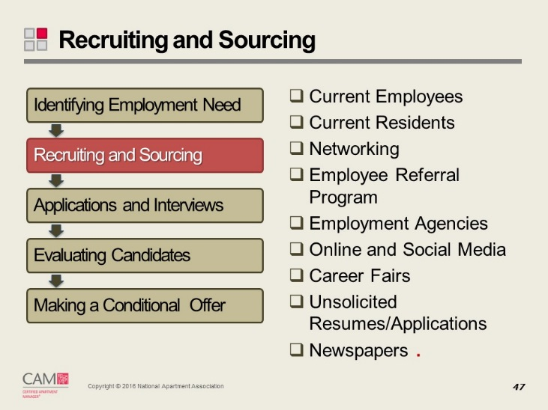

Recruitment Methods
Recruitment Method | Details
Current Employees as Candidates | Competent, experienced company employees should be given an opportunity to apply for open positions.
Current Residents as Candidates | Remember to include residents in your overall recruitment program. Send a flyer or keep a constant reminder in your monthly newsletter.
Networking | - Call other managers  - Check apartment association job banks or registries  - Network among residents, friends, business employees, company peers and family
Employee Referral Programs | Offering employees a recruitment bonus involves every employee in your search:  - Offer a cash bonus; typically from $100 to $500  - Provide a sliding scale for the bonus based upon the new employee’s salary/position or the total number of people referred within a period of time  - Can tie bonus payments to the longevity of the new employee  - 25% paid upon hire, 50% at six months of service, 25% at one year of service
Advertising | - Print media  - Classified section of the local newspapers  - Apartment association publications  - Minority, women’s, and/or neighborhood publications  - Online resources  - Work for you 24 hours a day  - Room for graphics and information about the company, benefits, & position  Watch for the following when placing the advertisement:  - No language indicating preference for a particular protected class; sex neutral job title  - Always use the Equal Employment Opportunity (EEO) abbreviation, logo, or wording  - Avoid narrow or limited recruitment sources
Employment Agencies | - Various types of employment agencies may be helpful.  - State unemployment agencies for unskilled labor or when unemployment is high  - Temporary agencies that specialize in apartment employees  - Employment placement firms (also called executive recruiters) for specialized positions such as property supervisors and management company executives  Note: agencies handle the recruiting and screening of candidates, and require payment of a fee for a hired candidate, usually based on the new employee’s salary.
Online Resources | Places you can post jobs online include:  - Your property or company website  - RPMcareers.org  - NAAEI career website  - General job posting websites
Social Media | Social recruiting (social hiring or social media recruitment) is recruiting candidates by using social platforms such as LinkedIn, Facebook, and Twitter.
Career Fairs | Career fairs offer a great opportunity to meet potential candidates in person. However, make sure you are utilizing various career fairs and not just the same one again and again. This could create, inadvertently, some discriminatory practices if the same type of person is continually being hired.
Newspapers | Place a job posting in local newspaper listings. Some candidates still do not have access to online resources. Use a variety of online and offline methods to reach potential applicants – especially maintenance candidates.
Unsolicited Resumes and Applications | Employers are not required to consider unsolicited resumes or applications. If your company does not consider them, think about a procedure to notify applicants.
All resumes and applications submitted must be retained for one year after the date received by the company.
Slide 48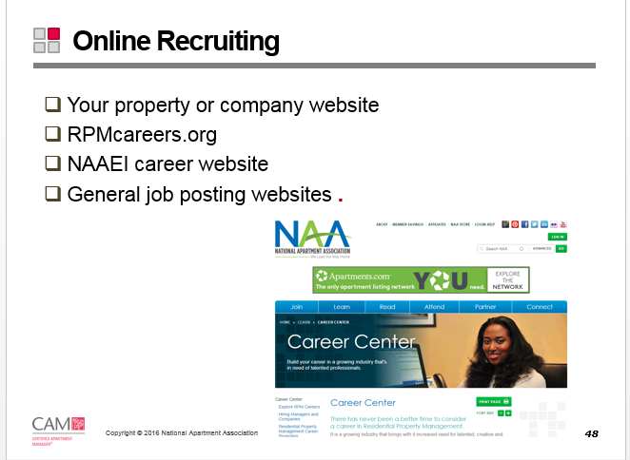
Slide 49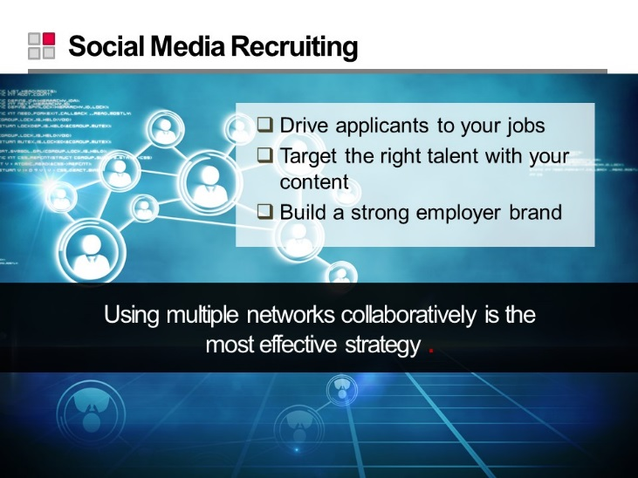
Slide 50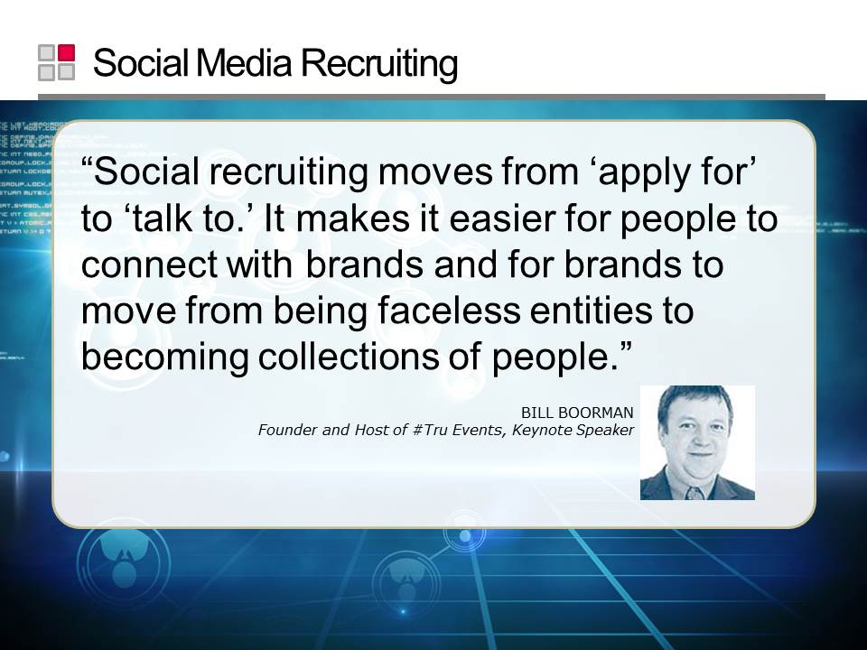
Slide 51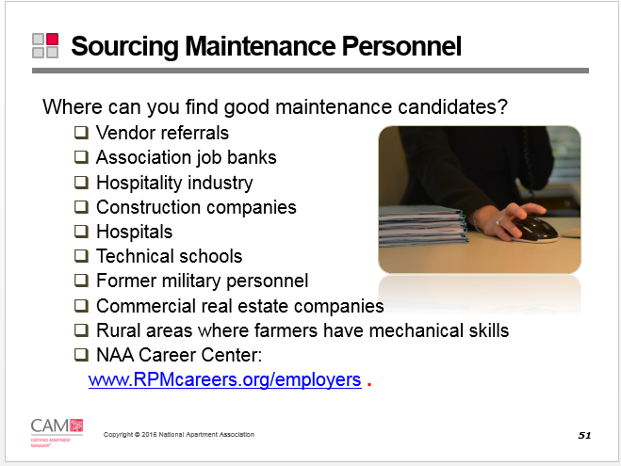
Slide 52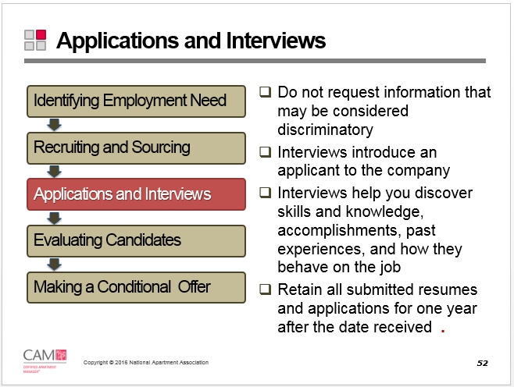
Slide 53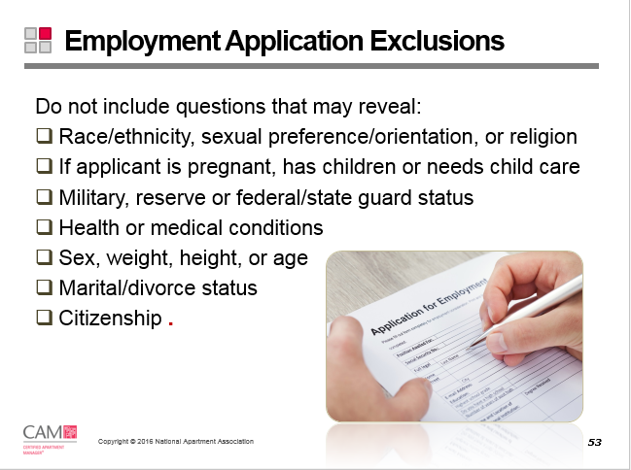
Slide 54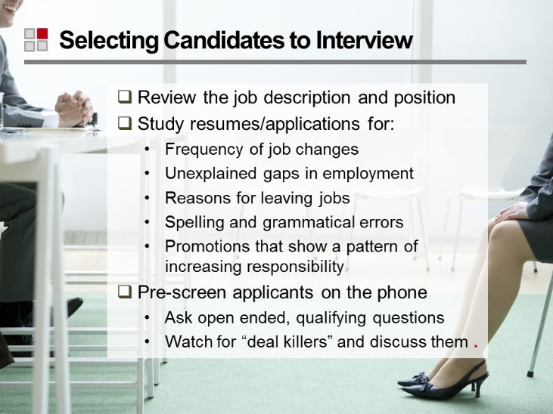
Slide 55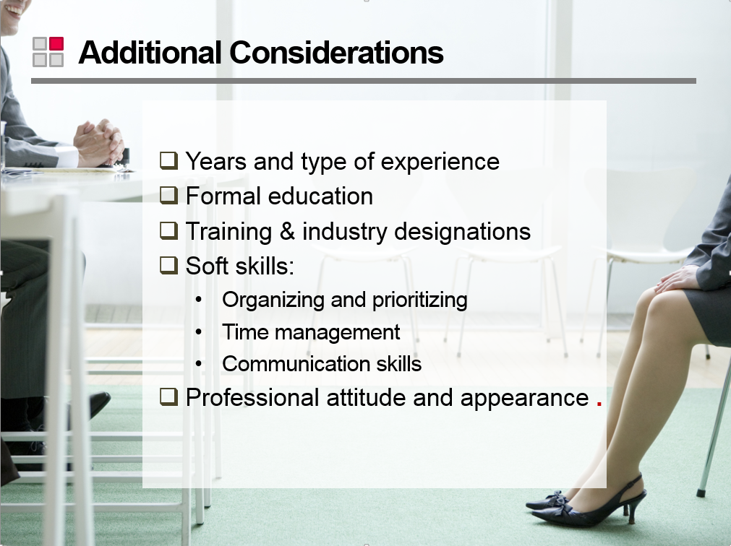
Slide 56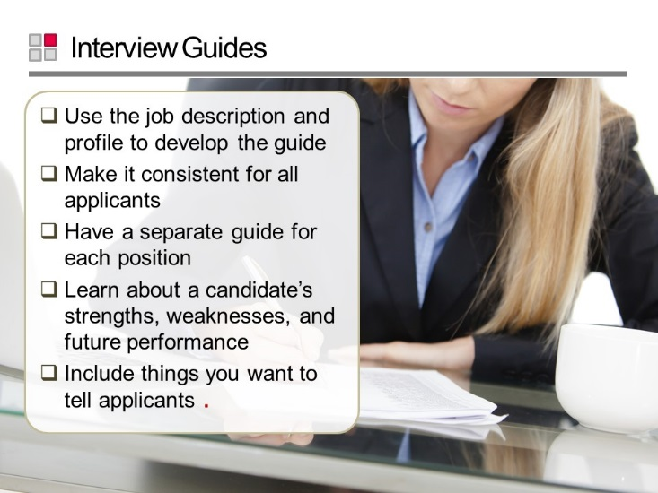
Reference Guide
Refer to the CAM Reference Guide document for an interview guide sample. Also available at: http://www.naahq.org/learn/education/candidate-resources

Slide 57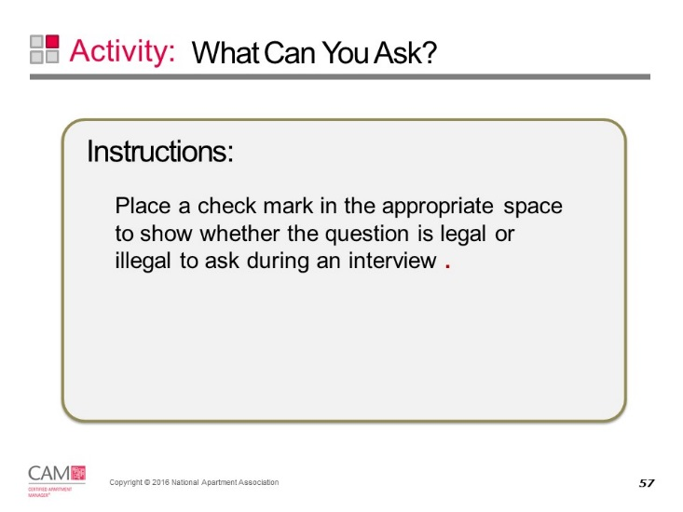

What Can You Ask?
Legal | Illegal | Question
 |  | You know how one's perspective about their job changes when you get past forty, don't you?
 |  | That's an interesting pronunciation of your last name. What nationality is that?
 |  | I see from your application that you ski. Have you gone to any singles ski weekends near here?
 |  | I guess anyone who was in the Special Forces must have an honorable discharge. Do you?
 |  | Who cares for your children?
 |  | You look pretty young to have all this experience. What year did you graduate from school?
 |  | What physical handicaps do you have?
 |  | Do you plan to have more children?
 |  | You say you contribute a lot of your spare time to church activities. What church is it?
 |  | Do you own your home? Rent? Live with your parents?
 |  | You're from a tough neighborhood. Were you able to survive without problems with police?
 |  | How much do you weigh?
 |  | What clubs and organizations do you belong to?
 |  | Would your husband care for your children if your job required you to be away overnight?
 |  | Since you're a woman, do you feel you will be able to sell effectively to men?
 |  | What type of military discharge did you receive?
 |  | What would you do if your husband got a job in another state?
 |  | Do you think someone of your race would have a problem working in this area?
 |  | Is there any history of mental disorders in your past?
 |  | That's a beautiful diamond you have. Are you engaged?
 |  | An attractive woman like you must be married. Are you?
 |  | Do you think being a male will be helpful in dealing with this type of clientele?
 |  | Where was your wife born?
 |  | Is it "Miss" or "Mrs." Jones?
 |  | Please don't be offended by this standard question. Have you ever been arrested?
 |  | As a woman, will you have difficulty learning technical material or relating it to male customers?

Examples of Acceptable/Unacceptable Interview Questions
Subject | You “May NOT” Ask | You May Ask
Age | - How old are you?  - What is your date of birth? | If hired, can you provide proof of minimum age?
Arrests/  Convictions | - Have you ever been arrested?  - Check with state and local laws | Have you ever been convicted of a crime?
Birthplace | - Where were you born?  - What country are you from? | If hired, can you provide employment eligibility verification?
Citizenship | - Are you a U.S. citizen? | If hired, can you provide employment eligibility verification?
Drugs/Alcohol | - Have you ever participated in a drug rehabilitation program? | Are you currently using illegal drugs?
Education | - When did you graduate? What year did you graduate? | List of academic, vocational, or professional education.
Height/Weight | - How tall are you? | No acceptable questions.
Marital/Family Status | - Are you married?  - Do you have any children?  - How many children do you have?  - What are the ages of your children?  - Are you pregnant?  - Are you single? Divorced? Widowed? | No acceptable questions.
Military Record | - Were you honorably discharged from the military? | Are you a veteran of the Armed Forces?
National Origin/Ancestry | - Where were you born? What country are you from? | Fluency in language if it is job related.
Photographs | - For a photo ID with the employment application. | For a photo ID after hire.
Race/Color | - What is your ethnicity? | No acceptable questions.
Religion | - What church do you attend? | Shift availability. Are you available to work weekends/holidays?
Residence | - Do you own or rent? Do you own your home? | Present address.
Sex (gender) | - Are you male or female? | No acceptable questions.
Disability | - Do you have a disability?  - What is the nature or severity of your disability?  - Have you filed any claims for workers’ compensation?  - How did you become disabled?  - What is your prognosis?  - How often will you require leave for treatment of your disability?  - Have you or any of your dependents ever had or been treated for any of the following conditions or diseases…  - Please list any conditions or diseases for which you have been treated in the past three years.  - Have you ever been hospitalized?  - Have you ever been treated by a psychiatrist or a psychologist?  - Have you ever been treated for any mental condition?  - Is there any health-related reason you may not be able to perform the job for which you are applying?  - How many days were you absent from work because of illness last year?  - Do you have any physical or mental defects that preclude you from performing specific kinds of work?  - Do you have any disabilities or impairments that may affect your performance in the position for which you are applying? If so, identify any accommodations that would enable you to perform the job.  - Are you taking any prescribed drugs?  - Have you even been treated for drug addiction or alcoholism?  - Are you involved or have you been involved with an individual diagnosed with the HIV virus?  - Do you wear contact lenses? | Can you perform the essential functions of the job with/without reasonable accommodation?

Slide 58
Slide 59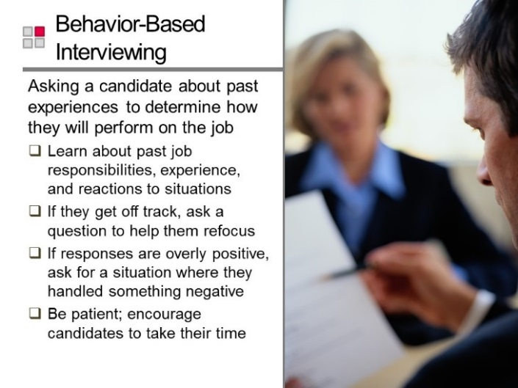
Slide 60
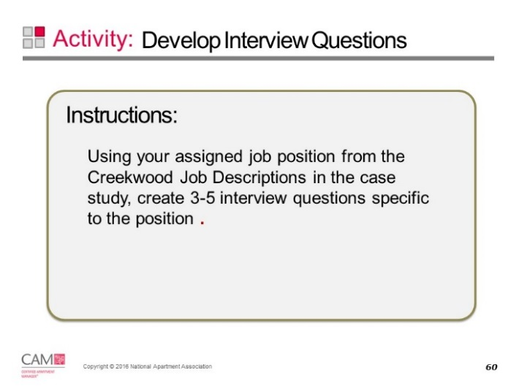

Interview Questions for Creekwood Job Descriptions

1.
2.
3.
4.
5.

Slide 61 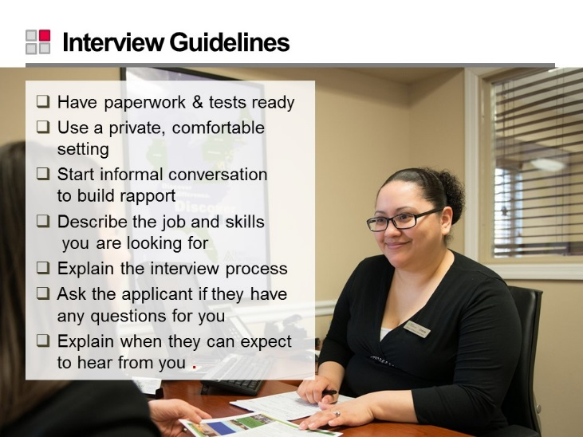
Slide 62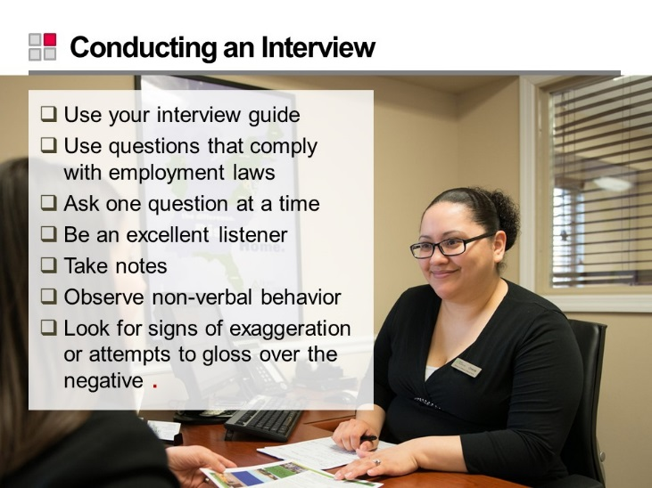
Slide 63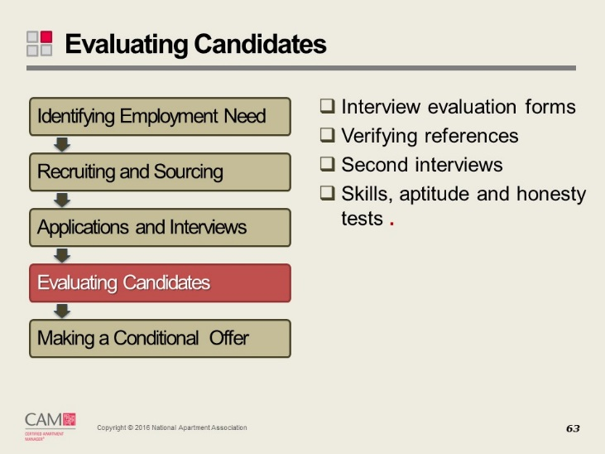
Slide 64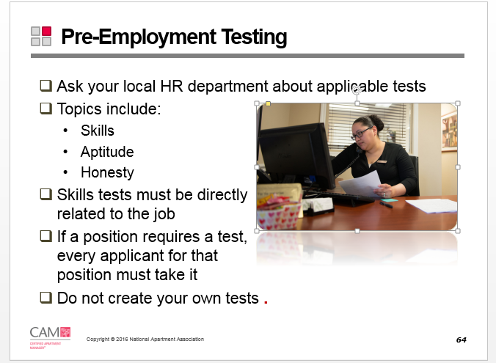
Slide 65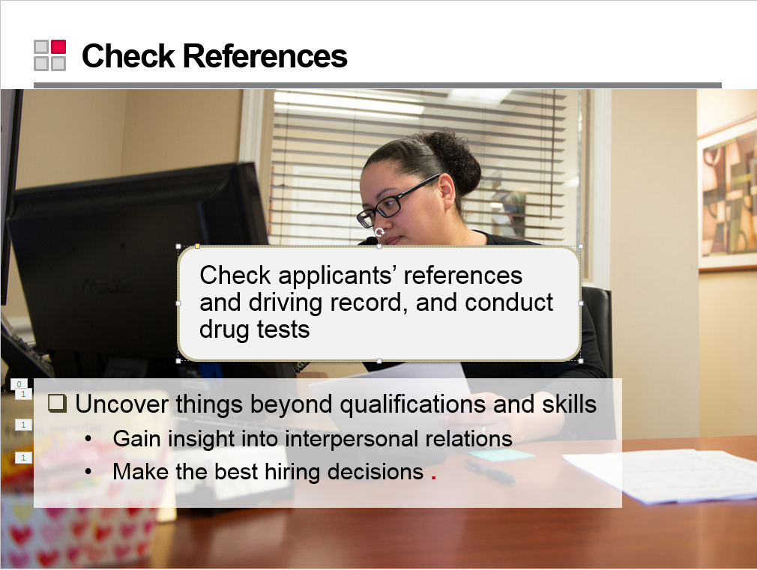
Slide 66 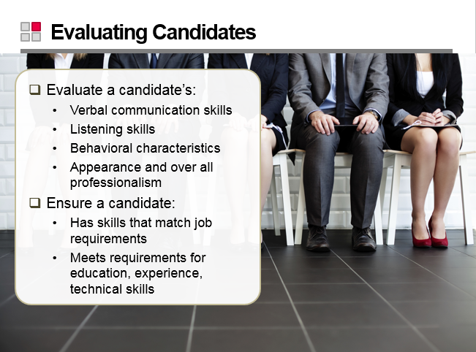
Slide 67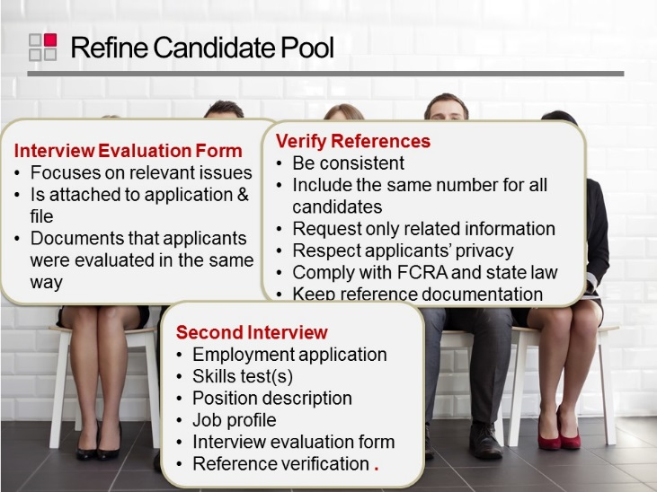
Slide 68
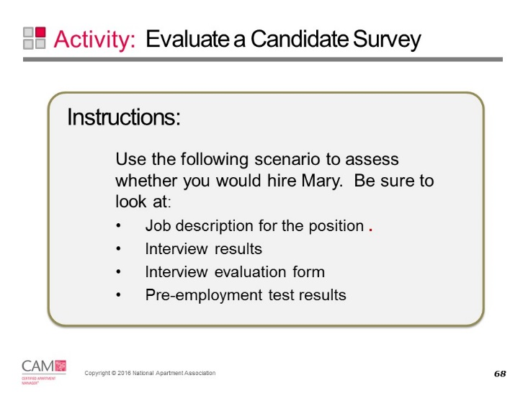

Candidate Survey
Job Description
The Leasing Consultant’s primary responsibility is the performance of all activities related to apartment rentals, move-ins, and lease renewals. The Leasing Consultant:
- Interacts directly with prospective and current residents to achieve maximum occupancy, including generating and handling traffic, leasing apartments, qualifying prospects, preparing lease documentation, and completing move-in paperwork and procedures
- Performs all of the above in accordance with applicable laws and company policies
- Assists with the company’s on-going relationship with the residents throughout their tenancy

The position may report to the Leasing Manager, the Property Manager, or Senior Property Manager and has no supervisory responsibilities.

Interview Results
Mary arrived at your office exactly at interview time. She was rushed but regained her composure quickly. She was seated by your leasing professional and given the company application to complete. She responded that she had brought a resume and would use that. The leasing agent explained the company policy on all candidates completing the application. After 15 minutes, she turned it in and the leasing professional brought it to you. It was hastily written and some blanks had abbreviations you did not understand. You were now 20 minutes into the 45 minutes you had allotted to this interview. Your next appointment with your supervisor’s conference call could not be delayed.

Mary is brought to your office and seated. She is dressed in appropriate business casual attire and carries a large handbag and small iPad holder. She takes out her phone and rests it in her lap after turning the sound to off. She is well spoken – although perhaps speaks a little quickly. You notice she uses the terms “tenant” and “complex”. A couple of your questions need to be repeated or clarified. Did Mary listen well or did you not ask directly? In your behavioral questioning, Mary explains how valuable she is and that few, if any problems were ever encountered in her current position. During the interview, she hits the phone button occasionally to check the time. She makes good eye contact, but frequently looks around your office, taking in its appearance. When you ask if she is looking for something, she replies that she is simply checking it out.

After several minutes of questions and answers, you end the interview and explain to Mary what will happen next. She seems eager to leave, explaining she has other appointments and thanks you for your time.

Interview Evaluation Form
Background Review

- What would your current employer have to do to keep you?

I am not sure they could do anything. It’s an okay company to work for, but everything has sort of fallen into habit and there is nothing new I am encouraged to do. There’s just a sort of daily grind. Even if they offered me more money, I am just not going to be happy where I feel like I am just part of a process more than I am a contributor. My manager is fine, but I just don’t feel like there is a connection with the corporate office and my property team.

- In your last job, for which tasks did you have full responsibility?

Since we have only 4 people in the office if we are all there, I am completely responsible for handling all initial prospect or visitor contact – phone, email or walk in. I verify applications, process them through our screening software and complete all the paperwork for new leases to be reviewed and approved by the manager. I write up work orders and post completed work orders to the system daily. I make both leasing and maintenance follow-up calls. I check for email leads every two hours. I make suggestions to the corporate office who posts on our social media accounts at Facebook and Twitter. I complete the monthly market survey reports by calling our comps. I am also responsible for pulling the daily activity report and proofing the weekly activity report on our property management software. Each month I distribute renewal letters and follow-up with residents who have not responded. If I have time, I love reaching out to our area retailers to see if we can have a relationship.

Leasing and Sales

- How many prospects do you handle in a day? How do prospects come to your property? What was your closing ratio – how many sales did you close on the average in a week?

In a typical day I usually get 8 phone calls, maybe 4 email leads from our ILS provider, another 3 from our website and maybe 2 that just walk in. We just added a mobile app, but not seeing much yet from that. I rarely see anything from apartmentratings.com. I think the manager sees those.

It’s hard to say what is an average close for me – it varies really on the applicant and how urgent their need is to lease an apartment. If there is someone who needs to get this arranged, I can close them at least 50% of the time. If they are just looking or just started looking and have a lot of lead time, I may not be able to get a deposit, but I see that as a chance to do a lot of follow-up!

- How did your sales effort affect the profitability of your property?

Our manager does a great job in weekly staff meetings about reminding us how much value each lease brings to the property. I focus on a lease at a market rent, but she has taught us to see the annual value – like a lease I closed at $1,115 a month was really $13,380 to the property. If I give that prospect a concession, it really just takes money away from the owner.

Administrative

- What types of reports (program or property) did you have to generate and how often? How were those reports used at the property?

I do a daily activity report, maintain a traffic log, record guest visits and phone calls. I also do the weekly activity report and keep the renewal log up to date with contacts and results. I input completed work orders each day to the weekly roll-up is accurate.

Customer Service

- Describe an instance in which you handled a difficult resident or customers. What was the outcome?

There is one resident on our property that is always upset about something. Either a work order was late, or kids were noisy outside, or a piece of trash landed on her patio – almost every day it’s a little thing. She gets angry and usually yells aggressively. One day she came in to complain about something and she wasn’t yelling so much as it seemed she was depressed or this had really gotten to her. So I mentioned that I was sorry that the oversight had really seemed to upset her. I didn’t say anything about the fact that she wasn’t yelling, but had just seemed to have given up. She stopped for a minute and sat down and explained a personal issue she was dealing with. She actually opened up. It hasn’t changed her attitude completely, but she seems to have taken a little less aggressive position on her complaints since then.

- Did you make any suggestions in any previous job to improve morale, increase output or increase customer satisfaction? What were they?

At my current job, I mentioned that it was sort of in a rut in terms of what I was doing. We recently got some pressure from our owner to move the rents up even more and be faster about getting vacancies filled. We had been working hard so this just seemed like more work and less appreciation. That’s what I felt anyway – but I tried to take the high road and be positive at the next staff meeting. My manager reviewed more about what the owner wanted and tried to do a “go get ‘em” speech and I spoke up and tried to explain how doing what the owner wanted would just make it easier for us in the long run. I mentioned to the other office staff that more leases meant more bonuses and we should make it a game to make sure no one left the presentation without giving us at least an application fee. Same thing for the maintenance, once they could get the units sparkling and we got them leased, the fewer make readies they would have to do and the more likely work orders from those units would be down. Everyone sort of appreciated that but it didn’t last long.

Follow-Up

- Describe to me how you organize your day. What types of “tools” or methods you have used to manage your time?

There are a couple of things I do – first, I end my day by clearing and organizing my desk – I try not to leave any papers or open tasks sitting on top of the desk – it just makes me feel stressed when I walk in the next morning. I also use my Outlook calendar for everything! Even if it’s just to remind me to “sparkle” up the show units, or check a particular area on the property where I noticed trash the day before to see if there is more today. I am a huge fan of “appointments” so I get a tickler. I like to cross things off on lists so I make a short to-do list at the end of the day. I used to make long ones and put everything on it, but so many times I couldn’t cross off a lot and that frustrated me. So now I keep it simple.

Decision Making

- What types of decisions do you make in your current role, without first checking with your manager? On what types of decisions do you ask for input prior to making a decision?

I make standalone decisions about when I do my daily tasks as long as they are done by the deadline – like sparkling the show units, or walking the grounds, or doing call backs on work orders. If the resident is not happy I will make a decision about asking maintenance to return – although I will always say I need to check with today’s work schedule. I decide what comps I shop and what information I tell them in return. I decide which work order call deserves special handling – without being discriminatory. I would never approve or disapprove an application or sign contracts or leases. I can make suggestions about work order or things I see that need to be done on the property exterior, but I can’t assign those a priority.

Risk Taking and Action Orientation

- Can you recall an instance in which you had to take a risk on a job? What was the situation and what made it risky? What happened?

I don’t take many risks or what I consider risks. When I spoke with that resident about her being upset and almost defeated by her complaint, I guess I risked her becoming even more angry and outspoken. Either I must have said it right or she was really feeling defeated, that she accepted my concern and opened up. That could have backfired, but I think my role on the team is all about appreciating our residents – even this one that is constantly complaining about something. She could have gotten really mad and gone to my manager, but she didn’t.

Change and Stress

- Describe a change that took place in your last job that you found difficult to understand or accept. What was the situation and how did you adapt to the change?

On this job, we recently had a change of supervisor – that was tough. My manager really had a good relationship with the regional, but the owner on another portfolio was upset so our VP changed up portfolios a little. So we all got a new boss. I think my manager struggled the most, but the new regional led a couple of our staff meetings right after the change. They were much more direct and business-like. The previous manager was more relaxed and encouraged staffers to speak up. I was concerned that all of our staff meetings would change because our manager would have to adapt. But I still asked questions and tried to be supportive of other team members who were really more upset about how direct and commanding the new regional was. I mentioned it to my manager privately and she encouraged me to keep it light – even when the regional was in attendance. Fortunately, the regional backed off of attending our meetings each week – I think it was just to get us on the same page with her.

Problem solving

- Tell me about a disagreement you had with your last manager or other property personnel. What was the situation and what did you do?

On my job before my current job, the manager and I did not see eye-to-eye on community service projects or any sort of community outreach. He just didn’t think that we got any direct benefits from helping out at a Chamber event or being a drop-off point for the city blanket drive. We were leanly staffed and he was afraid it would take too much time, force staff to be away from the property and not net any leases. I tried to convince him of the good press we would get online and in the local paper. Also tried to assure him that we could work out a schedule for when staff members would be away but I couldn’t convince him that we would be able to get additional leases or traffic because of this exposure. There was no way to track it and he was a numbers guy.

Motivation/Attitude

- Do you see yourself as a leader or a team member?

I think I see myself more of a team member. I have a great manager to work for and I have a long way to go to be able to be a manager, but I am learning from her. I like working with a group of people who are all on the same page. I think that is where I can add the most value. I keep it light and like to make the maintenance team members laugh – maybe give them a break. I know that in a previous job, we did not have that kind of relationship on the team and I know I would not want to lead a group like that. I think it takes the right people and the right leader and I like being on that team.

- What are the things you look for in a job?

There are a couple of things I want. I want to be respected for what I do, even if it’s just leasing. If I am not good at my job, then the property can’t really be successful. I also need a place where I can sort of do it my way. I know there are protocols and forms and processes a company has, but I like to do things my way. That means I like to work where I can ask why or how in order to make something better. I get frustrated when someone tells me that’s just the way we do things. I also need a manager that I feel comfortable going to with a question or idea. So someone who is knowledgeable and accessible to me. I want good pay and a chance to earn more and learn more.

Summary

- How does the position with our company “fit” with your overall career goals?

One of my goals is to grow and I see the chance to do that at this property. There are other sister properties in the area so that means there might be other opportunities. I also like the approach to supervision. It seems like everyone is happy to be here and do their job. I want to be happy in my work. I also see the chance to be able to do more outreach and try new advertising and promotion ideas – so even if I am still a leasing consultant I am doing more and different things. I like the fact that I will be able to change up my work schedule. I like that I have some operational exposure – like being a part of the inspection team and the preventive maintenance program. That’s all important to me as I grow in skills and eventually move up into a more regional marketing role or even an assistant manager position.

Pre-Employment Test Results
Mary is given several pre-employment tests –

Drug Screen – comes back clean

Vocabulary Test – she misses some word definitions as well as certain industry terms – being unable to connect the term with its definition on a matching quiz.

Software Test – even though she currently works with a different software, she can effectively record traffic, move-in a prospect and issue a work order on the test data base.

Property Online Research – you ask Mary to research your property and its online presence. She is able to correctly identify online sources and even goes to reputation sites to get current information.

Leasing Demonstration – After taking Mary to the model and allowing her a few minutes to prepare, she fairly effectively demonstrated the model to you in a prospect role-play. She is a little stiff and identifies features, but not benefits or emotional appeal. When you ask what she would do at the end of the demonstration, she incorrectly says she would return to the office with the prospect and give them an application.

Credential – She is an NALP and a CAM candidate – but checking the directory she is not listed as a NALP. She explains it has lapsed.

Slide 69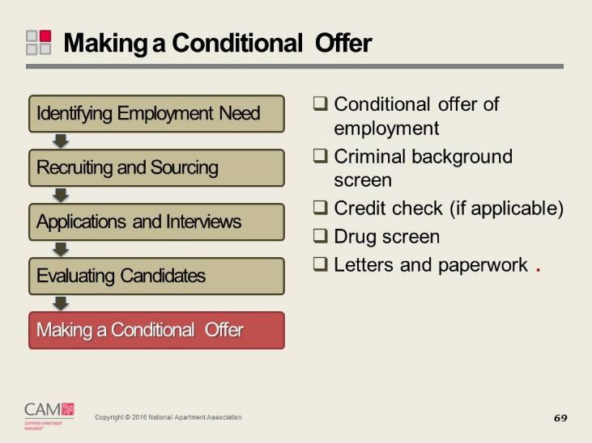
Slide 70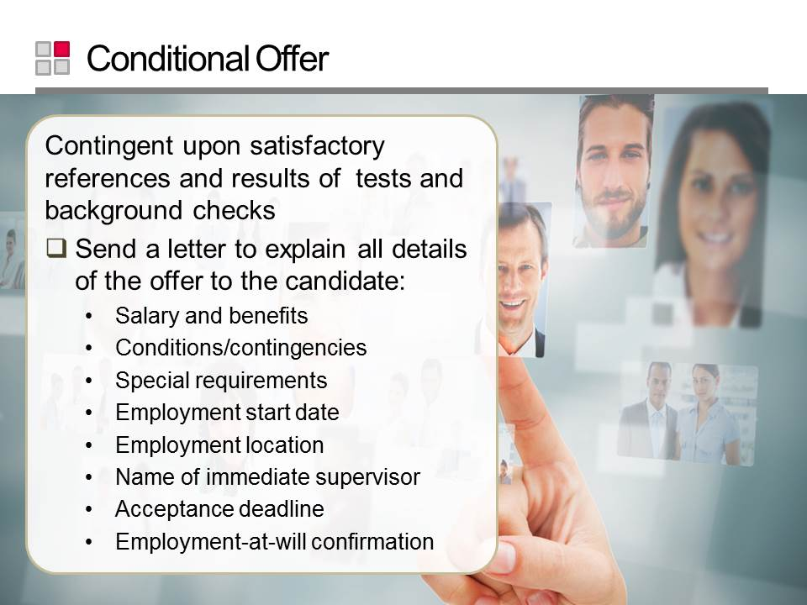
Slide 71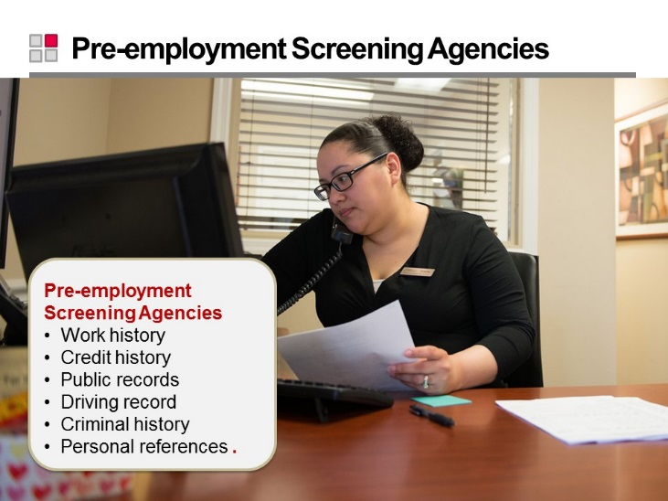
Slide 72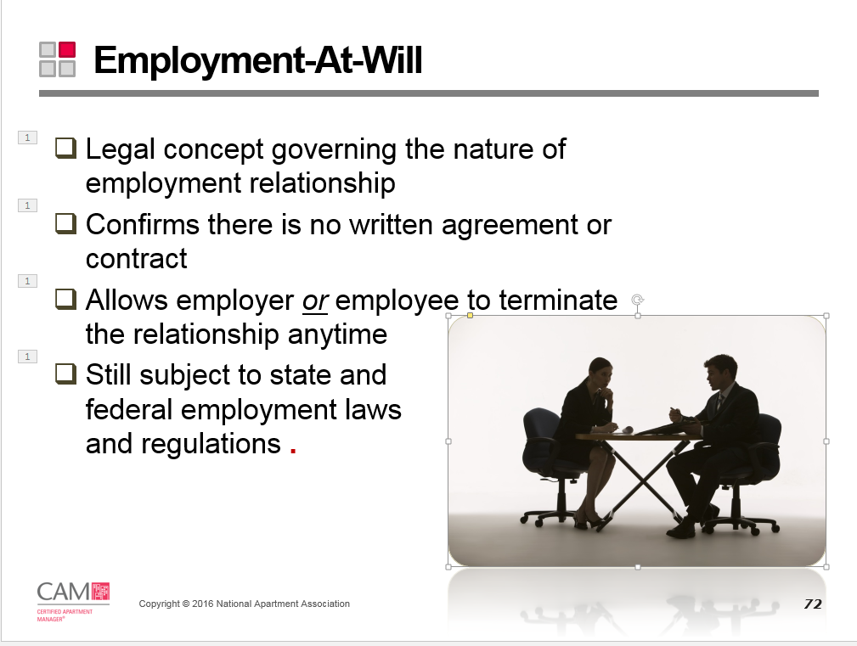
Slide 73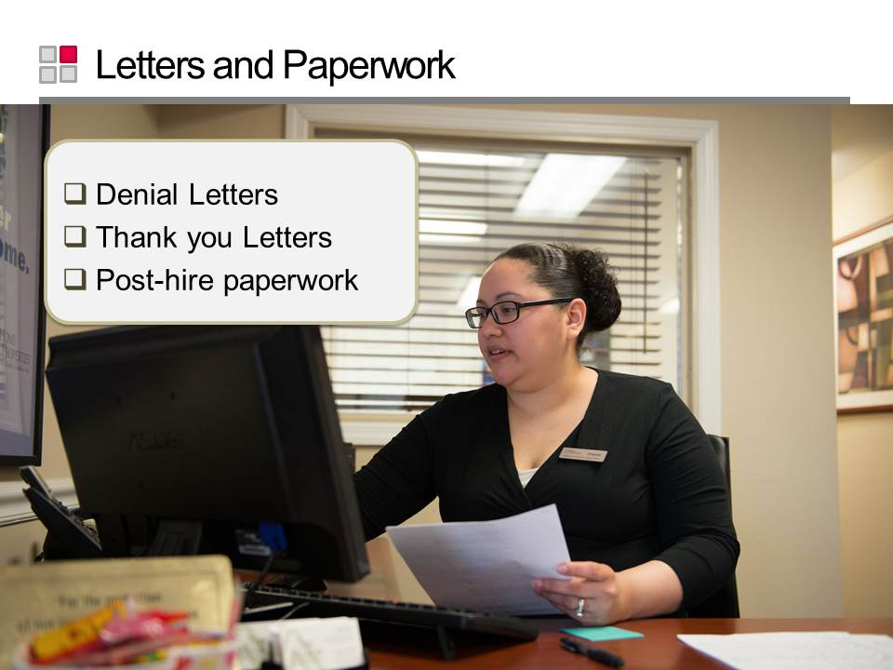

Employee Needs throughout Employment
Slide 74
Slide 75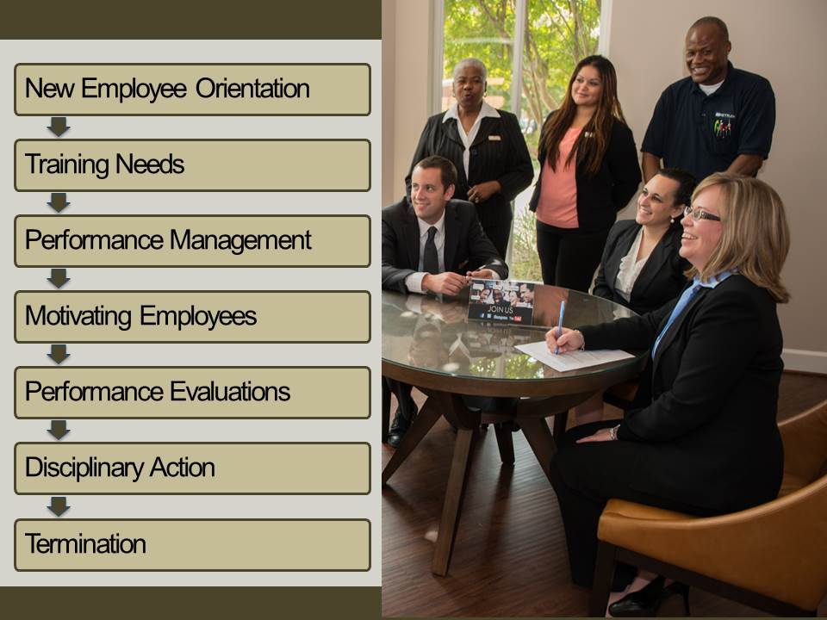
Slide 76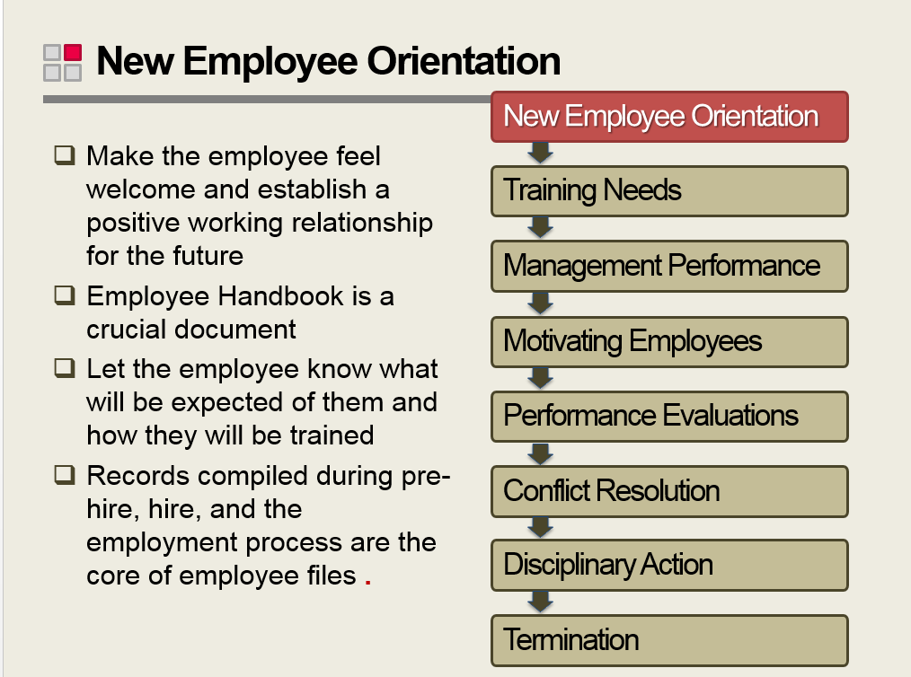
Slide 77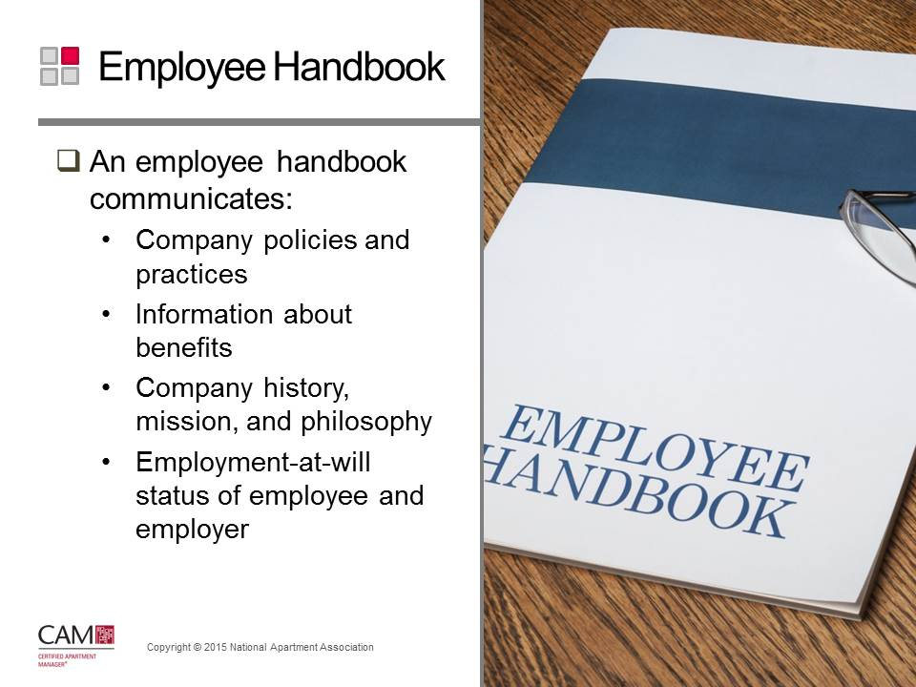

Reference Guide
The CAM Reference Guide lists management issues and policies that may be included in the handbook.

Slide 78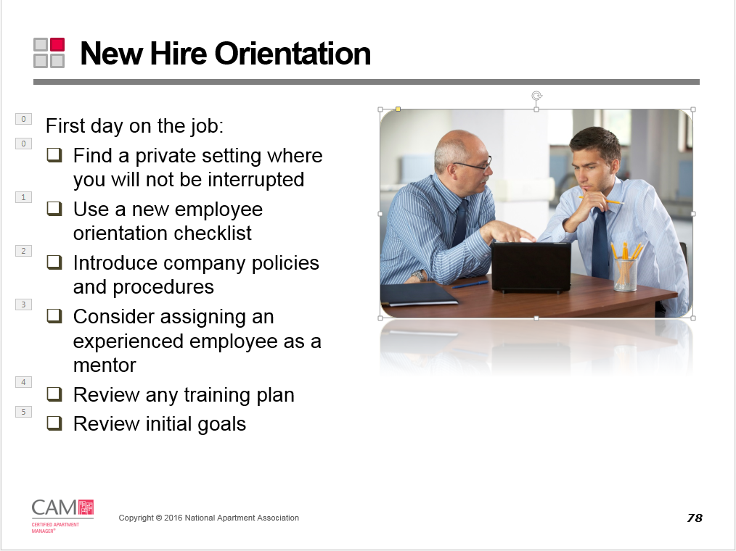
Slide 79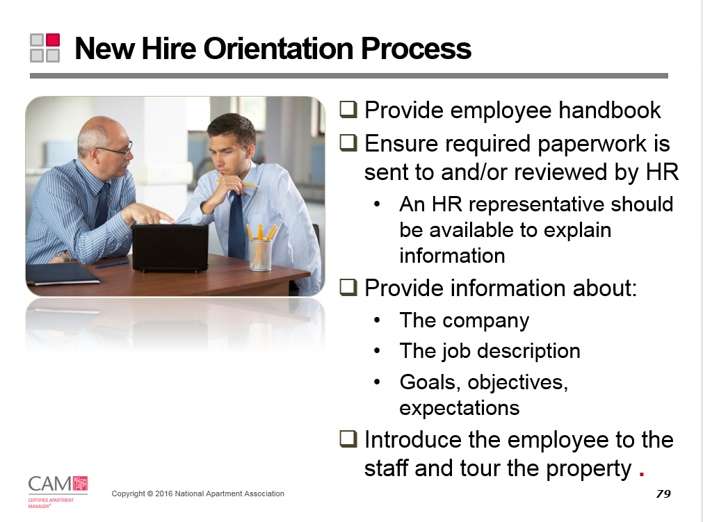
Slide 80 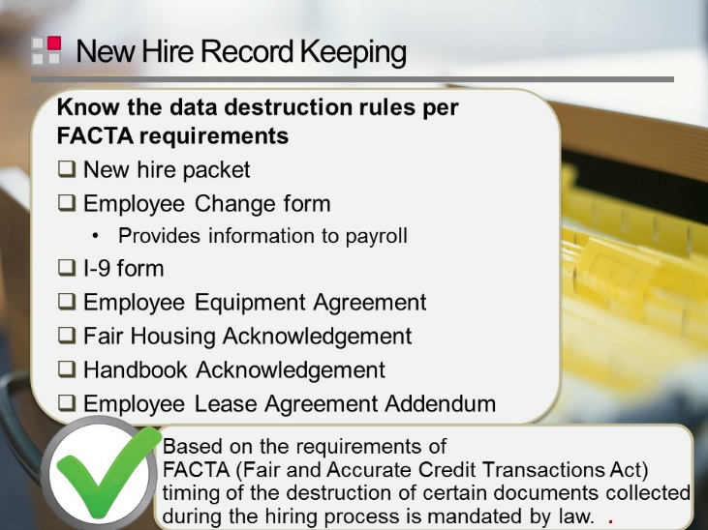
Slide 81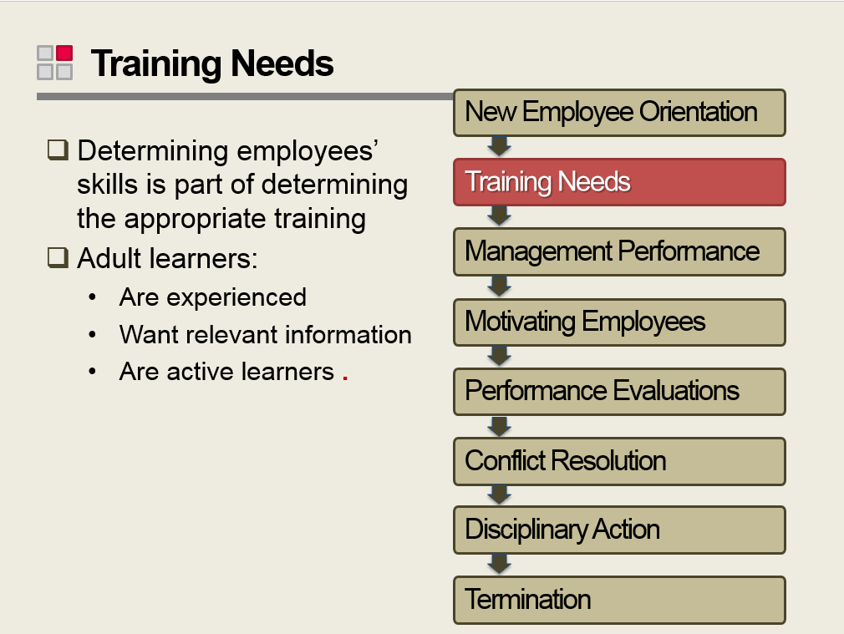
Slide 82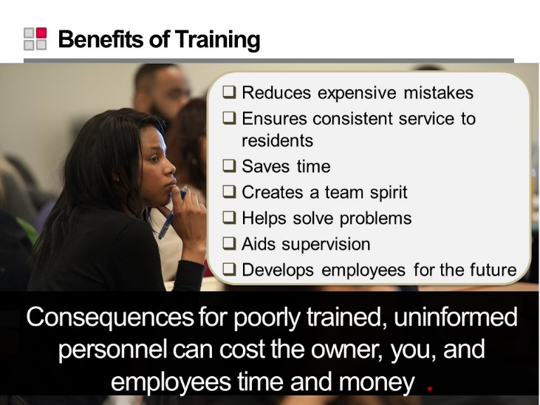
Slide 83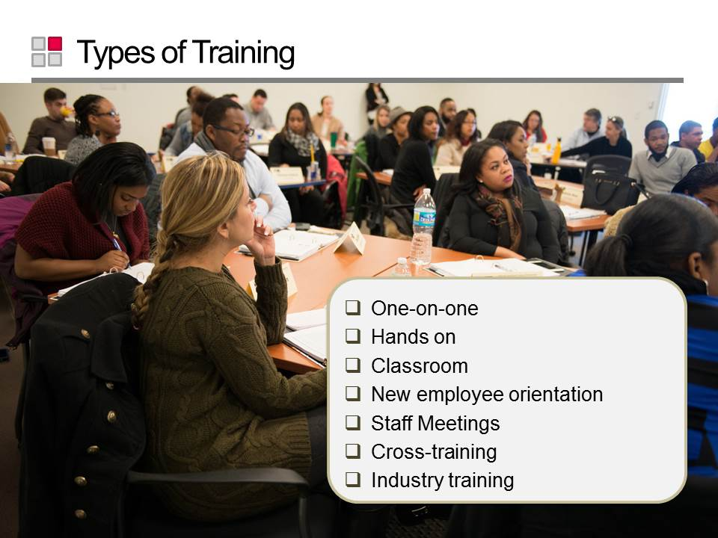
Slide 84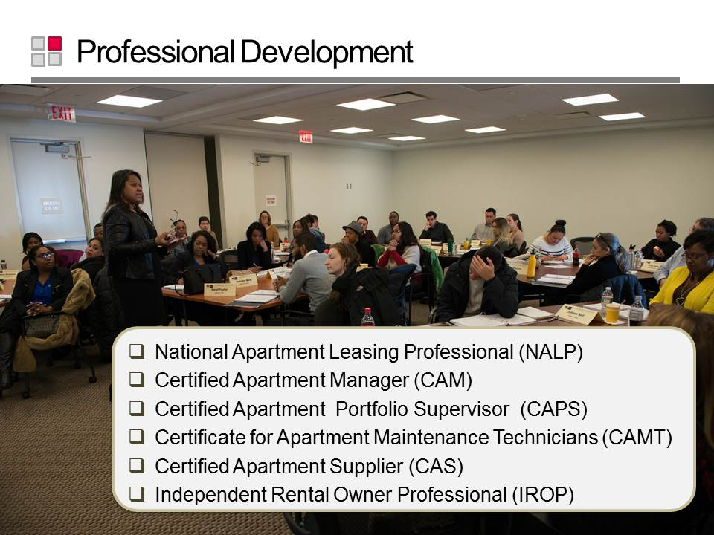

Online Resource
For further detail refer to NAAEI Skill Standards: http://www.naahq.org/learn/education/find-a-course/designate-benefits.

Slide 85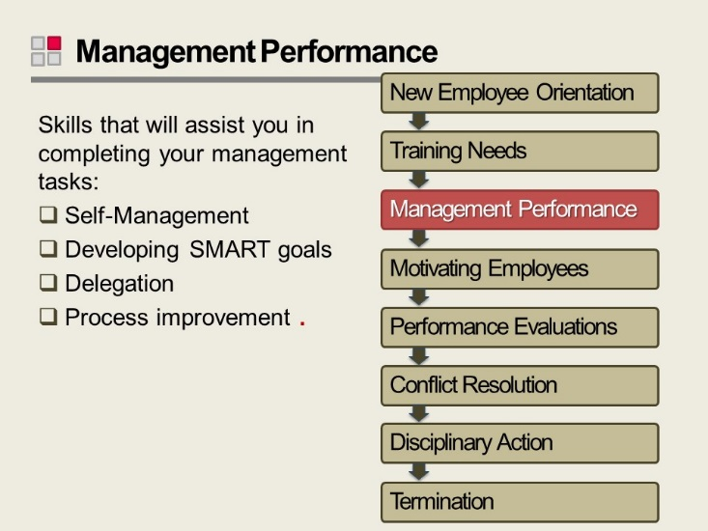
Slide 86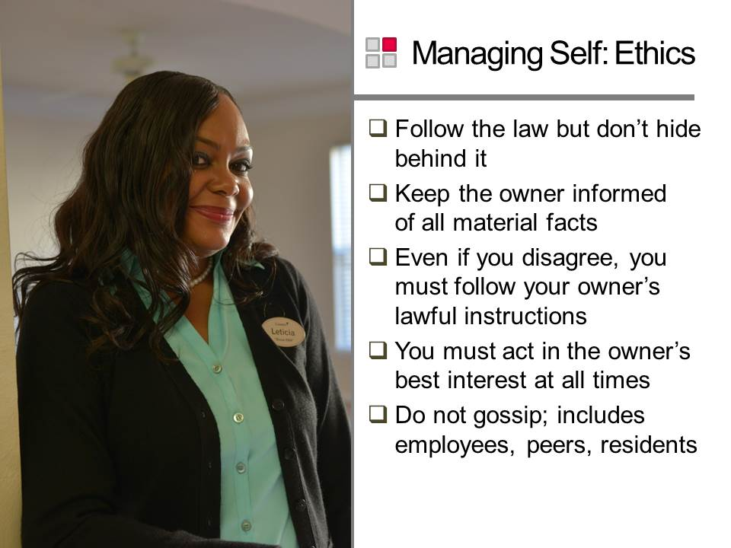
Slide 87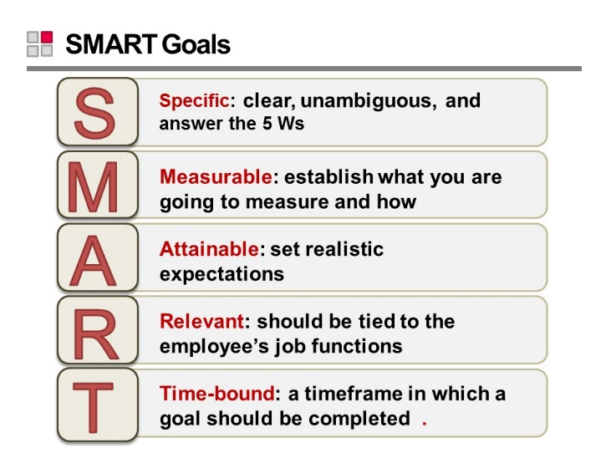
Slide 88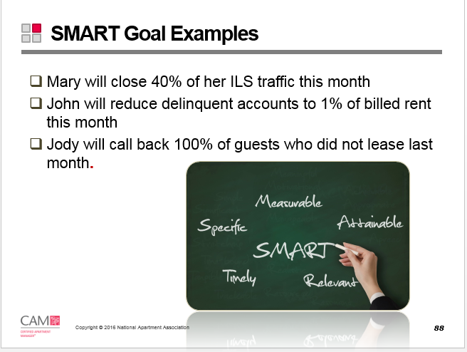
Slide 89

Writing SMART Goals
Component | Description
Specific | Goals should be well defined and specific. You have a greater chance of accomplishing a specific goal than a general goal. Being specific when writing goals means you answer the 5 Ws:  - Who: Who is involved?  - What: What do I want to accomplish?  - Where: Identify a location.  - When: Establish a time frame.  - Why: Specific reasons, purpose or benefits of accomplishing the goal.
Measurable | Measuring progress helps you stay on track and reach target dates. Measurement provides evidence that an employee has accomplished the goal. When possible, put concrete numbers in goals. To determine if your goal is measurable, ask questions such as:  - How much?  - How many?  - How will I know when it is accomplished?  During performance evaluations, review the goals you’ve set with the employee and discuss the results. To discuss results, you often need to use some type of measurement.
Attainable | Ensure your goals stretch you or your employee, but don’t make them so far out of reach they can’t be accomplished. To identify if a goal is attainable, ask if the person has the appropriate knowledge, skills, abilities, and time needed to achieve the goal.
Relevant | Goals should be based on the current conditions and realities of the business climate. Goals must be directly related to an employee’s job.
Timely | A timeframe in which a goal should be completed creates a sense of urgency and increases the likelihood of achieving the goal.
Specific: clear, unambiguous, and answer the 5 Ws
S
Measurable: establish what you are going to measure and how
M
Attainable: set realistic expectations
A
Relevant: should be tied to the employee’s job functions
R
Timely: a timeframe in which a goal should be completed
T
Slide 90
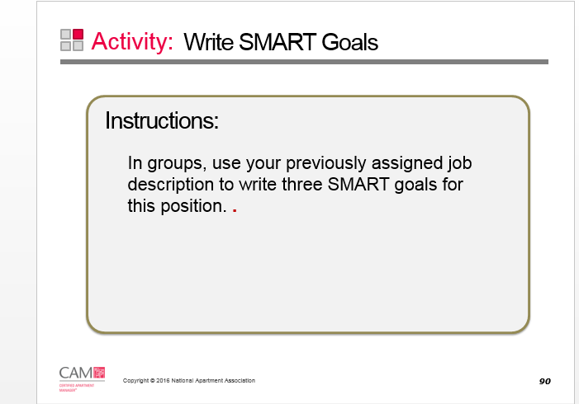

SMART GOALS
 | Specific | Measurable | Achievable | Relevant | Timely

Slide 91
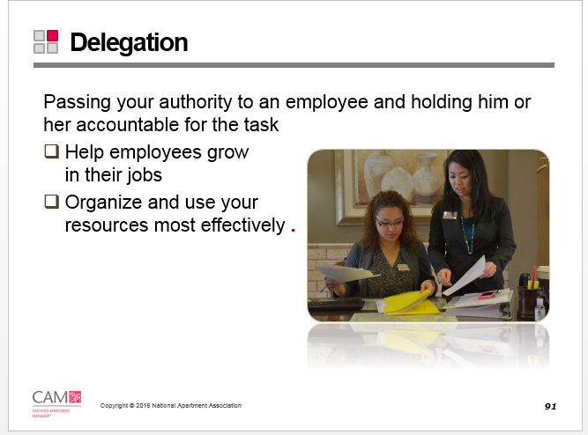
Slide 92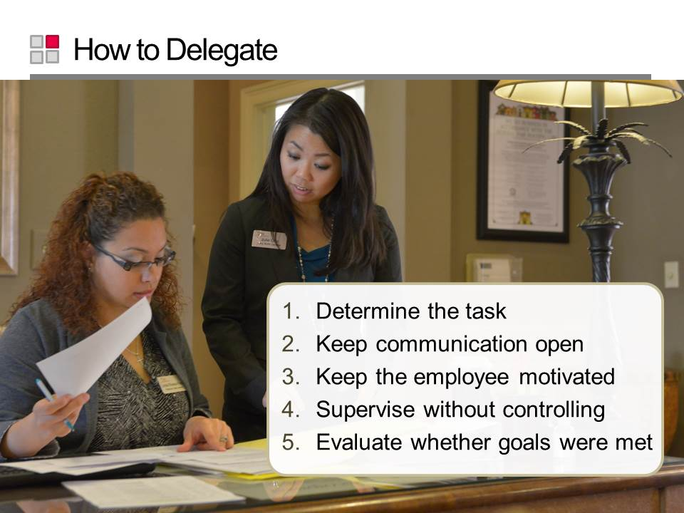
Slide 93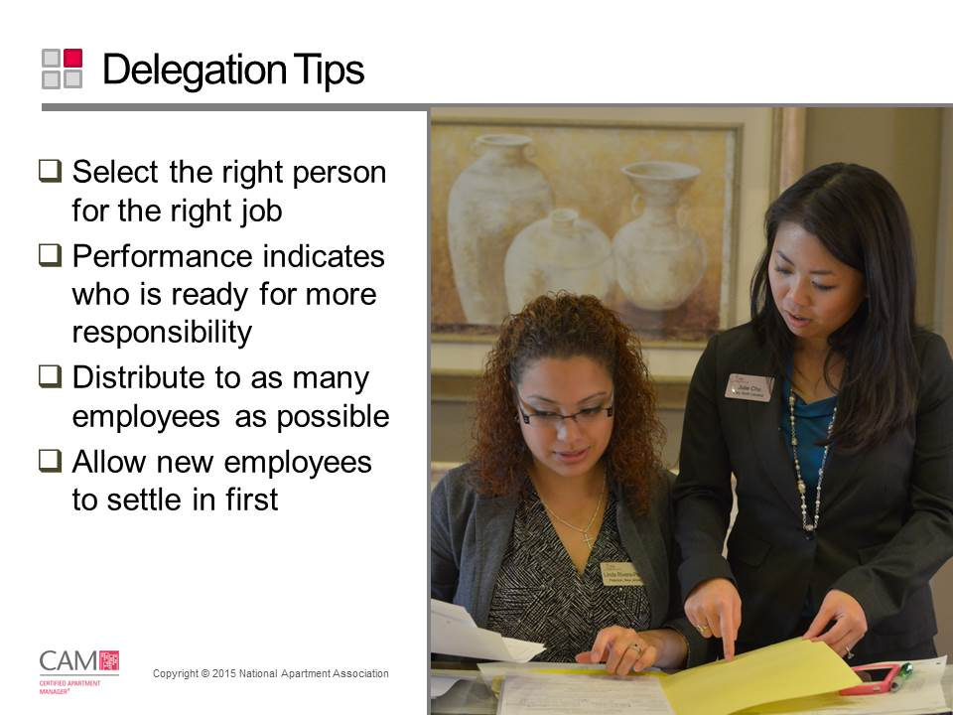
Slide 94
Slide 95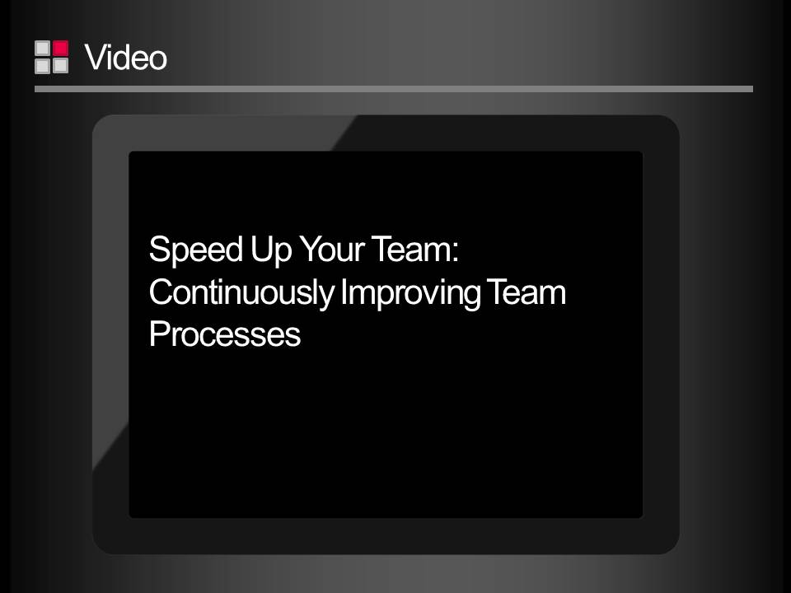
Slide 96
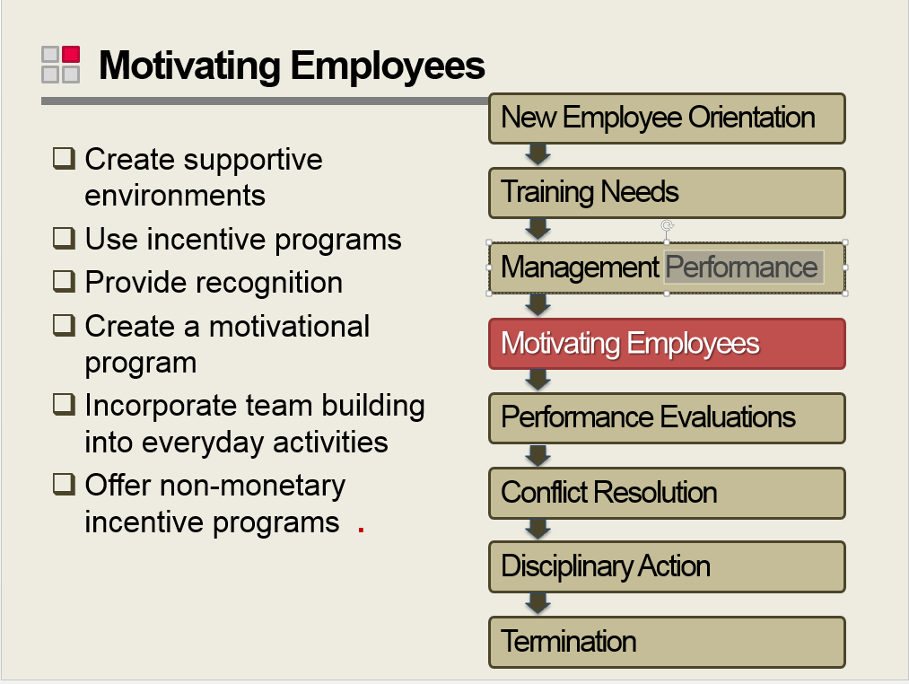
Slide 97
Slide 98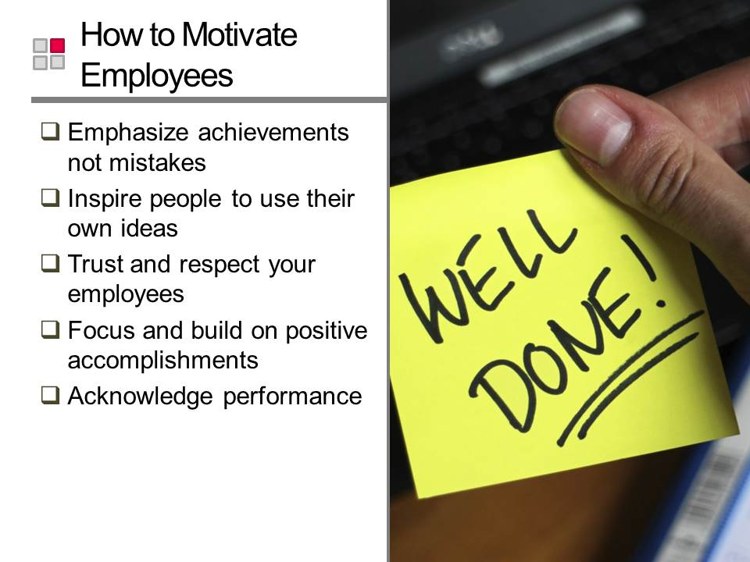
Slide 99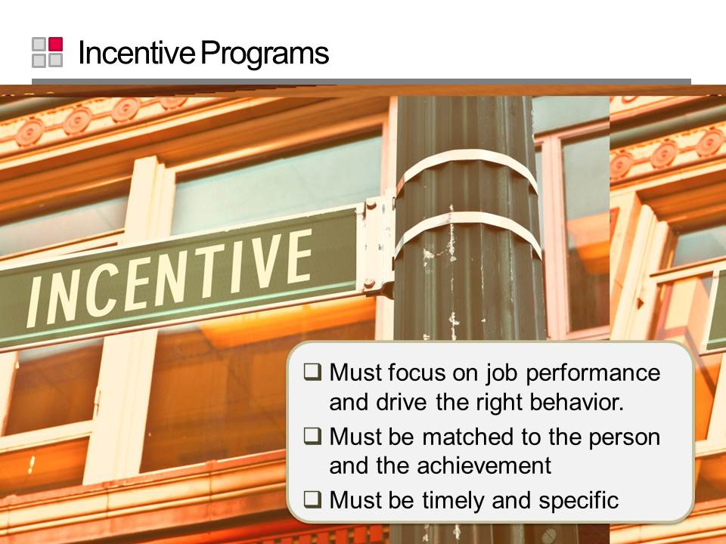
Slide 100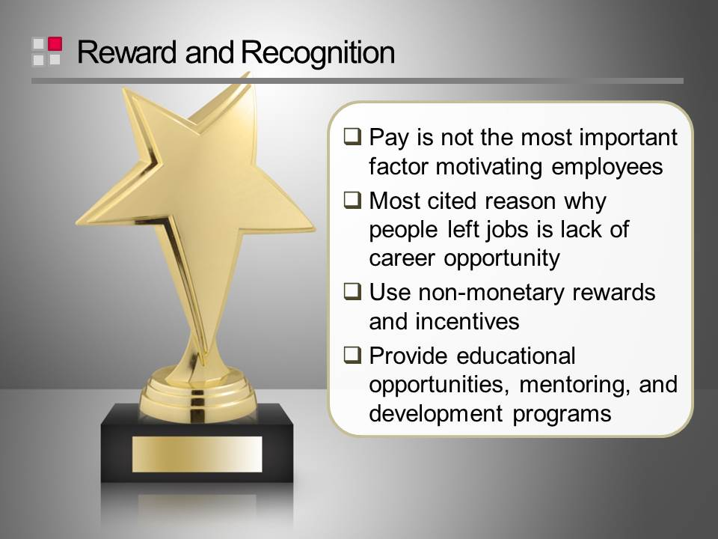
Slide 101

Motivational Program Ideas
- Reward small accomplishments.
- Give praise immediately and tell the employee specifically what he or she did right.
- Invite the employee into your office just to say thank-you.
- Have your supervisor call and issue a word of thanks to your employee.
- Write personal thank-you notes.
- Make a “success collage” using photographs of employees working on a project and display in the employee area of the office.
- Create a “yearbook” to display in the office. Again, use pictures of your staff at work.
- Make a “goal poster” listing property goals and list star performers who excelled in achieving those goals.
- Hide short Post-it notes of praise in a desk drawer or other obscure work area location. (Be careful to not invade their privacy.)Imagine the feel-good surprise they will receive.
- Buy lunch for the staff upon achieving specific goals.
- Celebrate a personal accomplishment with a short (15 minute) staff meeting. Serve refreshments and praise for a job well done.
- Give a day off to shop during the holiday season.
- Send a thank-you e-mail.
- Remember birthdays. Celebrate with a card signed by all other staff members and perhaps a cake.
- Trade jobs. Become the groundskeeper for a day, etc.
- Invite employees to breakfast one hour before the normal arrival time. Serve breakfast, decorate the facility, play upbeat music and provide employees with million dollar bills of praise and/or outline a new contest, goals, etc.
- Distribute “funny money” to employees throughout the year for achieving a series of short-term goals. Give the money to people when you catch them doing things correctly. At the end of the designated time period purchase a variety of gifts. Hold an auction and allow the employees to buy the gifts with their money.

Slide 102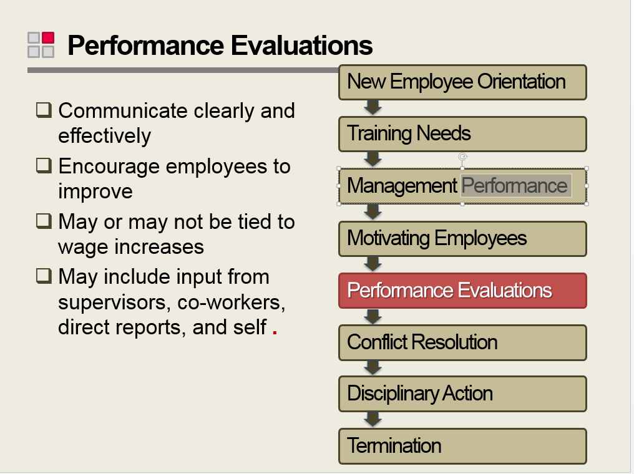
Slide 103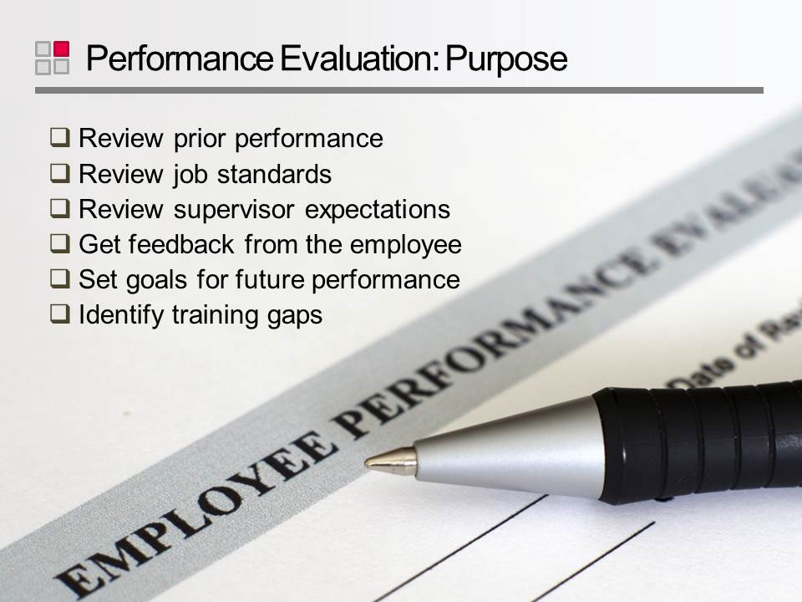
Slide 104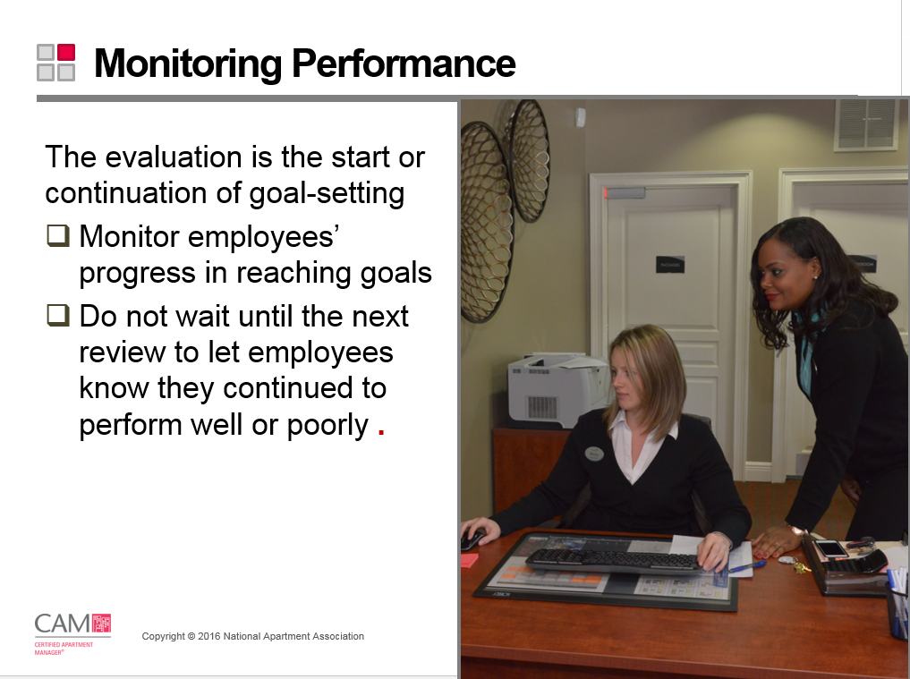
Slide 105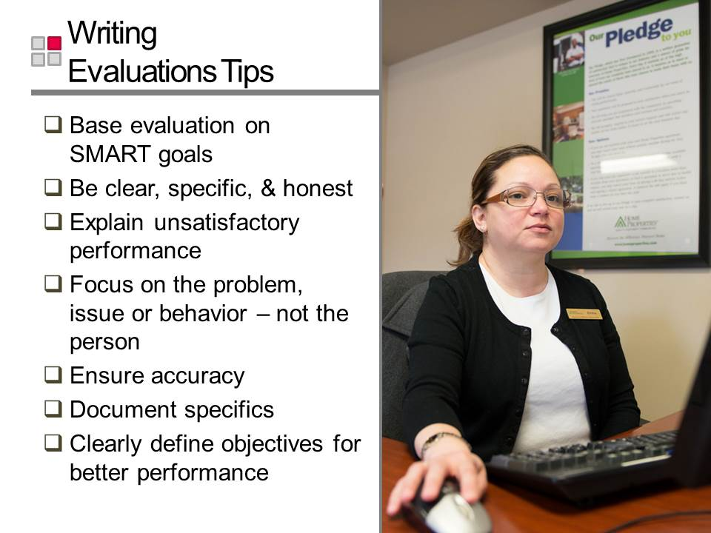
Slide 106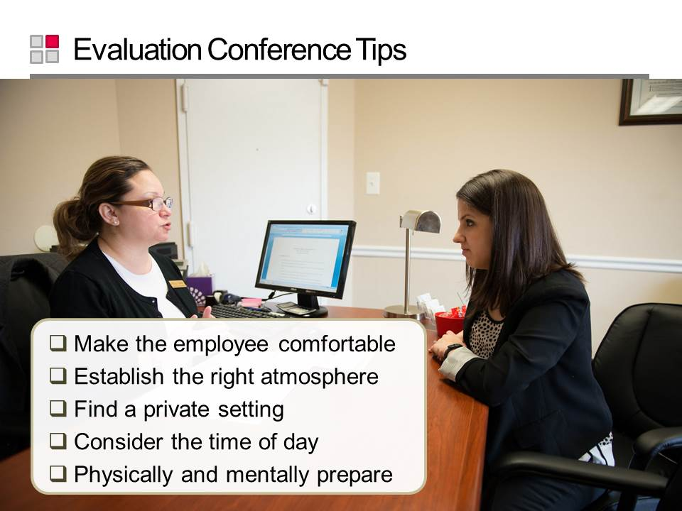
Slide 107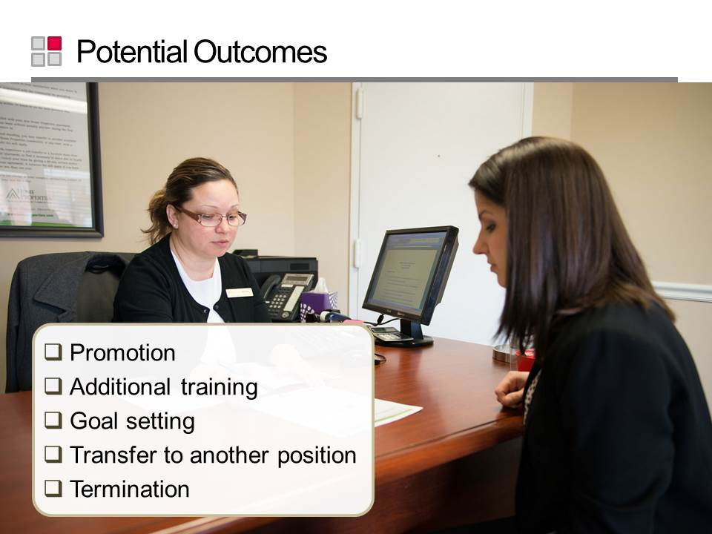
Slide 108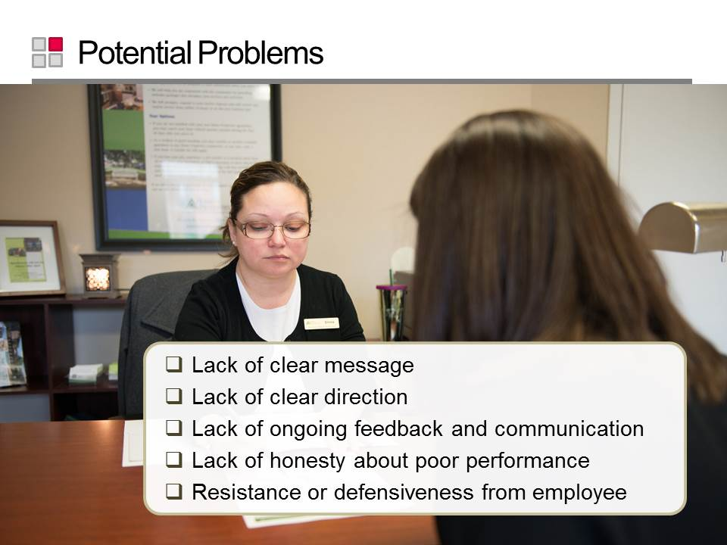
Slide 109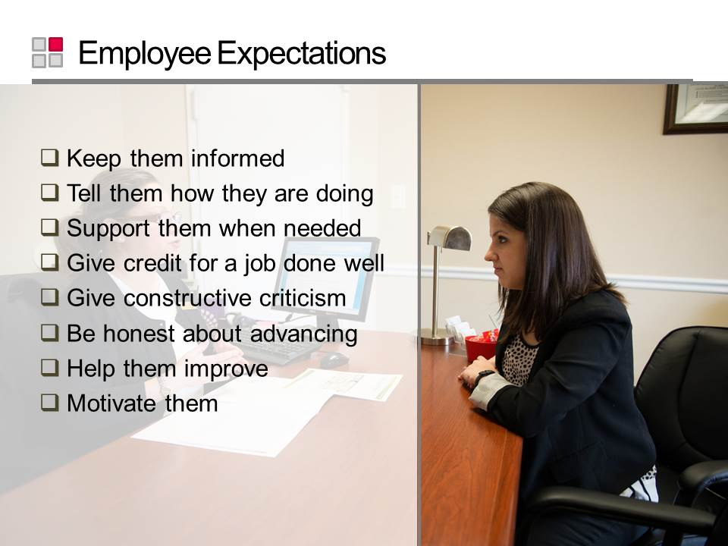
Slide 110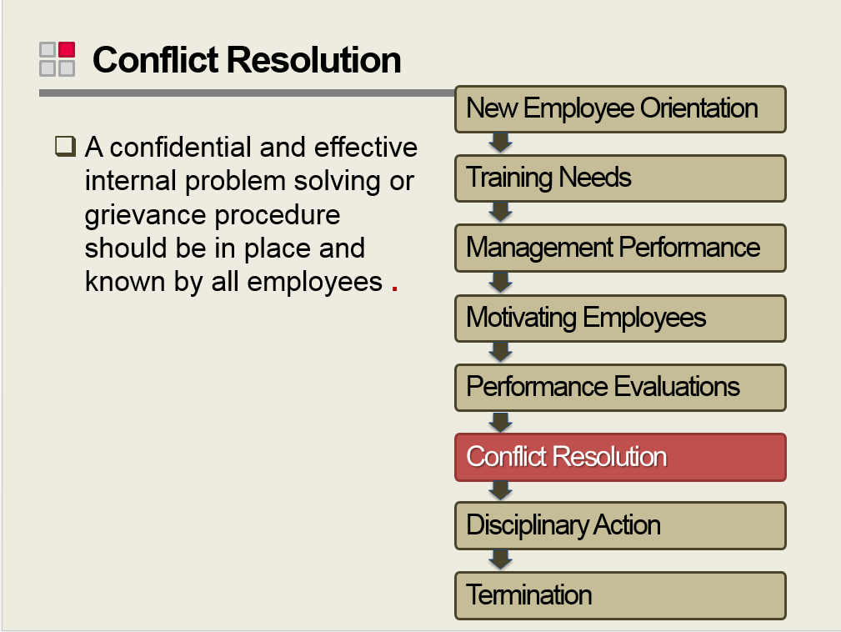
Slide 111
Slide 112
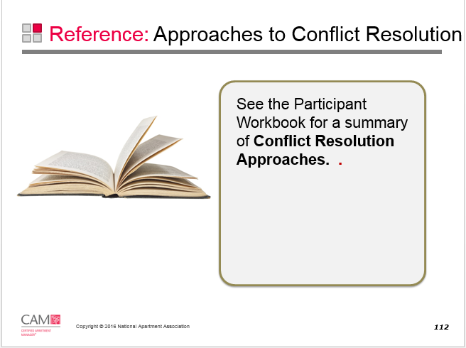

Conflict Resolution Approaches

Approach | Description
Avoidance | If the conflict is minor, sometimes it is best ignored. Interference can often cause even more conflict.
Accommodation | If a solution can be reached with an easy accommodation, give it a try. It is not always worth risking damage to relationships or causing more conflict.
Win/lose | You really are in charge and occasionally you must force the issue.
Compromising | All parties give a little and a compromise is reached. Often there is more than one way to reach a goal.
Problem Solving | Open communication can help develop a mutually beneficial solution for all parties.

Slide 113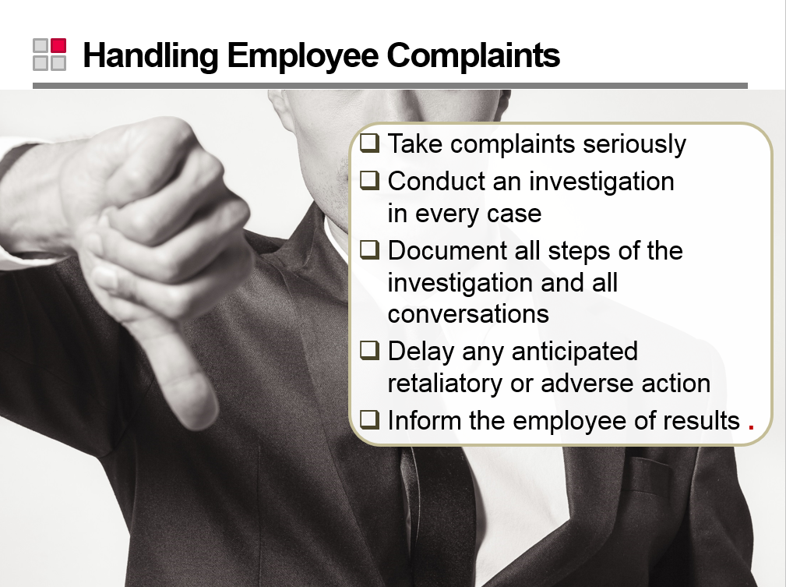
Slide 114
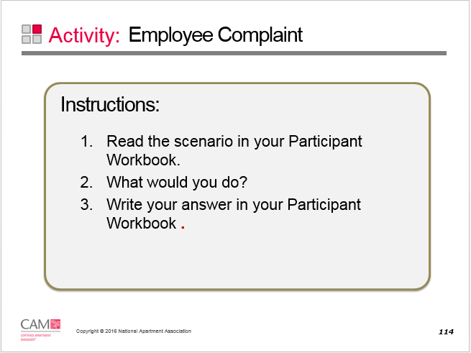

Employee Complaint Scenario Part One:

One of your Leasing Consultants, Anne, complains to you that her colleague, another Leasing Consultant in the office, Debra, is taking over prospects that Anne has cultivated. Debra reschedules appointments when Anne is not available and claims the leases as her own. She refuses to share commissions, stating that “she did all the hard work and got the sale.” Debra comes in early and stays late, frequently following up on Anne’s prospects. Anne wants you to intercede. What do you do?

Slide 115 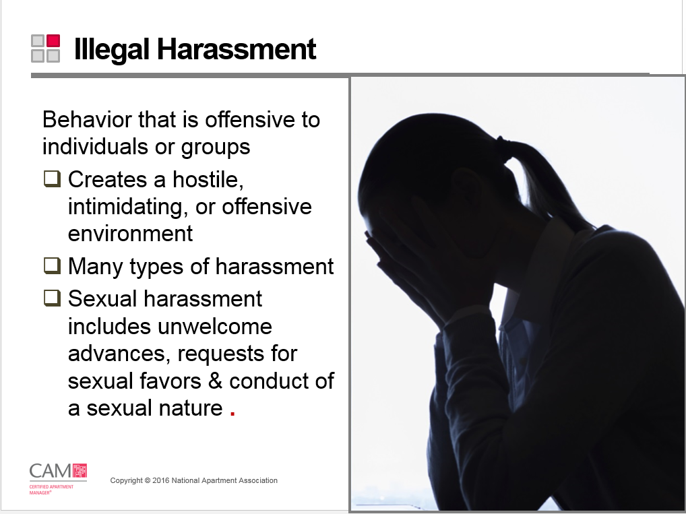
Slide 116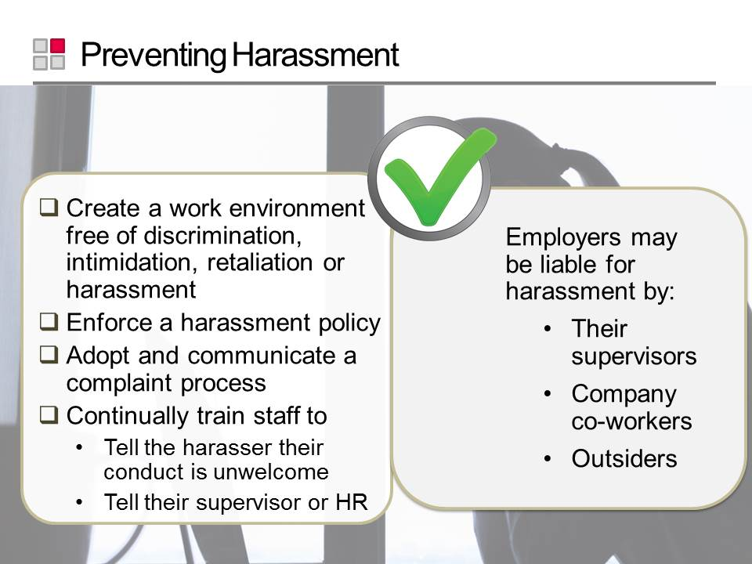
Slide 117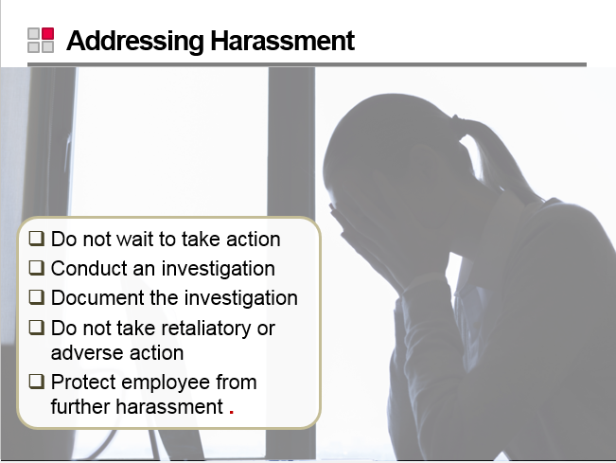
Slide 118
Slide 119
Slide 120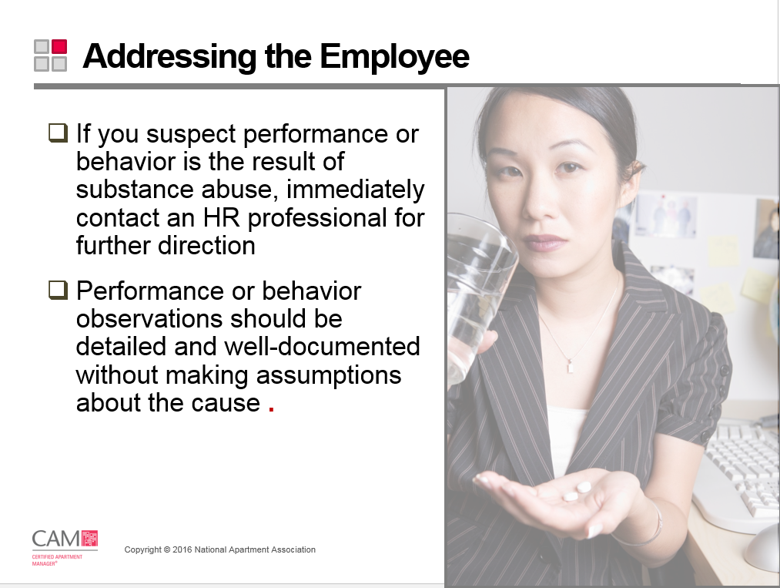
Slide 121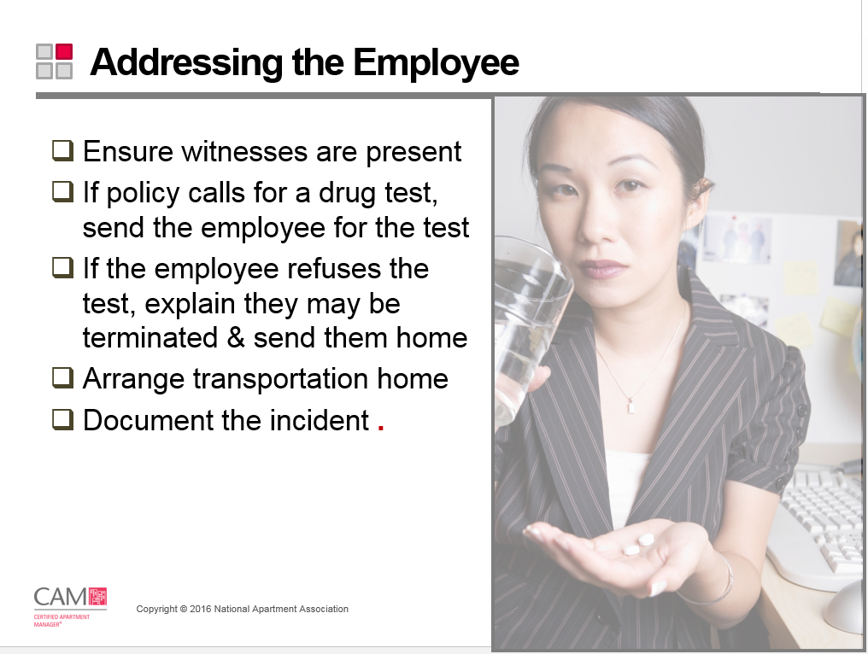
Slide 122
Slide 123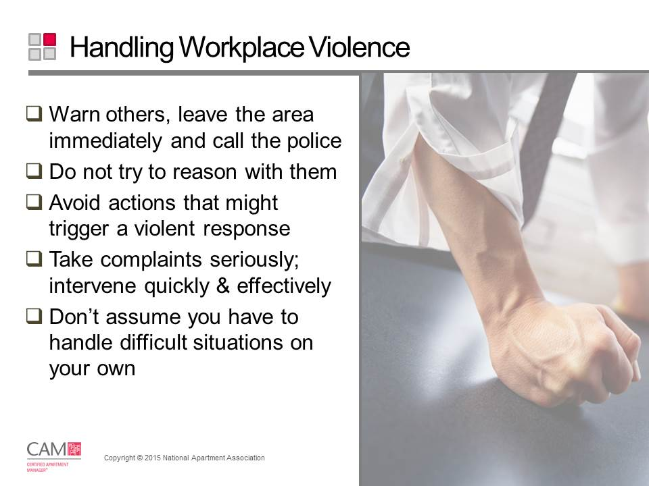
Slide 124 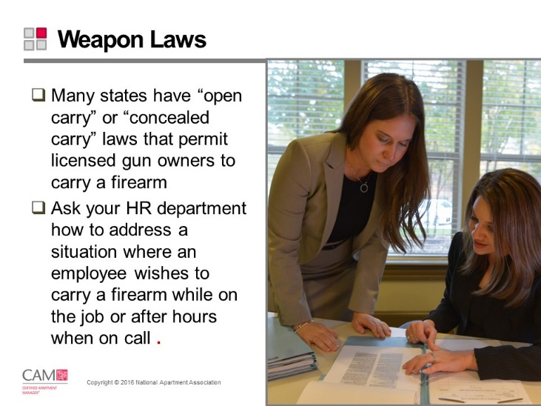
Slide 125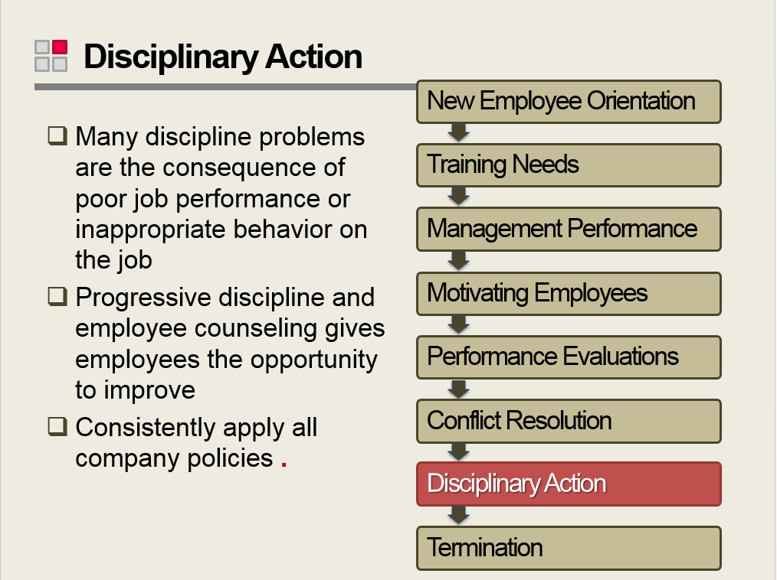
Slide 126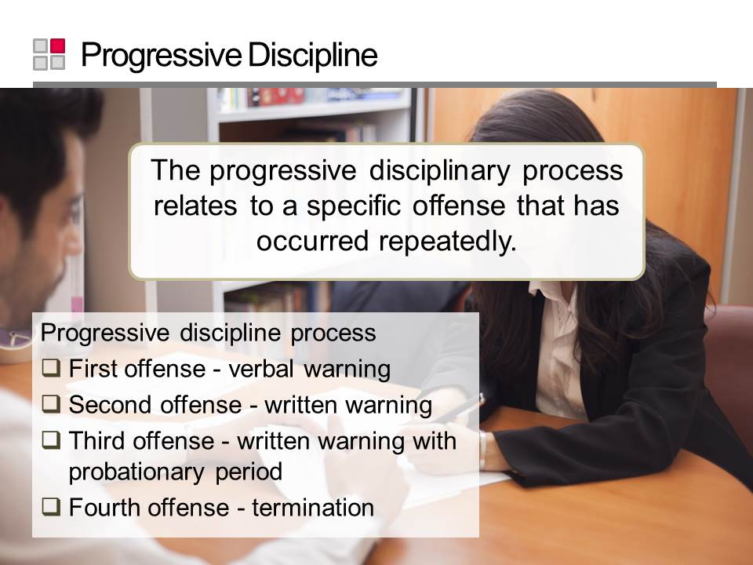
Slide 127
Slide 128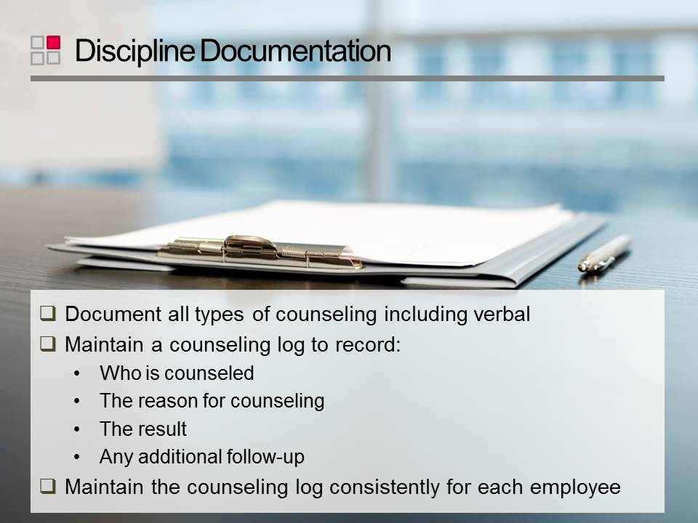
Slide 129
Slide 130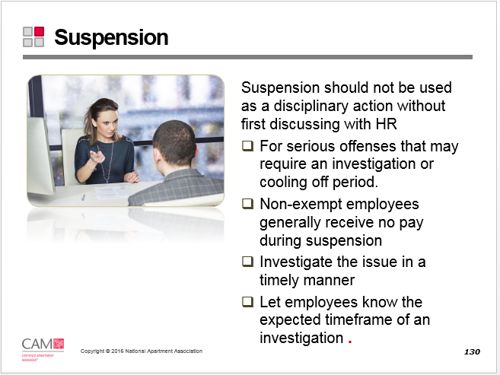
Slide 131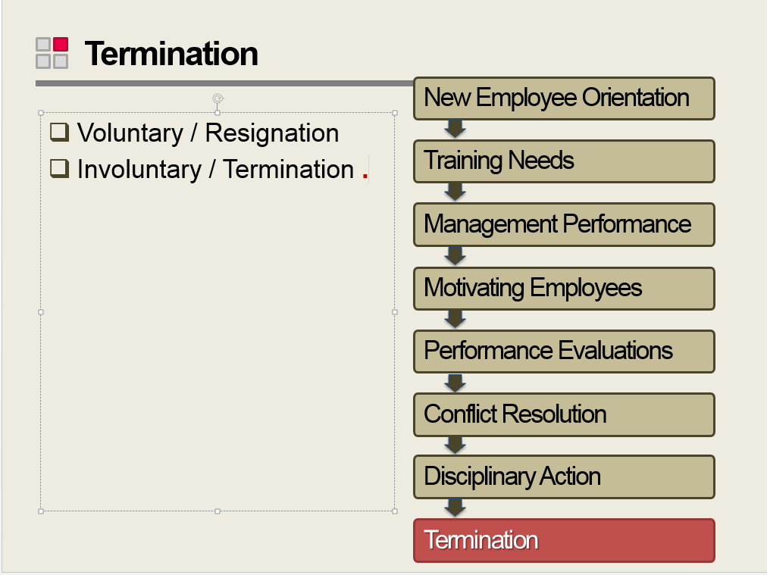
Slide 132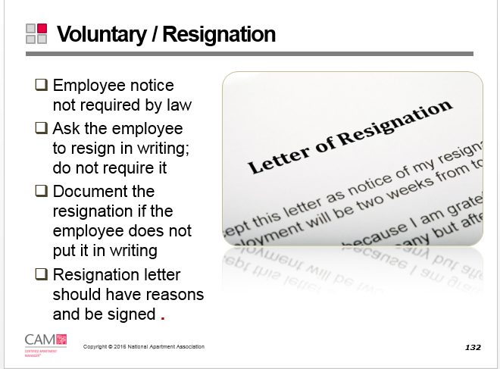
Slide 133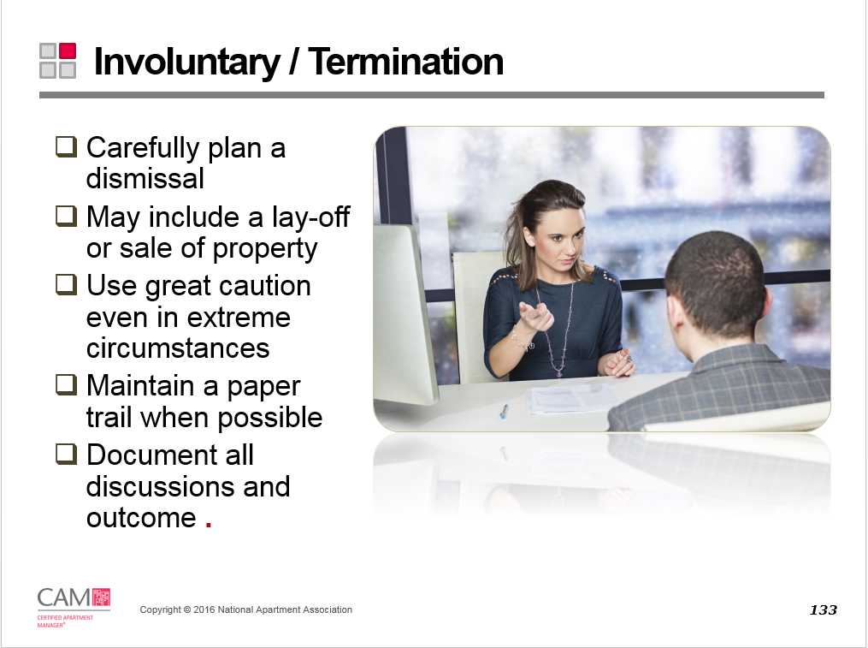
Slide 134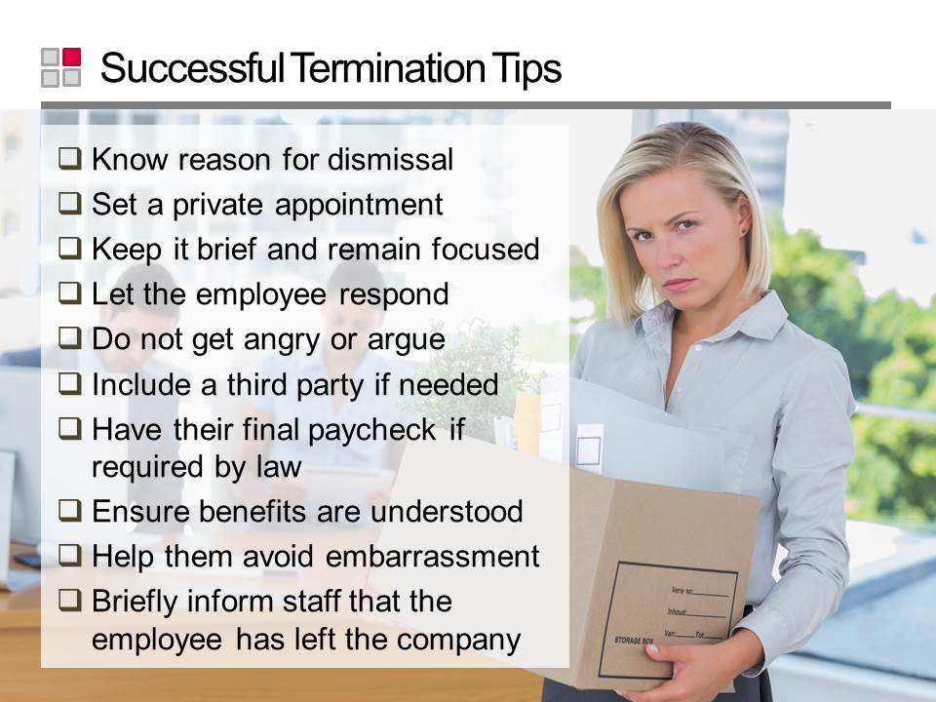
Slide 135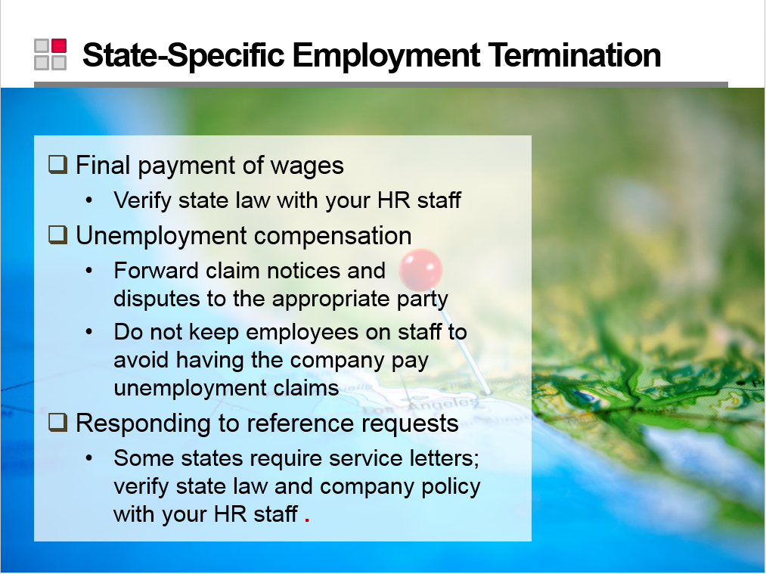
Slide 136

Wrap Up
Slide 137
Slide 138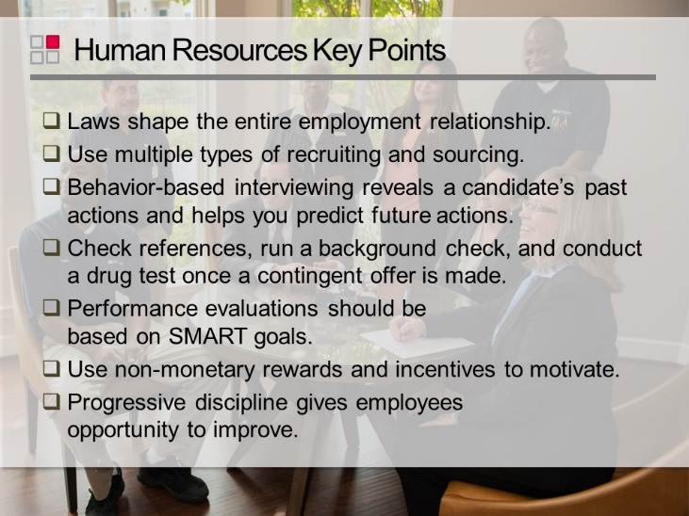
Slide 139

Knowledge Check Answers
