Producer: | - There is a breakout room activity scheduled for this session on Slide 26 (page 15 of this guide.) Collaborate with the Facilitator to decide if participants should be put into specific groups or if the groups can be chosen at random. There will be 3 groups of participants placed into 3 different rooms. Decide whether to keep the same groups as with Session 2 or devise new groups.
 | - Note that depending on the audience, the facilitator may be presenting the content for more than one phase during this session. Confer with the facilitator to ensure you know which phases will be covered.

Facilitator: | - This guide was developed for the purposes of delivering this course via WebEx Training Center, but it can also be used for classroom training with the following considerations:  - Breakout room activities will need to be adapted to fit the classroom environment.  - Questions will be made directly to learners, rather than by using WebEx response tools
 | - This session contains a breakout room activity, where participants will need to be divided into 3 groups. Collaborate with the Producer about whether you feel those groups should be formed a certain way or if the Producer can make them at random.
 | - Open the PowerPoint file associated with this guide
 | - Share the PowerPoint application and ensure that the WebEx Attendees and Chat panels are visible
 | - Some key talking points and questions are included in this guide but be prepared to add your own commentary and questions as well.
 | - Aim towards generating a response from the learner(s) at least once every five minutes; this will keep learners engaged and will encourage them to follow along closely. Examples of these types of responses have been noted using ASK

Session 1
Slides | Approximate Timing | Summary
1-9 | 10 min | Introduction
10-15 | 27 min | Detail Design
16-19 | 10 min | Security Analysis
20-31 | 35 min | Application Program Development and FAT Procedure
32-50 | 35 min | Installation and Testing Activities
Total: | 122-127 min.

Slide#)  Duration | Slide | Facilitator Notes | Producer Notes
- Less than 2 min. | 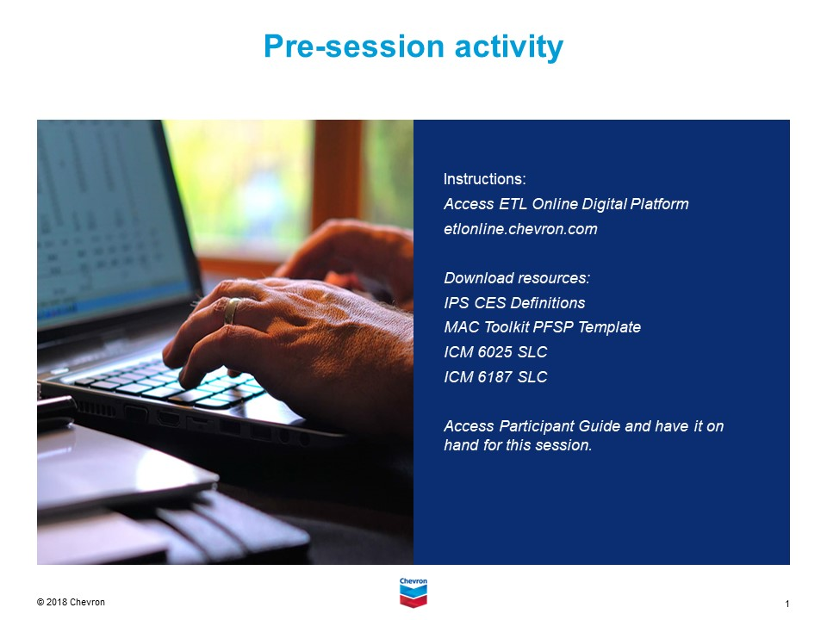 | DO:  - Welcome learners  - Introduce yourself  - Remind learners that that the session will be recorded and will be available for their review | DO:  - Check for facilitator readiness  SAY:  - Greet early learners as needed, letting them know the session will begin shortly  - Remind learners to have their printed materials ready (including the Session Exercise templates/handouts)  - Please remind everyone that they should remain muted unless called upon  - Also, to use the raise hand icon if they have questions
- 1 min | 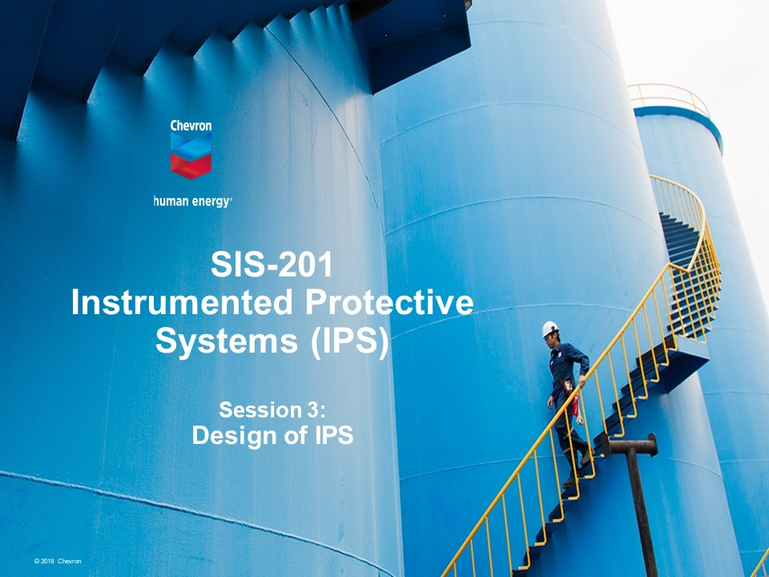 | DO:  - Introduce SIS-201, Module 3, which will focus on Design.
- 1 min | 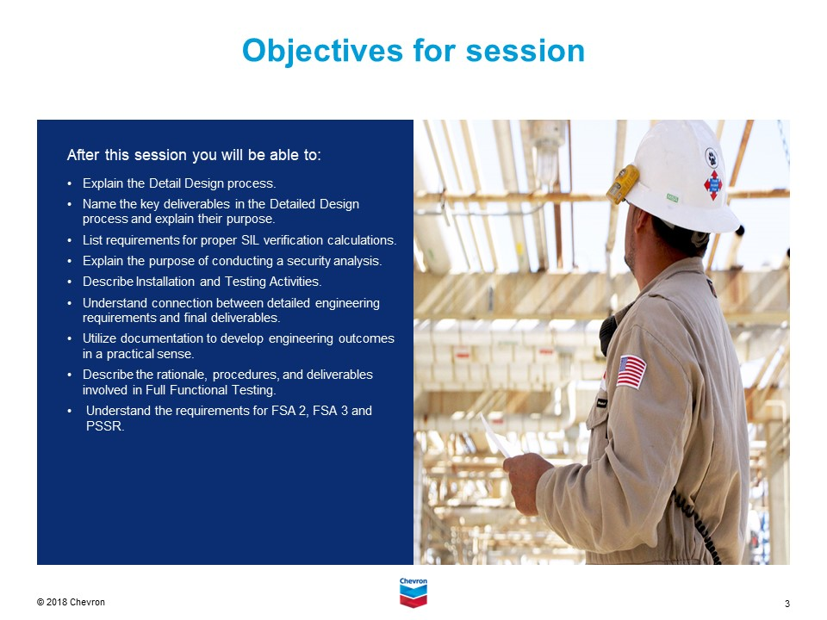 | DO:  - List objectives.
- 1 min | 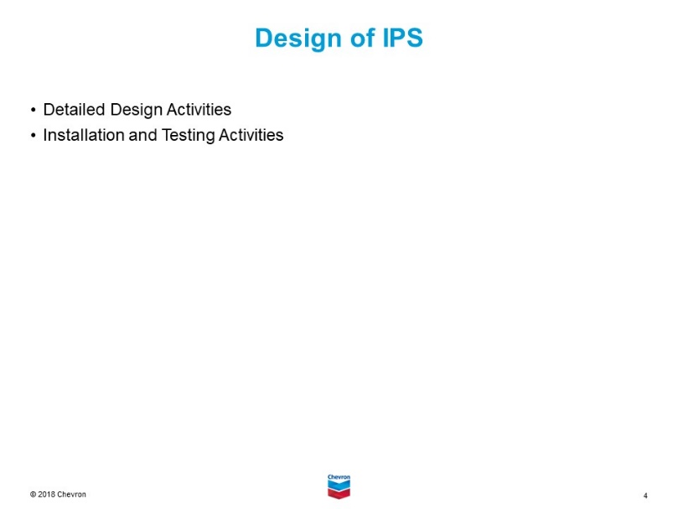 | DO:  - Review Design topics covered in this section.
- 1 min | 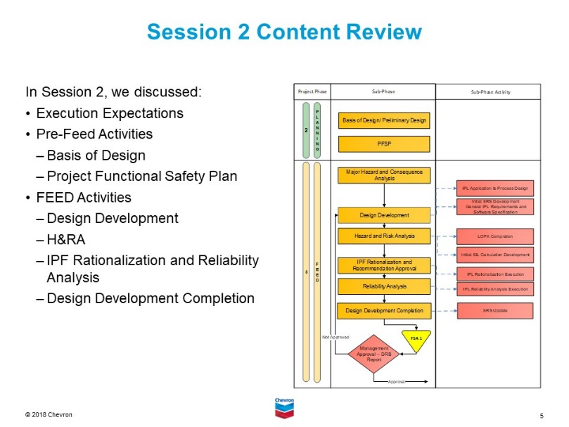 | DO:  - Review key points discussed in Session 2.
- 5-7 min | 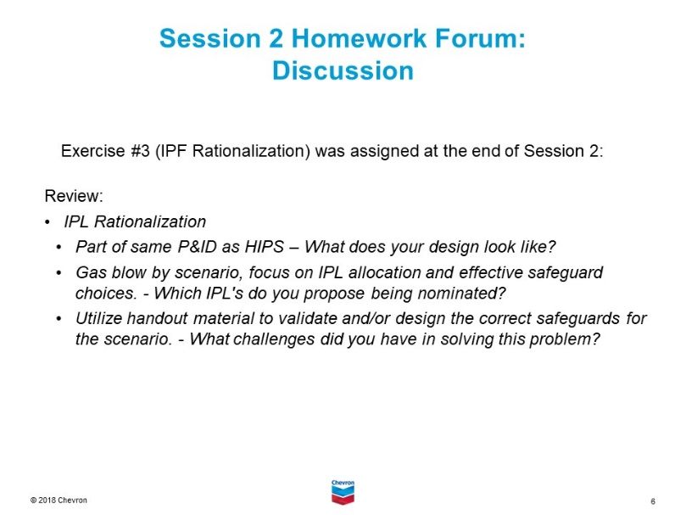 | DISCUSS:  - Part of same P&ID as HIPS – What does your design look like?  - Gas blow by scenario, focus on IPL allocation and effective safeguard choices. - Which IPL's do you propose being nominated?  - Utilize handout material to validate and/or design the correct safeguards for the scenario. - What challenges did you have in solving this problem?  (Note) Alternative Option to have students email homework summary to PAR prior to class and he will choose students to present based on the responses.
- 1 min | 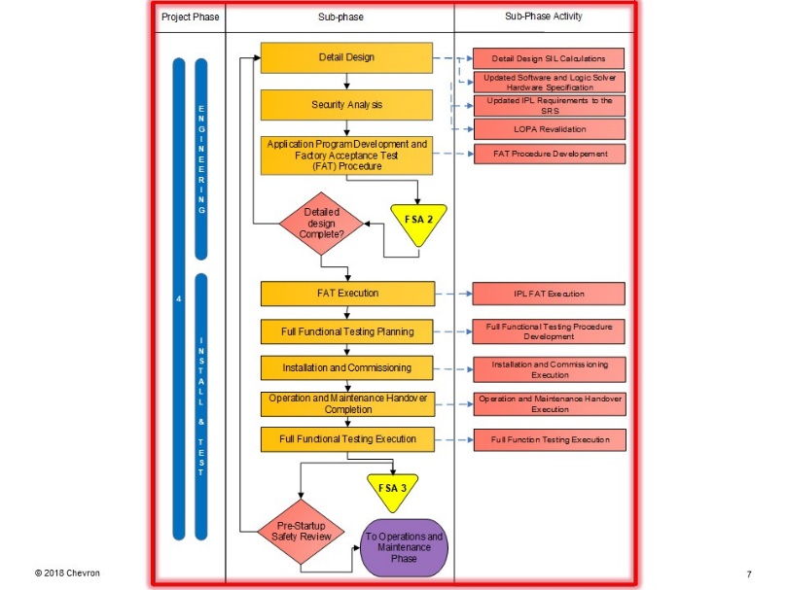 | EXPLAIN:  - This chapter is a continuation of Module 2 concepts, bridged to the Engineering and Install/Test areas (Phase 4) of the Safety Lifecycle  - In this session, we will break down procedures and standards for each item in the Sub-phase column of the flow chart.
- 1 min | 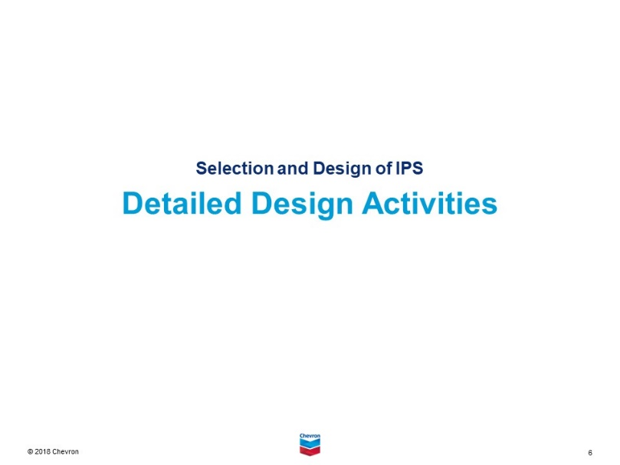 | DO:  - Introduced the Detailed Design Activities.
- 1 min | 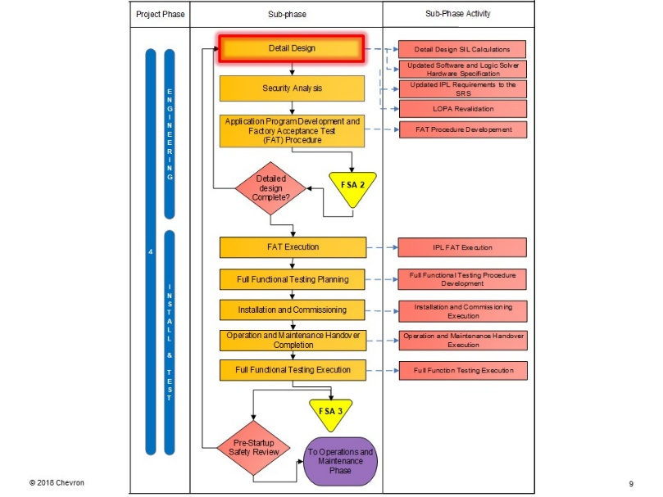 | EXPLAIN:  - Detailed Design is the first activity on the SubPhase section of this workflow.
- 3 min | 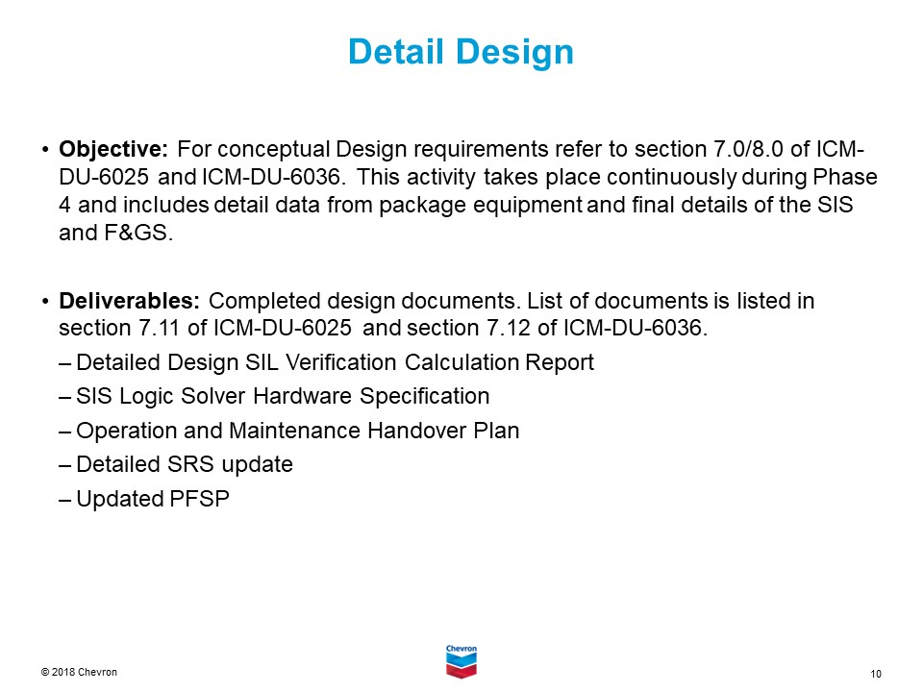 | EXPLAIN:  - The connection here is for the detail engineering concepts that are in the Chevron Engineering standards to be fulfilled.  - This includes the completed “Do” activities for the Plan, Do and Check work for the SLC.  - Review with the students that the bulk of the SIS engineering work is accounted for in this step of the SLC.

- 4 min | 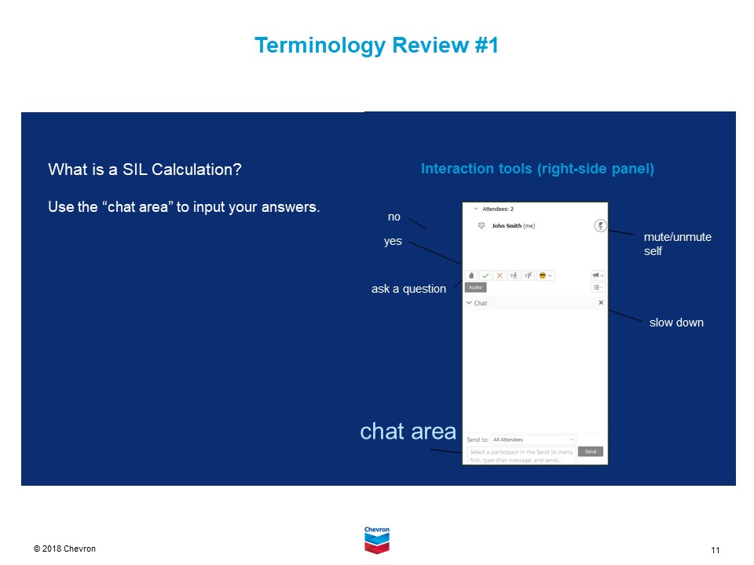 | ASK:  - What is a SIL Calculation?  DO:  - Instruct participants to type the definition into the chat.  - Review submissions and provide correct answer if no one provides it.  EXPLAIN:  - SIL Calculation is a discrete level (ranging from 1 to 4) for specifying the probability of a SIS (Safety Instrumented Function) satisfactorily performing the required SIF under specific conditions. SIL is a measure of the performance of a SIF.  - SIL Calculations are performed to determine the probability of failure on demand average
- 3 min | 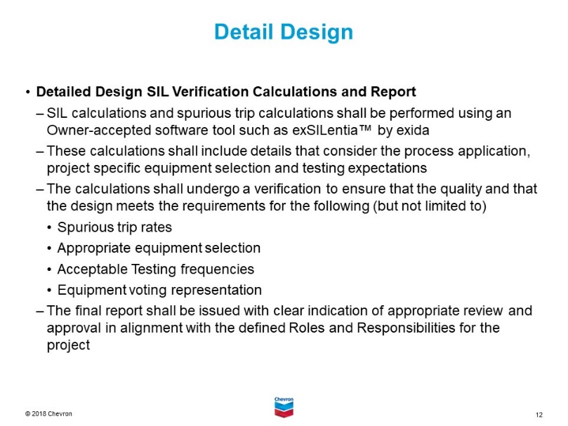 | EXPLAIN:  - For the class, we will review the components of the completed SIL Verification calculations and what is expected in a report.  - This includes the details contained in the SRS and how they are fulfilled in the design models.  - The SIL calculation, as noted before, is a digital twin of the field installation.
- 3 min | 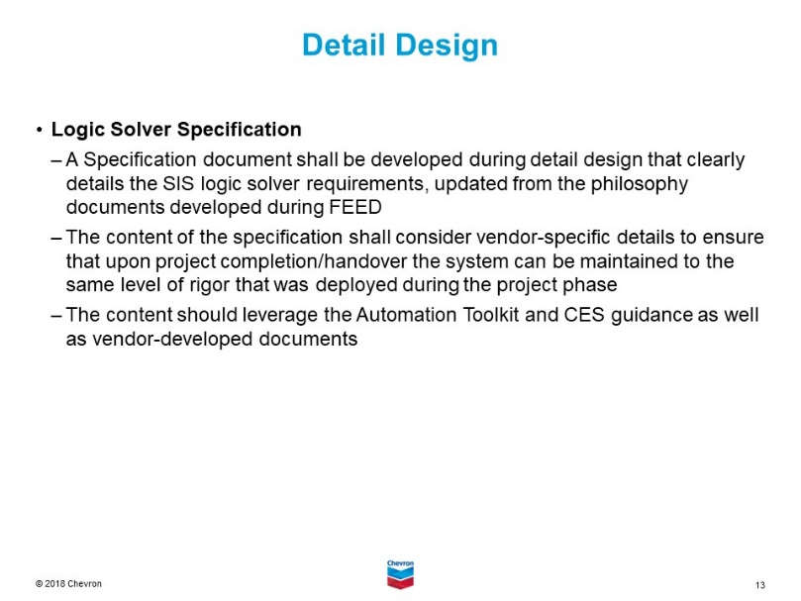 | EXPLAIN:  - Logic Solver Specification includes the details about:  - How the automation hardware is used  - The configuration of the components (hardware and software working together)  - How the data is presented to the operations personnel.
- 3 min | 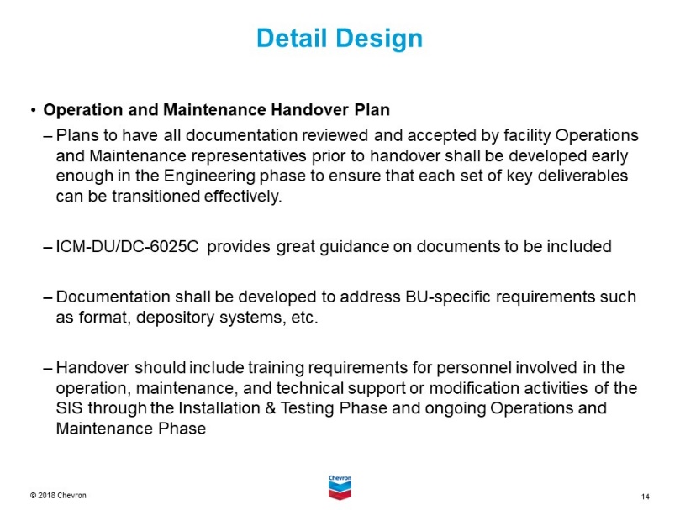 | EXPLAIN:  - As part of planning, this is the point that you need to be thinking about the future state of the design.  - How is it going to be maintained, tested, documented?  - How and what is being engineered?  - How will that be delivered to the owners of the equipment?  - It starts, here, with a handover plan.  - What documents and when?  - What training and when?  - What tools and when?
- 3 min | 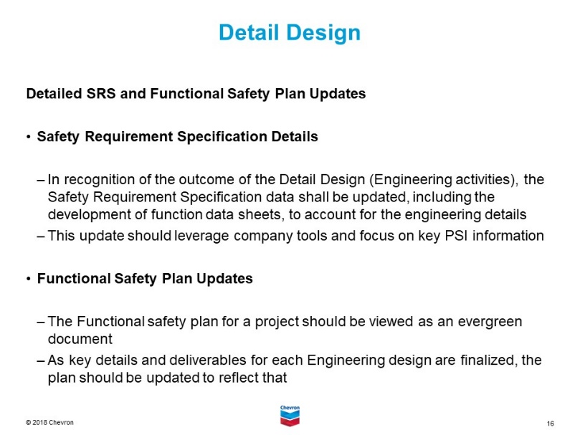 | EXPLAIN:  - As part of the completed Detail design, the practitioner will then need to update the suite of documents that represent the work completed.  - This includes the SRS design outcomes (results of the quality work) and then updating the plan for work to be completed.
- 1 min | 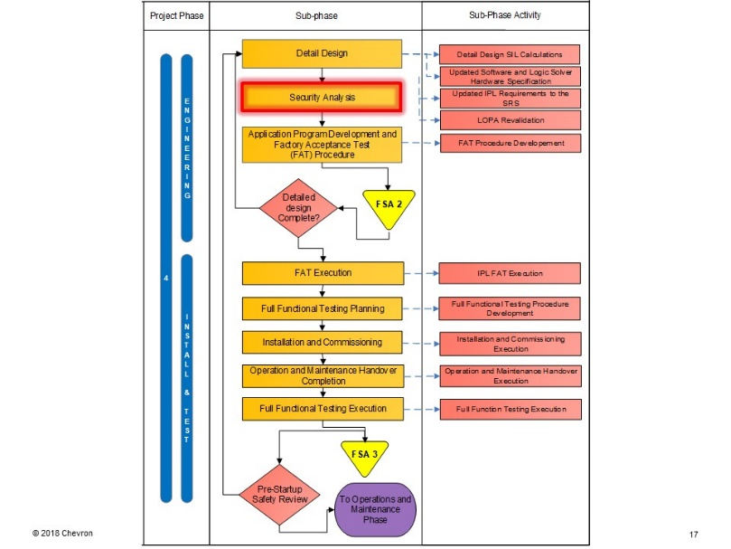 | DO:  - Introduce the section on Security Analysis.
- 3 min | 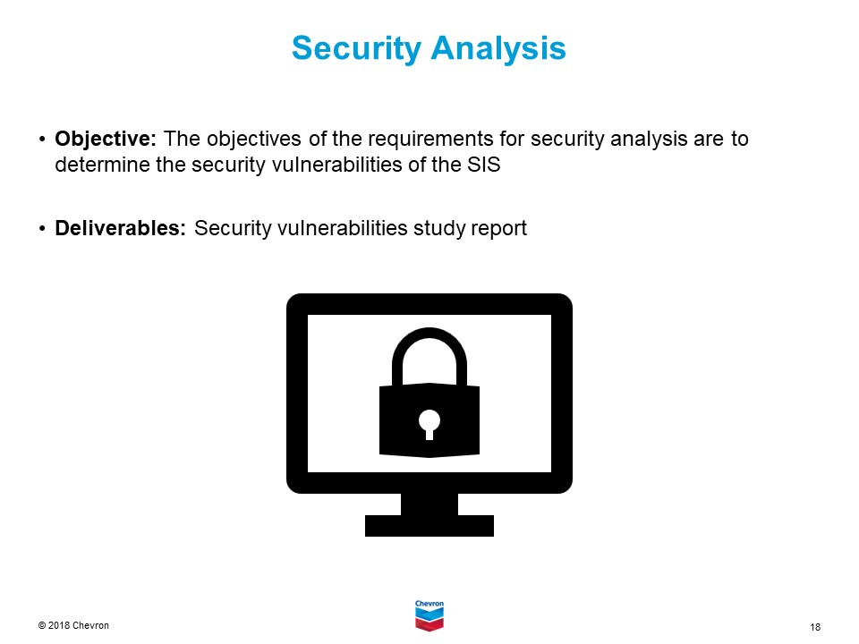 | SAY:  - Here we are looking at threats. This is required by both international standards and Chevron CES.  - This is done in concert with IT process and cyber security reviews.  DO:  - Focus on the need for both physical and cyber reviews.
- 3 min | 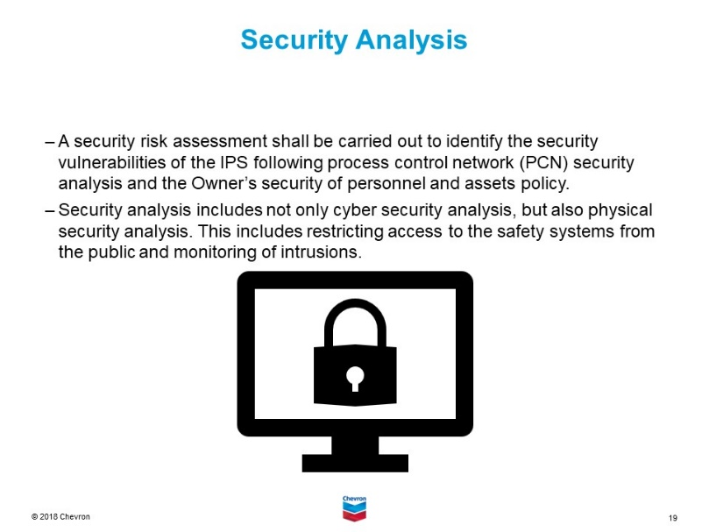 | DO:  - See notes on slide.  - Focus on the need for both physical and cyber reviews.
- 4 min | 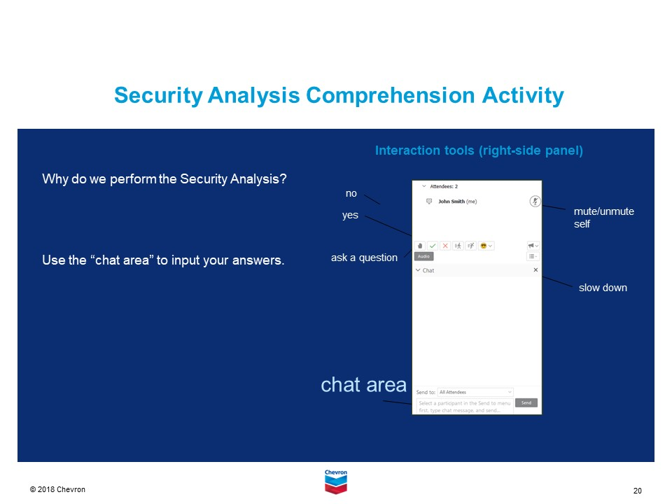 | ASK:  - Why do we perform the Security Analysis?  DO:  - Instruct participants to type the answer into the chat.  - Review submissions and provide correct answer if no one provides it.  EXPLAIN:  - A security risk assessment shall be carried out to identify the security vulnerabilities of the IPS, both physical and cyber in nature.
- 1 min | 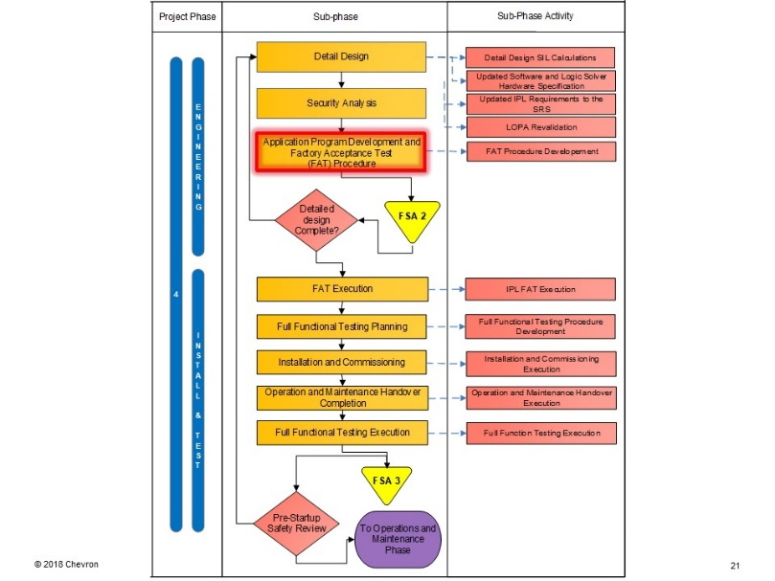 | DO:  - Introduce the section on Application Program Development and Factory Acceptance Test (FAT) Procedure
- 3 min | 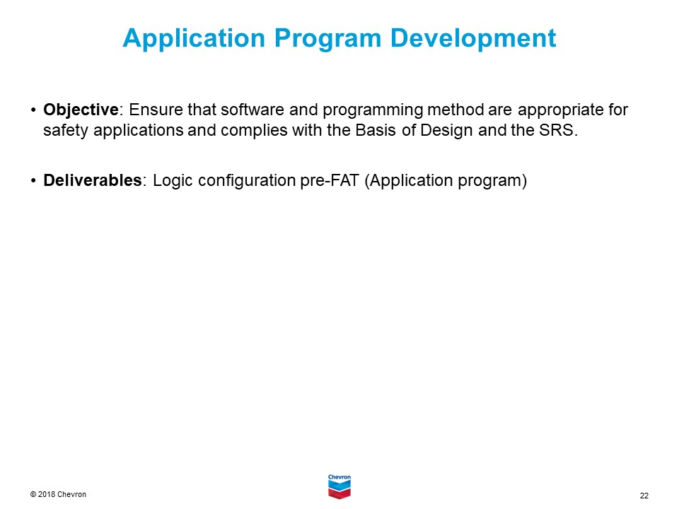 | SAY:  - Here we will talk about the evolution of the automation system.  - This is the taking of the specification (the requirements) and turning that into a finished product.
- 3 min | 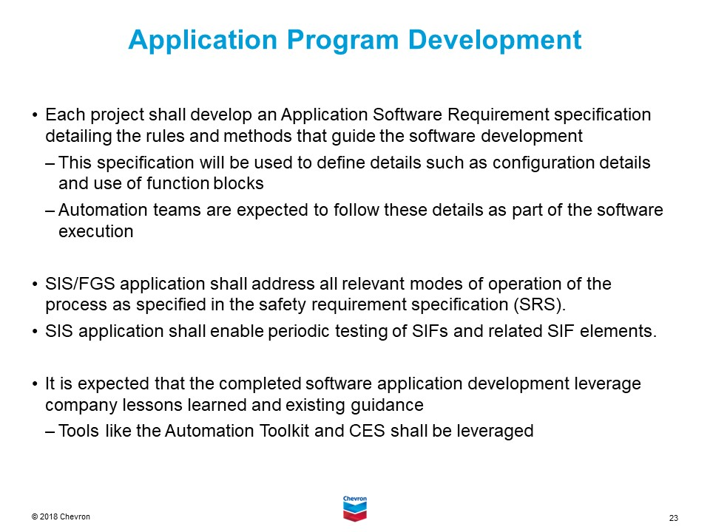 | SAY:  - The expectation is that the logic solver spec (hardware) shall also have a software spec supplement.  - Whether this is a secondary document or extension of the hardware is up to the project/facility.  EXPLAIN:  - If the implementation is at an existing facility, the software requirements should complement the existing style and programming implementation. This is important for continued maintenance and sustainability.
- 2 min | 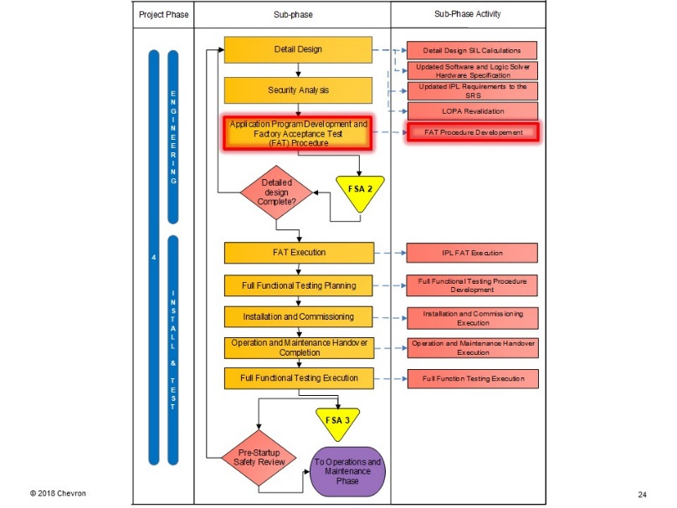 | DO:  - Introduce the section on the sub-phase – FAT Procedure Development.
- 3 min | 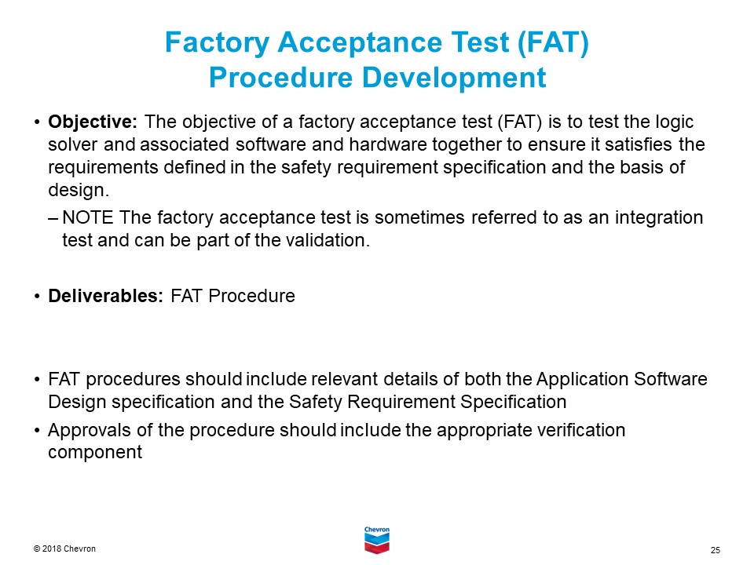 | EXPLAIN:  - The key here is to write the FAT procedure against the requirements in both the SRS and the software/hardware specification; NOT against the completed software.  - Plan for testing against all of the requirements.
- 15 min | 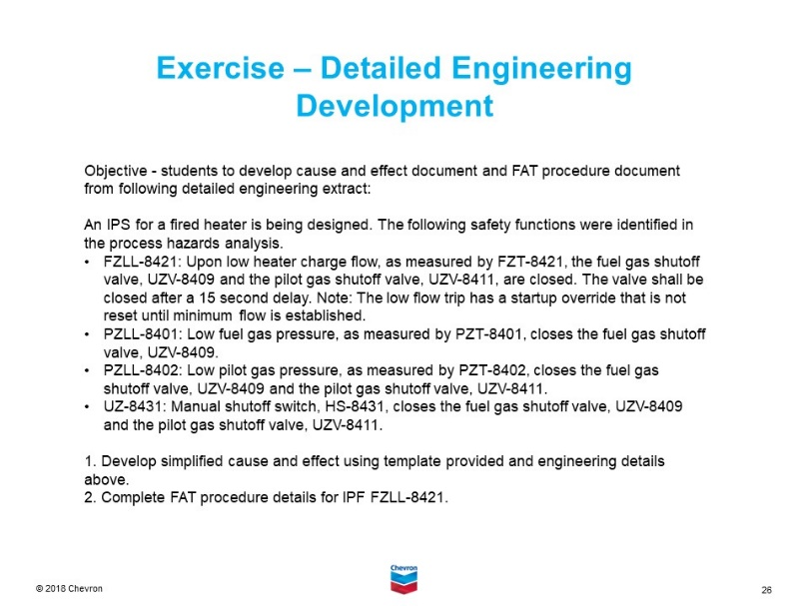 | DO:  - Introduce exercise on Detailed Engineering Development. Explain the objective of this exercise.  - Explain that in this exercise, participants will be broken up into 3 groups and placed into breakout rooms where they will do #1 and 2 at the bottom of the slide – Develop a simplified Cause and Effect using the template provided and the engineering details above and complete FAT procedure details for IPF FZLL-8421.  - Explain that they need to have a printout of the Cause and Effect template and the FAT procedure from the ETL site to complete this exercise, and upon completion, there will be a debrief.  - Ask them to assign a spokesperson to talk about what was discussed upon return to the large group.  - Define the rules of the breakout session  - Roles and responsibilities in the group  - Any parameters and regulations that need to be followed in devising the solution  - Define successful outcome for solution.
 | 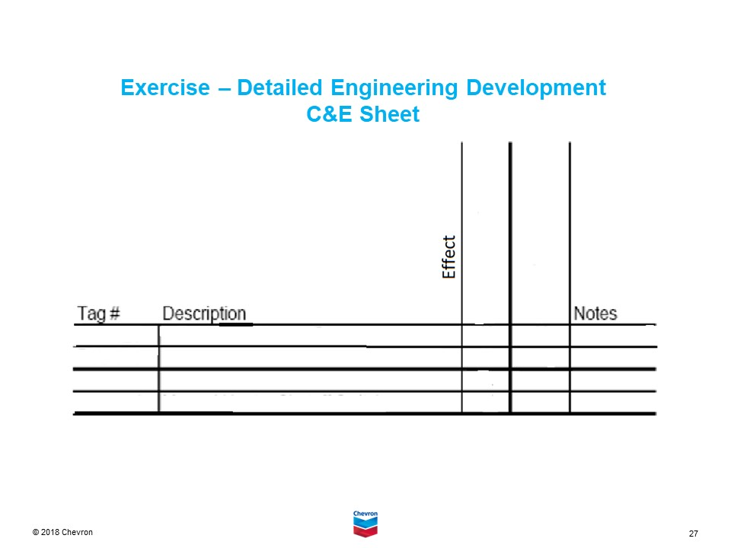 | EXPLAIN:  - This is the template you will use to analyze the Cause and Effect.

